Partnerships in Dementia Care (PiDC) Alliance Connection

Providing Updates; Communicating Findings; Sharing Resources, Connecting Partners

Volume 4, Issue 1. (accessible version)  
April 2015

[www.uwaterloo.ca/pidc](http://www.uwaterloo.ca/pidc) [sian.lockwood@uwaterloo.ca](mailto:sian.lockwood@uwaterloo.ca)

# 30th International Conference of Alzheimer’s disease international 15-18th April 2015

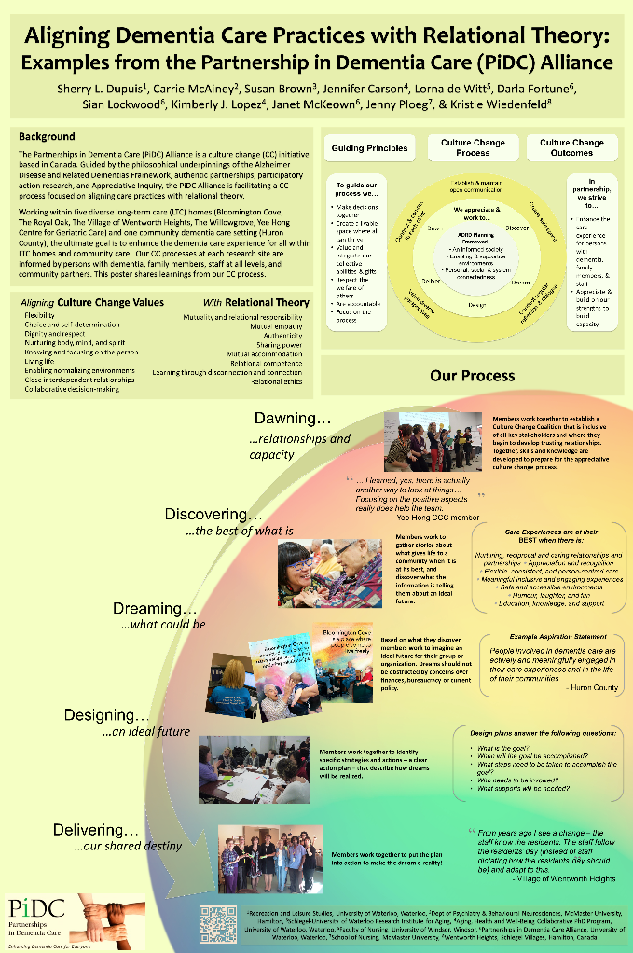 On April 16th 2015 Dr. Dupuis presented a poster at the 30th International Conference Alzheimer ‘s Disease International in Perth, Australia. On Aligning Dementia Care Practices with Relational Theory: Examples from the Partnerships in Dementia Care (PiDC) Alliance Dr. Sherry L. Dupuis, Dr. Carrie McAiney, Susan Brown, Dr. Jennifer Carson, Dr. Lorna de Witt, Dr. Darla Fortune, Sian Lockwood, Kimberly J. Lopez, Janet McKeown, Dr. Jenny Ploeg, Kristie Wiedenfeld.

The poster shared learnings from our 4 year iterative culture change (CC) process, during which CC coalitions formed in 6 diverse long-term care (LTC) and community settings and actively integrated the voices of individuals with dementia, residents in LTC, family care partners, volunteers, and staff at all levels in decision-making.

In the poster, we shared examples of how our CC coalitions worked collaboratively to: (a) discover their positive core, (b) dream new possibilities, (c) design a plan for achieving desired aspirations, and (d) implement changes to transform their care and community settings.

Key enabling factors necessary for CC emerged from our work: adopting creative ways to engage persons with dementia, nurturing CC champions, building caring relationships, being supported by transformative leaders, celebrating accomplishments, and being flexible and responsive to the uniqueness of different settings. By including relationship-centred concepts and practices (e.g., power sharing, responsibility, authenticity, accommodating one another) into the CC process, participants learned new ways of acting in a more appreciative and compassionate manner.

**Culture Change Coalition Updates**

# *bloomington cove community care*

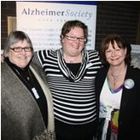In January 2015, in celebration of Alzheimer Awareness month, Bloomington Cove Community Care and the Alzheimer Society of York Region hosted two performances of Cracked: New light on dementia for the Stouffville community. Also, the leadership, staff and family care partners at Bloomington Cove are leading the development of their design plan for making their four aspiration statements a reality.

# *Huron County partners for dementia support*

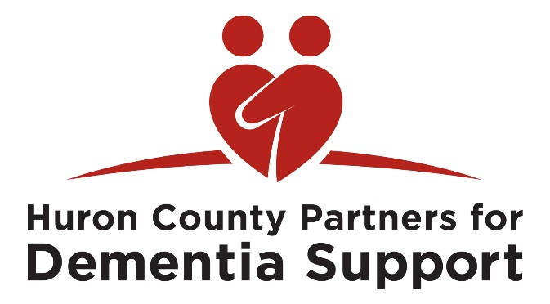The Huron County Partners for Dementia Support created a new logo and a directory of services to help increase awareness of their coalition in the community. This month they will continue to work on their Design plan to create concrete actions around their three themes: relationships, education and awareness, and social engagement.

# Reaching for new heights

The Reaching for New Heights (Village of Wentworth Heights) team would like to Congratulate Dr. Jennifer Carson on her successful defense of her doctoral dissertation.

The Reaching for New Heights team also received great feedback from their recent culture change survey. When asked “what does culture change mean to you”, staff members replied “knowing our residents, assisting them with decisions to enrich their lives, offering choices, and being respectful.” The group also asked their Village to design a new aspiration T. Shirt. They received great suggestions and will be unveiling the winning T. Shirt design soon! The next goal is for the Village is to decide which aspiration statements to focus on next. Jennifer Carson and Schlegel Villages team

# Yee hong culture change coalition

The Yee Hong Culture Change Coalition have completed Discovery and are now working through the Dream phase to ‘dream what might be.’ Their next goal will be to create aspirations statements that will help them visualize what positive change might look like and act as a guide for the future.

# the Willowgrove dream weavers

The Dream Weavers culture change coalition has been busy deciding what methods to use to discover the ‘best of what is’ in The Willowgrove community. The group have decided to use the CARE profiles and identify WOW moments to capture what residents, family members, staff, and community members think is working well. The recreation staff will also be using art-based activities with the residents to find out what makes residents happy and what they enjoy about living at The Willowgrove.

# the royal oak making a difference committee

The Making a Difference Committee have created a visual representation of their guiding principles that they shared with residents, family members, and staff. The group is also looking at different methods that they might use to discover what is working well at The Royal Oak. One of the goals of their Discovery phase is to: “know how to foster relationships that result in a feeling of connection and belonging.”

**Partnerships in Dementia Care (PiDC) Alliance Partners**

**Culture Change Coalition Sites**

[Bloomington Cove](http://www.specialty-care.com/index.php/bloomington-cove)  
[Huron County](https://uwaterloo.ca/partnerships-in-dementia-care/alliance-partners/culture-change-coalitions/huron-county-culture-change-coalition)

[The Royal Oak](https://uwaterloo.ca/partnerships-in-dementia-care/alliance-partners/culture-change-coalitions/royal-oak-culture-change-coalition)

[The Village of Wentworth Heights](http://schlegelvillages.com/hamilton)

[The Willowgrove](https://uwaterloo.ca/partnerships-in-dementia-care/alliance-partners/culture-change-coalitions/willowgrove-culture-change-coalition)

[Yee Hong Centre for Geriatric Care](http://www.yeehong.com/)

**Research Management Team**

Sherry Dupuis, PiDC Alliance, University of Waterloo

Carrie McAiney, St. Joseph’s Hospital   
Hamilton, McMaster University

Jennifer Carson, University of Waterloo

Anita Cole, South West CCAC

Lorna de Witt, University of Windsor

Kim Fitzpatrick, Specialty Care, Inc.

Amy Go, Yee Hong Centre for Geriatric Care

David Harvey, Alzheimer Society of Ontario

Paul Holyoke, Saint Elizabeth Health Centre

Janet Iwaszczenko, Bloomington Cove

Sharon Kaaslainen, McMaster University

Ken LeClair, Queen’s University

Carol McWilliam, Western University

Jenny Ploeg, McMaster University

Bryan Smale, University of Waterloo

Catherine Ward-Griffin, Western University

Frances Westley, University of Waterloo

Kristie Wiedenfeld, Wentworth Heights

Josie D’Avernas, Schlegel-UW Research Institute for Aging

Susan Brown, Schlegel-UW Research Institute for Aging

**PiDC Alliance Staff**

Darla Fortune, PiDC Alliance

Janet McKeown, PiDC Alliance

Kimberly Lopez, PiDC Alliance

Sian Lockwood, PiDC Alliance

**PiDC Alliance Partners**

Advocacy Centre for the Elderly

Alzheimer Knowledge Exchange

Alzheimer Outreach Services

Alzheimer Society, Hamilton and Halton  
Alzheimer Society, Huron County

Alzheimer Society, London and Middlesex

Alzheimer Society, Peel

Alzheimer Society of Canada

Alzheimer Society of Ontario

Alzheimer Society, York Region

Canadian Coalition for Seniors’ Mental Health

Canadian Dementia Knowledge Translation Network

Canadian Gerontological Nurses Association

[Chartwell Long Term Care Homes](http://www.chartwell.com/)

Concerned Friends of Ontario Citizens in Care Facilities

Conestoga College Institute of Technology and Advanced Learning

Dementia Advocacy and Support Network  
International  
Department of Psychiatry and Behavioural   
Neurosciences, McMaster University

Department of Psychiatry, Queen’s University

[Dotsa Bitove Wellness Academy](http://www.dotsabitove.com/)

Division of Geriatric Psychiatry  
McMaster University Faculty of Applied Health Sciences, University of Waterloo

Faculty of Health Sciences, McMaster University

Faculty of Health Sciences, Western University

Faculty of Nursing, University of Windsor

Geriatric Psychiatry Program, Mount Sinai Hospital

Hamilton Niagara Haldimand Brant LHIN

Homewood Health Centre

Java Music Club

Local Health Integration Network – Central

Long-Term and Continuing Care

Association of Manitoba

Ministry of Health and Long-Term Care

Murray Alzheimer Research and Education Program

National Initiative for the Care of the Elderly

Office of the President, University of Windsor

Office of the Vice-President, Research,

University of Waterloo

One Care

Ontario Association of Non-Profit Homes and Services for Seniors

Ontario Community Support Association

Ontario Dementia Network

Ontario Family Councils’ Program

Ontario Interdisciplinary Council of Aging and Health

Ontario Long-Term Care Association

Ontario PsychoGeriatric Association

Ontario Seniors’ Secretariat

Regional Geriatric Program Central

Registered Nurses’ Association of Ontario

Revera Incorporated

Saint Elizabeth Health Care

Schlegel-UW Research Institute for Aging

School of Part-Time Studies, Algonquin College

Seniors Health Research Transfer Network

Sheridan Elder Research Centre, Sheridan College

South West Community Care Access Centre

South West Local Health Integration Network

Specialized Geriatric Services of Southwestern Ontario

The Village of Wentworth Heights

University of British Columbia

Waterloo-Wellington LTCH Linkages

Yee Hong Centre for Geriatric Care

**Sherry L. Dupuis, PhD**

Co-Principal Investigator

Professor, Department of

Recreation and Leisure Studies

Faculty of Applied Health Sciences

University of Waterloo

Waterloo, Ontario N2L 3G1

519-888-4567 x. 36188

sldupuis@uwaterloo.ca

www.uwaterloo.ca/pidc

**Carrie McAiney, PhD**

Co-Principal Investigator

Associate Professor,

Department of Psychiatry and

Behavioural Neurosciences

McMaster University and

Director of Evaluation and

Research, Seniors Mental Health, St. Joseph’s Healthcare Hamilton

100 West 5th Street, Rm E117D

Hamilton, Ontario L8N 3K7

905-522-1155 x. 36722

mcaineyc@mcmaster.ca

www.uwaterloo.ca/pidc

**Contact Us/Join our Mailing List** sian.lockwood@uwaterloo.ca

**Join us Online!**

www.uwaterloo.ca/pidc

@pidcalliance

PartnershipsInDementiaCareAlliance