Partnerships in Dementia Care (PiDC) Alliance Connection
  - Providing Updates; Communicating Findings; Sharing Resources, Connecting Partners
  - Volume 5, Issue 3. (accessible version)
December 2015
www.uwaterloo.ca/pidc sian.lockwood@uwaterloo.ca
Celebrating the Partners of the PiDC Alliance:
Inspiring Culture Change in Dementia Care

On November 20th 2015 the Partnerships in Dementia Care Alliance held an event to celebrate the partners of the Alliance and inspire service providers, retirement/long-term staff and
persons in the community to enhance dementia care through culture change. The day started with an energetic performance of Chuck Pyle’s “Step by Step” by Dr. Al Power and a keynote on
Dementia Beyond Disease: Creating a culture of well-being for all.

Creating the Ideal Culture Change Process
During this exercise participants reflected on their culture change journeys so far and what an ideal culture change process would look like. Together they created a visual representation of what would be needed for culture change to work at its best.
“Like the sun, CHANGE, brings LIFE
to an organization and the people
who LIVE there”
∗ Youth and children
∗ Relationships
∗ Champions
∗ Resident voice/choice
∗ Music
∗ Humour
∗ Attitude adjustment
∗ Individuality
∗ Well-being
∗ Celebration
∗ Reflection
∗ Flexibility
∗ Evaluation
∗ Residents, staff and community engagement
∗ Ownership
∗ Increase in staff to resident ratio
∗ Innovation
∗ Language change
∗ Capacity building
∗ Modeling behavior
∗ Passion
∗ Strong leadership
∗ Commitment
∗ Life, laughter, love

Characteristics of Ideal Care Experiences and Indicators of Culture Change

During this exercise, groups were asked to reflect on the characteristics of an ideal care experience and identify indicators that will tell us that culture change is happening and an ideal care experience is in place.

Below are some examples of what the groups came up with.

Caring experiences are at their best when:

• there is nurturing, reciprocal and meaningful relationships between all in the care context including persons with dementia/residents, family members, and staff

- residents help each other; there are smiles and laughter; families know the names of staff; the management and staff hierarchy is broken down (are colleagues)

• persons with dementia/residents, family members and staff all feel valued, appreciated and recognize

- residents trust that staff will listen and respond; families feel that they are heard and have a say; staff are well supported and have enough time to provide customized care

• flexible, consistent, life-affirming and person-centred care is the norm and choices are respected and honoured
- residents’ culture is learned and honoured; family members’ opinions are valued; staff have enough time to build relationships with residents

• persons with dementia/residents, family members and staff participate together regularly in meaningful, inclusive, and engaging activities
- persons with dementia/residents contribute to the life of the home; families participate, and are present in activities; staff have more time to participate in activities and the ability to be flexible and build rapport

• living spaces and environments are safe, accessible and feel/are like home

- residents have a combination of multi-purpose spaces (social, quiet) with access to meaningful resources (e.g., books, cards, films); families can share birthdays and have family get-togethers;
staff have a dedicated space for them to recharge on their breaks

• there is humour, laughter and fun

- residents report feeling happy and healthy, fun and safe; families are empowered to be involved (e.g., playing piano, singing, feeding, decorating, and attending various parties); staff are smiling and happy

• persons with dementia/residents, family members, and staff have the education, knowledge, information, and support they need to live and care well

- residents participate in the delivery of every dementia care or culture change program;

families experience lower burnout, less stress, less time off, and visits to the doctor; 100% of LTC staff across all departments receive training in diverse approaches to dementia care (at least annually)

Culture Change Posters
The PiDC Alliance culture change coalitions were asked to share what they were most proud of during their culture change journey. The following posters represent their stories and experiences. The posters can also be viewed at:
http://bit.ly/1OzOYaM
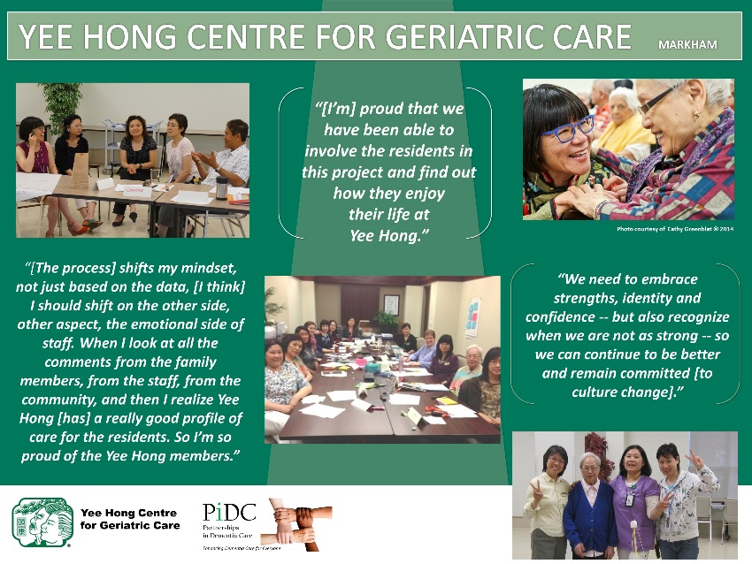
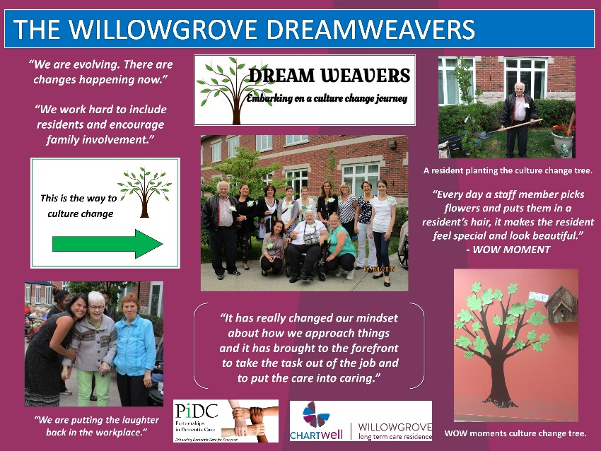

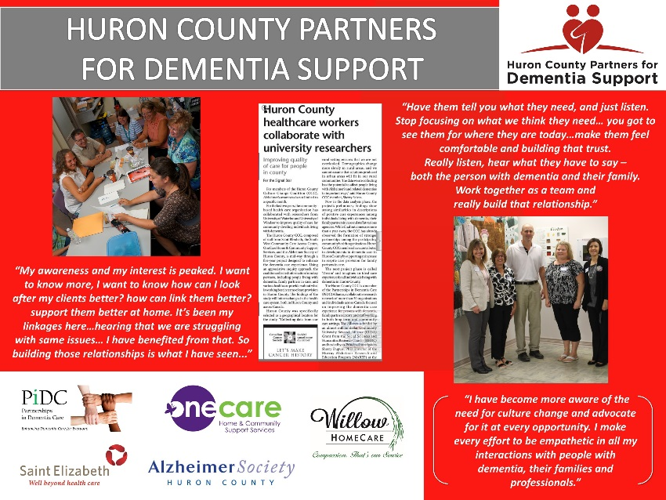
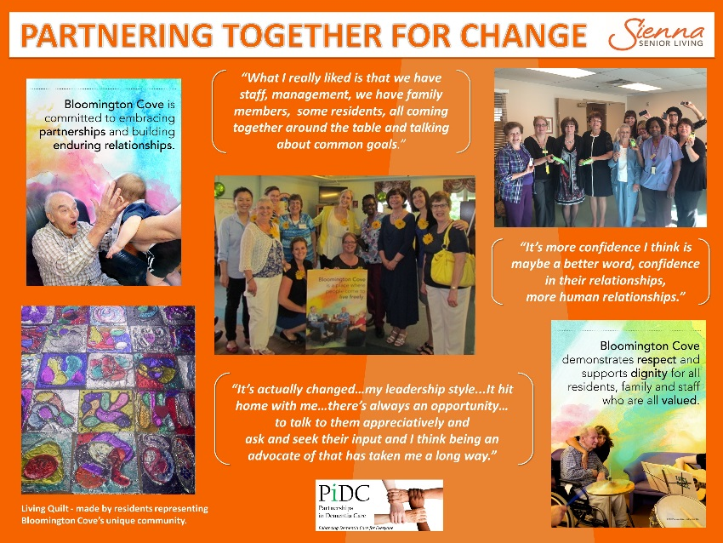

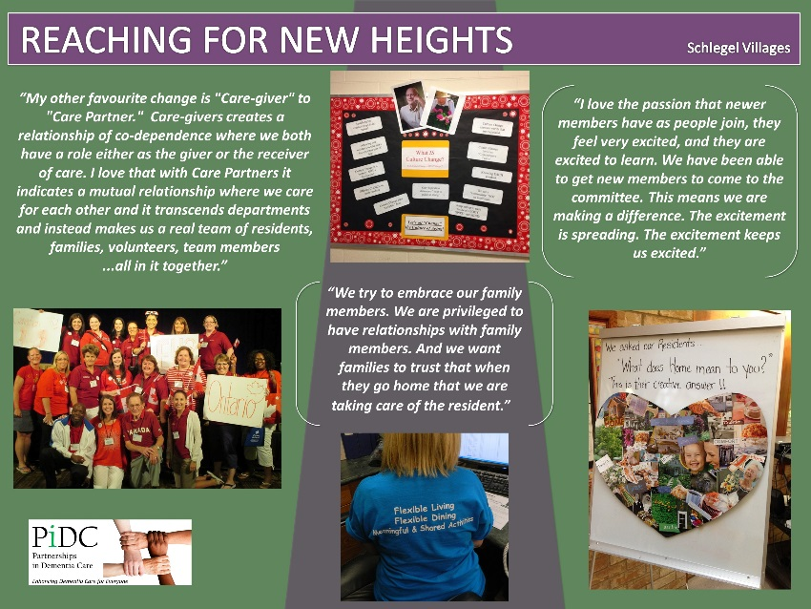
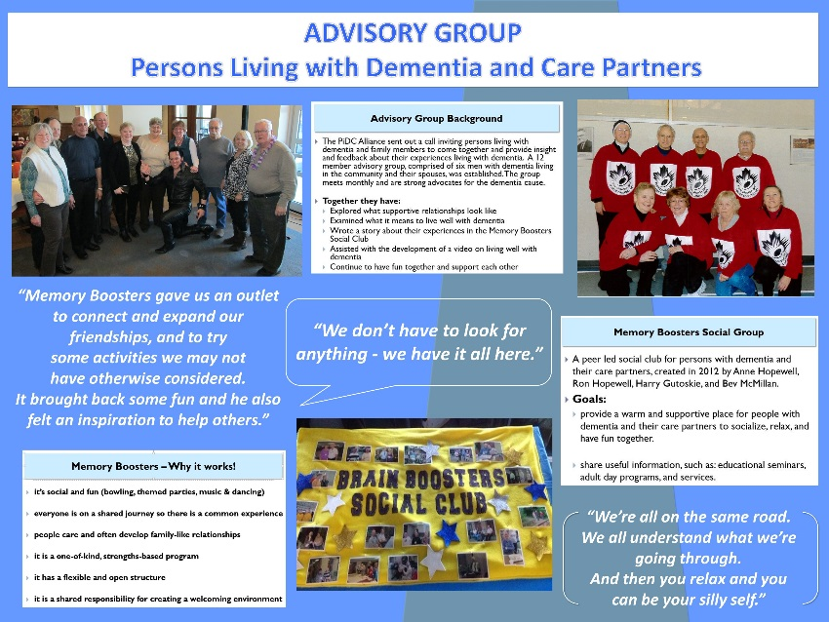

LIVING Well with Dementia Video
During the celebration event the PiDC Alliance launched
LIVING Well with Dementia, a video created in
partnership with the PiDC Advisory Group of persons living with dementia and their family members.
The video speaks to what it means for persons with dementia and their care partners to
live well with dementia.
It can be viewed at: https://youtu.be/HQLNHJB1OjU

Walk with Me Conference
Walk with Me:
Changing the Culture of Aging in Canada
March 10-11, 2016
Fantasyland Hotel, Edmonton, Alberta

Walk with Me 2016 marks Canada’s second national conference on culture change, and will bring together older adults/residents, caregivers, educators, policy makers, students and researchers from across the country to learn how to enhance the journey of aging across the continuum of care.
The conference will share culture change initiatives from across Canada, and features four exciting keynotes, including Dr. Sherry Dupuis (see below) and closing keynote Daniella Greenwood from Arcare Australia. Daniella will highlight the power of a relationship-focused approach to elder care, including key operational tips and practical tools that will assist in bringing relational approaches to life in your organization.
To register for Walk with Me 2016 and view the program, visit www.the-ria.ca/walkwithme
Keynote
March 11, 2016, 8:45AM – 10:00AM
‘Just Dance with Me’: The Power of Relationships in LIVING
Dr. Sherry Dupuis, Recreation and Leisure Studies and the PiDC Alliance, University of Waterloo
Relationships at multiple levels shape our everyday experiences, limiting and supporting our potential for and ability to live to the fullest. In this interactive session, we will explore relationships at the personal,
organizational, and system levels that shape the aging experience and imagine new possibilities for supporting thriving in later life.

Walk with Me 2016 is hosted by the Schlegel-UW Research Institute for Aging and the CapitalCare Foundation with feature sponsorships from Schlegel Villages, Revera Inc., Rexall, and Medical Mart/First Quality.

Partnerships in Dementia Care (PiDC) Alliance Partners

Culture Change Coalition Sites
Bloomington Cove
Huron County
The Royal Oak
The Village of Wentworth Heights
The Willowgrove
Yee Hong Centre for Geriatric Care

Research Management Team
Sherry Dupuis, PiDC Alliance, University of Waterloo
Carrie McAiney, St. Joseph’s Hospital
Hamilton, McMaster University
Jennifer Carson, University of Waterloo
Anita Cole, South West CCAC
Lorna de Witt, University of Windsor
Kim Fitzpatrick, Specialty Care, Inc.
Amy Go, Yee Hong Centre for Geriatric Care
David Harvey, Alzheimer Society of Ontario
Paul Holyoke, Saint Elizabeth Health Centre
Janet Iwaszczenko, Bloomington Cove
Sharon Kaaslainen, McMaster University
Ken LeClair, Queen’s University
Carol McWilliam, Western University
Jenny Ploeg, McMaster University
Bryan Smale, University of Waterloo
Catherine Ward-Griffin, Western University
Frances Westley, University of Waterloo
Kristie Wiedenfeld, Wentworth Heights
Josie D’Avernas, Schlegel-UW Research Institute for Aging
Susan Brown, Schlegel-UW Research Institute for Aging

PiDC Alliance Staff
Darla Fortune, PiDC Alliance
Janet McKeown, PiDC Alliance
Kimberly Lopez, PiDC Alliance
Sian Lockwood, PiDC Alliance

PiDC Alliance Partners
Advocacy Centre for the Elderly
Alzheimer Knowledge Exchange
Alzheimer Outreach Services
Alzheimer Society, Hamilton and Halton
Alzheimer Society, Huron County
Alzheimer Society, London and Middlesex
Alzheimer Society, Peel
Alzheimer Society of Canada
Alzheimer Society of Ontario
Alzheimer Society, York Region
Canadian Coalition for Seniors’ Mental Health
Canadian Dementia Knowledge Translation Network
Canadian Gerontological Nurses Association
Chartwell Long Term Care Homes
Concerned Friends of Ontario Citizens in Care Facilities
Conestoga College Institute of Technology and Advanced Learning
Dementia Advocacy and Support Network
International
Department of Psychiatry and Behavioural
Neurosciences, McMaster University
Department of Psychiatry, Queen’s University
Dotsa Bitove Wellness Academy
Division of Geriatric Psychiatry
McMaster University Faculty of Applied Health Sciences, University of Waterloo
Faculty of Health Sciences, McMaster University
Faculty of Health Sciences, Western University
Faculty of Nursing, University of Windsor
Geriatric Psychiatry Program, Mount Sinai Hospital
Hamilton Niagara Haldimand Brant LHIN
Homewood Health Centre
Java Music Club
Local Health Integration Network – Central
Long-Term and Continuing Care
Association of Manitoba
Ministry of Health and Long-Term Care
Murray Alzheimer Research and Education Program
National Initiative for the Care of the Elderly
Office of the President, University of Windsor
Office of the Vice-President, Research,
University of Waterloo
One Care
Ontario Association of Non-Profit Homes and Services for Seniors
Ontario Community Support Association
Ontario Dementia Network
Ontario Family Councils’ Program
Ontario Interdisciplinary Council of Aging and Health
Ontario Long-Term Care Association
Ontario PsychoGeriatric Association
Ontario Seniors’ Secretariat
Regional Geriatric Program Central
Registered Nurses’ Association of Ontario
Revera Incorporated
Saint Elizabeth Health Care
Schlegel-UW Research Institute for Aging
School of Part-Time Studies, Algonquin College
Seniors Health Research Transfer Network
Sheridan Elder Research Centre, Sheridan College
South West Community Care Access Centre
South West Local Health Integration Network
Specialized Geriatric Services of Southwestern Ontario
The Village of Wentworth Heights
University of British Columbia
Waterloo-Wellington LTCH Linkages
Yee Hong Centre for Geriatric Care

Sherry L. Dupuis, PhD
Co-Principal Investigator
Professor, Department of
Recreation and Leisure Studies
Faculty of Applied Health Sciences
University of Waterloo
Waterloo, Ontario N2L 3G1
519-888-4567 x. 36188
sldupuis@uwaterloo.ca
www.uwaterloo.ca/pidc

Carrie McAiney, PhD

Co-Principal Investigator
Associate Professor,
Department of Psychiatry and
Behavioural Neurosciences
McMaster University and
Director of Evaluation and
Research, Seniors Mental Health, St. Joseph’s Healthcare Hamilton
100 West 5th Street, Rm E117D
Hamilton, Ontario L8N 3K7
905-522-1155 x. 36722
mcaineyc@mcmaster.ca
www.uwaterloo.ca/pidc

Contact Us/Join our Mailing List
sian.lockwood@uwaterloo.ca

Join us Online!

www.uwaterloo.ca/pidc
@pidcalliance
PartnershipsInDementiaCareAlliance

