RENISON: A ROAD MAP FOR
STUDENT BELONGING
SPRING 2024
PREPARED BY RYAN CONNELL, ASSISTANT DIRECTOR, STUDENT EXPERIENCE & HOUSING
With gratitude, we acknowledge that Renison University College is located on the traditional territory of the Anishinaabeg, Hodinohsyó:ni, and Attawandaran (Neutral) Peoples, which is situated on the Haldimand Tract, land granted to the Six Nations that includes ten kilometres on each side of the Grand River from mouth to source. Our active work toward reconciliation takes place in all corners of our campus through research, learning, teaching, community building, and outreach. We are guided by the work of our Anti-Racism and Decolonization Spokescouncil, and the University of Waterloo Office of Indigenous Relations.
We express deepest gratitude to every student who participated in our consultation process, including all session participants and survey respondents. We share our appreciation to Dr. Christine Logel in the Department of Social Development Studies for her support as facilitator for two consultation sessions, as well as Laura Mutton, Allison Marlowe, and Stefany Kraft from the Student Experience and Housing team for transcription support during the consultation sessions. Thank you to A.J. Dixon for his support with this report.
Lastly, we thank the Racialized Students of Renison collective for their brave voices
to get this important conversation started on what more Renison should do to support equity-deserving students.
TABLE OF CONTENTS
INTRODUCTION 3
THE CONSULTATION PROCESS 3
EQUITY-DESERVING STUDENT COMMUNITIES 4
TOTAL PARTICIPANTS 5
KEY ACTION ITEMS: WHAT STUDENTS TOLD US 6
IN DEPTH: WHAT EQUITY-DESERVING STUDENTS TOLD US 9
2SLGBTQIA+ students 9
Black, Indigenous, and Racialized Students 11
International Students and English Language Learners 14
Mature Students 15
Neurodivergent Students 16
All students, including other-identified equity-deserving students 18
IN CLOSING 19
APPENDICES 20

INTRODUCTION
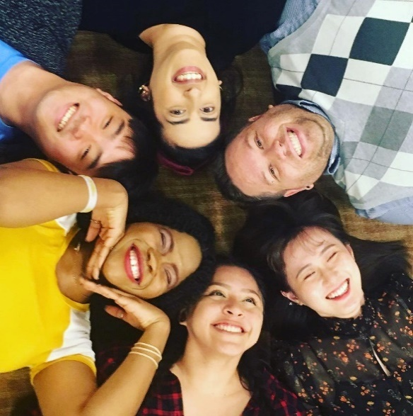
Renison University College is embarking on an exciting new era with the release of our 2024 – 2027 Strategic Plan. Most exceptional to this new direction forward is Renison’s continued commitments to equity, diversity, inclusion, and anti-racism in what we do and who are we as a college. Continued efforts to decolonize and strengthen opportunities for Indigenization across our institution remains critical to our work.
Renison’s Student Experience and Housing team strives to amplify student voices in all it does while serving as an advocate in progressing the important work of Renison’s Strategic Plan. To ensure that student voices are present in its work involves the prioritization of students from equity-deserving communities on our campus. In Winter 2024, the Student Experience and Housing team launched a series of consultation sessions and a feedback survey to explore the gaps that equity-deserving students see from Renison as an institution. It is our hope that these consultations will help to advance priorities within Renison’s strategic plan, particularly:
PRIORITY #1 - Nurture transformative student leaders: Renison’s learning and living environments nurture dynamic students who flourish as purposeful individuals with the capacity to make a difference in the world.
PRIORITY #2 - Embed Indigenization, decolonization, and inclusion, diversity, and equity throughout all aspects of Renison life: We value the diverse backgrounds and perspectives of our students, staff, and faculty. We will cultivate a foundation of Indigenization and inclusion, diversity, and equity that is core to our curriculum, community expectations, policies, and practices. This will help Renison move forward toward an environment in which everyone feels welcome, that they belong, and that they are able to contribute their best. We will also foster safe and inclusive living, learning, and working environments so that all students, staff, and faculty can thrive at Renison.
PRIORITY #3 - Foster a strong, inclusive, and healthy community: Our community is what makes Renison strong. We will continue to foster positive living, learning, and working environments where all members of the Renison community feel a sense of belonging and in which they are recognized, valued, and respected. We will foster a community that engages students, staff, and faculty and allows them to contribute fully and authentically to the work of Renison.
To propel these priorities forward, we recognize, honour, and value the importance of the student voice. This document serves as a road map for how Student Experience and Housing plans to take action based on the valuable student feedback.

THE CONSULTATION PROCESS
The tremendous value of student voice was exemplified thanks to the Racialized Students of Renison (RSOR) collective who mobilized and delivered an impactful student panel discussion event in March 2023. The voices identified many gaps within the Renison community, including the desire for more inclusion-focused community space. Following this, a consultative process was identified as a critical first step to learn from more equity-deserving students.
To this end, the Student Experience and Housing department identified three key areas as information gaps that required consultation from Renison students to understand more deeply:

STUDENT BELONGING: how a student feels they belong at Renison in terms of its physical environment, including safety.
CONNECTION: opportunities for students to connect with other individuals from similar equity-deserving populations as oneself.
SUPPORT: the ability to access peer mentorship or support from Renison, including its staff and faculty, and college-wide resources.
It was decided that two processes to gather information would be utilized: a series of student consultation sessions and an online feedback survey. Key action items for the Student Experience and Housing team based on student feedback is included within this report.

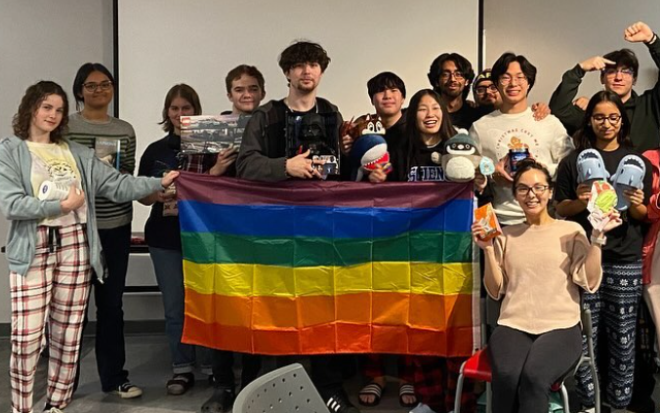
EQUITY-DESERVING STUDENT COMMUNITIES
Gathering feedback from some of the largest equity-deserving student communities at Renison was necessary to ensure that decision-making was aligned with student needs. Consultation sessions dedicated to specific groups would allow an opportunity for unique voices to be adequately represented.
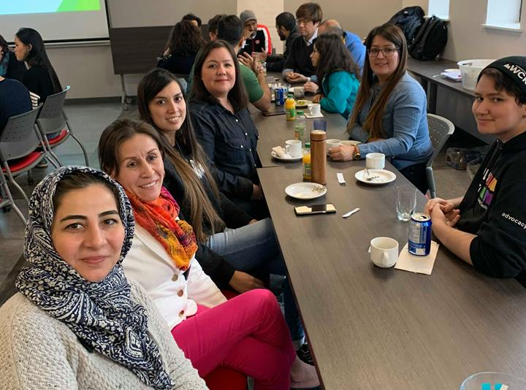
Numerous equity-deserving communities are present within Canadian higher education who all deserve meaningful, equitable, and appropriate support to thrive. For the purposes of this initial work and to ensure capacity within Renison to adequately support each community, five specific equity-deserving communities were identified:
- 2SLGBTQIA+ (Two-Spirit, Lesbian, Bisexual, Trans, Queer, Intersex, Asexual, Plus) students
- Black, Indigenous, and Racialized (BIR) students
- Self-identified mature students
- Neurodivergent students
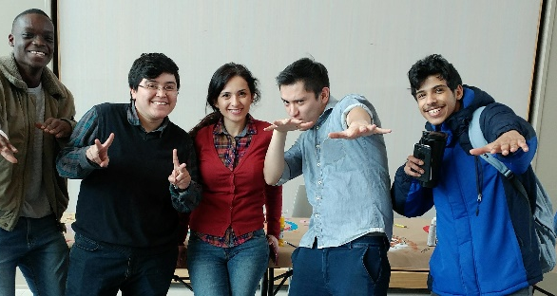
- International students and English language learners.
These populations were identified as equity-deserving groups who:
- Are high-frequent users of Renison: while Renison does not gather demographic data on its student population, both students and employees have brought forward questions and queries in recent years on how Renison can better support these specific populations.
- Have expressed desire for more support: As mentioned, the Racialized Students of Renison (RSOR) group is one example of a student collective who have identified the need for more support.
- Experience barriers to student success: Research in the field of Student Affairs and higher education identify a number of these student populations as being at risk for success in university. Ontario's Ministry of Colleges and Universities as well as the Higher Education Quality Council of Ontario also identify many of these populations at risk for succeeding (1, 2).
We know when students feel supported and feel they belong in university, it will positively affect student success and retention. We want all students to be successful. In future phases, more work can be considered by the Student Experience and Housing team to seek out additional equity-deserving student voices who may be missing from the conversation, including first generation students, students with disabilities, and off-campus students.

TOTAL PARTICIPANTS

Consultation Sessions n
Six consultation sessions were facilitated during the weeks of January 29 and February 5, 2024. Pizza and refreshments were provided to all participants who attended. A total of 34 students participated in the six consultation sessions.
Consultation Session | Date | Total Participants | Programs of Study Represented
All Students Session  Facilitator: Ryan Connell  Note-taker: Laura Mutton | Monday, January 29  4:30pm – 5:30pm  Dunker Family Lounge | 5 | Bridge to Academic Success in English  Computer Science  Environmental Studies  Social Development Studies
2SLGBTQIA+ Students Session  Facilitator: Ryan Connell  Note-taker: Allison Marlowe | Tuesday, January 30  4:30pm – 5:30pm  Norma & Arthur Brown Seminar Room | 8 | Bridge to Academic Success in English  English Literature and Philosophy  Honours Arts  Honours Mathematics  Social Development Studies  Statistics
Black, Indigenous, and Racialized Students Session  Facilitator: Dr. Christine Logel  Note-taker: Ryan Connell | Wednesday, January 31  4:30pm – 5:30pm  Dunker Family Lounge | 4 | Physics and Astronomy  Social Development Studies
Mature Students Session  Facilitator: Ryan Connell  Note-taker: Laura Mutton | Thursday, February 1  4:00pm – 5:00pm  Dunker Family Lounge | 5 | English For Academic Success  Honours Arts  Masters in Optometry  Social Development Studies
Neurodivergent Students  Facilitator: Dr. Christine Logel  Note-taker: Ryan Connel | Monday, February 5  4:30pm – 5:30pm  Dunker Family Lounge | 5 | Honours Arts  Honours Health Sciences (co-op)  Social Development Studies
International and English Language Learner Students  Facilitator: Ryan Connell  Note-taker: Stefany Kraft | Tuesday, February 6  4:30pm – 5:30pm  Dunker Family Lounge | 7 | Accounting and Financial Management  Computer Science  English For Academic Success  Honours Arts and Business  Honours Music  Social Development Studies
6 consultation sessions |  | 34 students | 14 programs represented

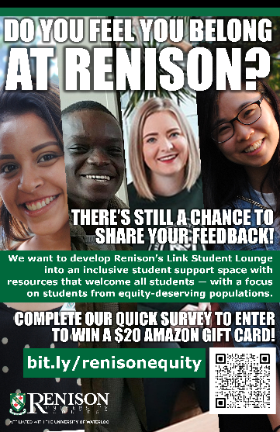
Feedback Survey n
Following the consultation sessions, an equity-deserving student feedback survey was issued across the Renison community from February 13 to March 3, 2024. A total of 38 responses were received from the survey. A draw for a $20 Amazon gift card was offered as an incentive for students to participate.
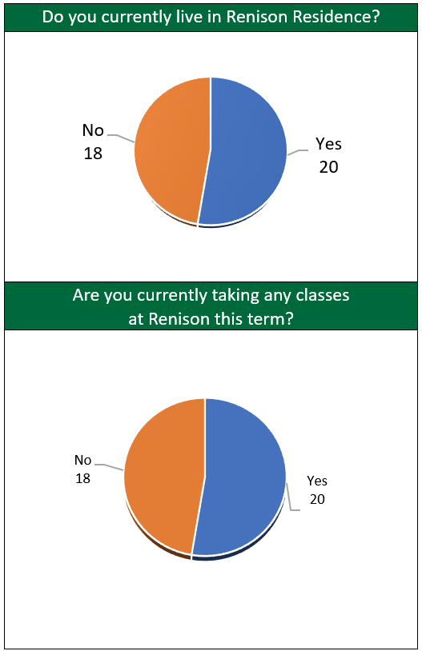
Some demographic data from survey participants was collected:
Please help us to understand some demographic information about you.
This will provide us with useful insight for how to best support other students from similar equity-deserving backgrounds.

Please select any or all options that apply. If no options apply to you, skip this question.

KEY ACTION ITEMS: WHAT STUDENTS TOLD US
Overall, the consultation sessions and survey feedback highlight several key action items that the Student Experience and Housing team will work towards developing. Based on the three areas of information gaps (student belonging, connection, and support), three key initiatives will be developed for the upcoming 2024/2025 academic year to address each area.
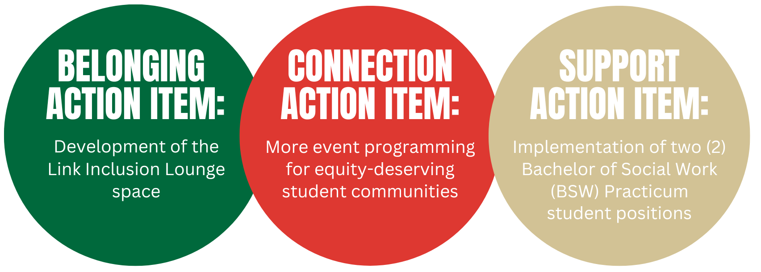

Student Belonging n
Students expressed the importance of feeling safe, supported, and included in the Renison community. Recommendations for improving belonging included better roommate matching processes for residence students, creating safe and private spaces, providing education on queer issues, celebrating holidays and cultures, and ensuring representation and visibility of diverse identities.
A large component of the consultation sessions and survey explored opportunities to develop a “Link Inclusion Lounge” at Renison, utilizing existing space in Room 1401 beside the Moose Tracks Connection Desk. There were suggestions for improving this physical space at Renison to better meet the needs of equity-deserving students. Recommendations included creating comfortable and inviting lounge spaces with a variety of seating options, ensuring accessibility features, providing resources and information, and incorporating cultural representation in decor. The need to ensure that all students feel welcome and included was a priority identified for students. Suggestions included providing resources for student access, creating inclusive programming and events, and information about where to access support when discrimination or exclusion occurs.

Key Action Items for Student Belonging
Improvements to the Link Student Lounge (Room 1401) are a key priority for this category. Recommendations include:
- Comfy and moveable furniture: Sourcing quality furniture that is comfortable is imperative for the space. Couches need to be comfortable and relaxing for social, study, and relaxation purposes. Ideally, couches should be configured in small pods that allow multiple groups to access the room at the same time, while alleviating anxieties that one individual using the space may unintentionally send a message that the entire room is thereby occupied. At the same time, the couches need to be easily configurable to allow for circular group event programming in the room. Coffee tables and side tables for the space is beneficial, as well as bean bag chairs for relaxation.
- Removing the ping pong table room: Removing the temporary wall structure that surrounds the current ping pong table in this space is recommended, along with removing the ping pong table itself. The space should consist of additional couch seating as well as a small set of tables/chairs.
- New walls and artwork: A desire for a space that is colourful – but not obnoxiously so – is encouraged. Both the outside and inside space should reflect warmth and colour as a space that appears separate from Renison’s present institutional décor. Additionally, featuring rotating artwork from local artists – with a focus on Black, Indigenous, and racialized artists – could be welcome.
- Whiteboards, plants, and lamps: Access to large whiteboards on one or more of the walls would be welcome for student use. Multiple times during the consultation sessions, houseplants and lamps were suggested for the space to minimize the harsh fluorescent lighting that’s common on campus and to make the place feel more inviting.
- A kitchenette area: A small kitchenette space that would allow for a fridge and sink area would be beneficial. One of the study space areas could be re-purposed into the kitchenette. This space would be particularly useful to mature students and other non-residence students to access during the daytime to store lunches as necessary.
- A one-on-one meeting space area: A space that could still be used for multi-purpose reasons, including one-on-one touchpoints with students or for open study purposes is an attractive use for students.
- Access to cleaning supplies: With the room being utilized so frequently, access to sanitation wipes was identified as a priority so that students can wipe surfaces clean before or after use.
- Colourful window decorations and window barriers: While the outdoor windows of the Link Lounge would remain in place, it is recommended that the frosting on the windows would be replaced with colourful designs that could also be used as a mechanism to communicate the lounge’s purpose as well as regular event programming. To address concerns related to student safety during events, a window curtain like what was previously used in the Registrar’s Office space should also be considered.
- Resources & Signage: Signage that explains various resources and services available to UWaterloo students, including information about where to report incidents of discrimination and harassment, should be visible and easily accessible in the space.
- Reading Resources: Access to books on topics related to equity-deserving communities could be made available in the space on a bookshelf for students to access and learn more. Members of the Renison community will be invited to contribute any books about equity, diversity, inclusion, and Indigenization to this collection.

Connection n
Students value the sense of community at Renison and emphasized the importance of events and programs that facilitate more connections among students. Suggestions included creating inclusive events, providing opportunities for cross-cultural exchange, and fostering interactions between students and staff/faculty members.
Key Action Items for Connection
Event programming is identified a key priority for this category. The following are four key action items for reinforcing student connection at Renison:
- Launch new BSW Practicum Student positions for Fall 2024: Student Experience and Housing will partner with the School of Social Work to recruit two (2) Bachelor of Social Work (BSW) practicum student placements. These positions, co-supervised between the Director, School of Social Work and Renison’s Student Experience and Housing team, will support in the development of the Link Student Lounge as a social inclusion space for students to connect with students from similar equity-deserving communities. The roles will also work to assess gaps for equity-deserving student groups over the 2024-2025 year and provide feedback in the expansion of additional supports, programming, resources, and student roles for the college.
- Strengthen and expand event opportunities: Thanks to the leadership of the two BSW positions, more opportunities can exist to expand Renison’s current Mature Student Coffee Chat and Queer & Cozy events. Additionally, similar events can be developed to bring together neurodiverse students, connect Black, Indigenous & Racialized students with each other, and allow for more conversation spaces that intentionally welcome both English language learners and international students. Events/programming that also celebrate culture and provide opportunities for students to share their own cultural identities and roots will be essential for the entire student community.
- Strive toward crossover event opportunities: As a feeling of ‘community’ develops within each of the equity-deserving communities throughout the academic year, the goal would be to also develop crossover programming that allow for equity-deserving students from the various communities to come together.
- Continue to be aware of other communities missing: The consultation phase of this project prioritized five equity-deserving communities that appeared dominant across the Renison community. However, more feedback will need to be gathered on a continuous basis to identify further equity-deserving communities missing and what opportunities may exist to provide connection accordingly.

Support n
Students praised existing supports at Renison, such as supportive staff like Renison’s Chaplain as well as programs like Queer & Cozy and the Mature Student Coffee Chat events. However, gaps were identified, including the need for more training on diversity, equity, and inclusion (DEI) for student staff, and clearer pathways to access both immigration consultants for international students and registering for AccessAbility Services at the University of Waterloo.
Key Action Items for Support
Expanded support for equity-deserving students at Renison can include:
- Navigator for resources/issues: The implementation of the BSW practicum student positions can provide support by way of event programming, but also with being a touchpoint for equity-deserving students needing support navigating resources, services, and policies at the University of Waterloo. This role will receive dedicated training that will inform them on Waterloo and Renison student services. In addition to this, the roles will be trained on how to navigate Renison’s Harassment, Discrimination, and Abuse Prevention Policy, University of Waterloo Policy 33 – Ethical Behaviour, Policy 42 - Prevention of and Response to Sexual Violence, Policy 58 – Accessibility, and Policy 71 – Student Discipline. More specifically, the roles will understand the applicable support resources that exist at the University of Waterloo to direct students to, including the Office of Equity, Diversity, Inclusion and Anti-Racism, AccessAbility Services, Student Success Office, WUSA’s Centre for Academic Policy Supports (CAPS), etc. The BSW practicum student positions are not designed to be direct advocates for individual student cases, but rather can navigate and empower students to access and use current mechanisms that are already available, such as Renison’s Student Advocacy and Wellness Committee and advocating supports within WUSA.
- Posters and information access: Many helpful resources already exist that would be useful to have posted within the Link Student Lounge, including Renison’s Resources poster (PNG), Campus Wellness’ Crisis Navigation Tool poster (PDF), Campus Wellness’ Do you need help with your mental health? poster (PDF), and the Sexual Violence Prevention and Response Office’s Responding to a Disclosure poster (PDF). Additionally, postcards and brochures that specifically focus on equity-deserving supports and resources from various campus services should be made available in the space, including WUSA’s student-run services.
- Collaboration and partnership with campus services: Further relationship-building between Renison’s Student Experience and Housing department and diversity, equity, and inclusion-focused services and spaces at the University of Waterloo will need to take place. These connections can work to minimize any gaps between spaces and allow for collaboration. In particular, Student Experience and Housing can collaborate with Campus Wellness’ equity-deserving counselling team to proactively ensure support is provided should any incidents of harm occur within the respective space or during programming initiatives, as well as to provide healing support during times when global events impact respective equity-deserving communities.
Overall, the feedback underscores the importance of creating an inclusive and supportive environment at Renison that celebrates diversity, fosters connection, and provides resources and support for all students.

IN DEPTH: WHAT EQUITY-DESERVING STUDENTS TOLD US

2SLGBTQIA+ students n

Student Belonging
Words used to describe the Renison community by 2SLGBTQIA+ students were overwhelmingly positive. Descriptors included “friendly”, “home”, “close-knit”, “small”, and “diverse”. When the word “home” was used during the consultation session and participants were asked to expand upon what makes Renison feels like home, “events”, “community”, “people”, and the familiarity of people and faces are credited for the warm atmosphere they experience.
While the general consensus of the students’ experience at Renison were positive, opportunities for future improvements to strengthen belonging were identified. Both the consultation session and survey identified three key issues:
- Ensuring privacy and safety in any inclusion space: When spaces are identified as welcome spaces for marginalized populations, there can be risks surrounding safety. Efforts will need to be considered for how to navigate incidents if/when they occur with active mechanisms to address it.
“Having a safe space for students in particular communities to connect with others in that community,
to let them know they are not alone.”
- Survey respondent
Community standards for the space, modified using Renison’s Shared Commitments (pdf), can be developed to allow students accessing the space to understand the necessary rules for engagement. As a consultation session participant voiced, “If there’s an hour put aside for an LGBT space (in the Link Student Lounge), what can stop something negative from happening?”. Mechanisms that communicate rules for engagement as well as opportunities to report incidents will be beneficial.
- Identifying supportive staff at Renison: While many offices around Renison prominently display Pride flag stickers as well as the University of Waterloo Making Spaces stickers in support of the 2SLGBTQIA+ community, more messaging that reinforces supportive staff was suggested. For example, a webpage on the Renison or Student Experience and Housing website that could emphasize allies and queer staff at Renison, while outlining ways that Renison promotes inclusion (examples: communicating training that student leader staff undergo annually, that Renison hangs the rainbow flag during Pride Month, etc.)
- Refining roommate matching processes and floor assignments: Students identified concerns surrounding the residence’s roommate matching process as well as floor assignments. For Trans, non-binary, and gender non-confirming students, more consideration should be given to pair students with others who identify with other gender-expansive identities rather than just male or female. Additionally, more inclusive floor assignments should be considered. More efforts can be made to assess a roommate’s comfort level with diversity and inclusion when pairing self-disclosed 2SLGBTQIA+ residents with a roommate.

Connection
Students provided strong praise for the newly-implemented Queer and Cozy events that Renison began organizing in the Fall 2023 academic term. The events were identified as being a positive space for students to be themselves, connect with other 2SLGBTQIA+ students on campus, but without necessarily having the subject matter only needing to focus on queer issues.
From feedback gathered, opportunities like Queer and Cozy are critical in building a welcoming community within the Renison sphere for 2SLGBTQIA+ students. When asked to describe Renison’s role in supporting 2SLGBTQIA+ students, a survey respondent shared: “I think Renison's role is primarily to provide students with a safe space to go for support, comfort, and resources. It is very easy to feel lonely in university so it is crucial that students have a place to go where they can feel less alone during challenging times.”
“From last year to this year, I’ve felt so much more community in this space (by) having the privilege
to be involved in Queer and Cozy and make that safe space.”
- Consultation Session participant

Support
Renison employees are credited as being a strong force in how Renison’s presence as a welcoming space is perceived. In terms of how students have been supported during their time at Renison, the Chaplain, Scott McLeod, is praised as a non-judgmental, supportive person: “It was comforting how he was not judgmental, was open to listening, not judgmental of people of other faiths, in the queer community, trying to figure stuff out, open-minded, I really appreciate that – especially coming from a Chaplain.”
Residence Dons are also credited as being a supportive presence in residence: “Here it feels like the Dons care about you. I was able to slip through the cracks at [another institution previously attended by the student], but here, everyone is checking in on you. It’s such an improvement.”
“I have felt very supported by the people at Renison. I enjoy being a part of this tight-knit community as I have been supported in many different ways. My Don is one of the biggest supports I have had at my time at Renison. She is always willing to talk to me about whatever is on my mind and she always helps me find resources that can help me during challenging times.”
- Survey respondent
While staff members are commended for their inclusion, it is recognized that more efforts can be made to educate the broader student community about 2SLGBTQIA+ students. Within the consultation session, Renison Residence’s past work coordinating bystander intervention training was commended, recognizing how further training for students about queer inclusion is valuable. In particular, further education for international students to understand Canada’s human rights laws that promote and protect the human rights of the 2SLGBTQIA+ community is necessary.
“More knowledge about LGBT+ to international students [is needed]. In BASE [Bridge to Academic Success in English] classes, we talk about LGBT and other people say “oh, you’re lesbian or gay?” and they don’t talk to us.
They don’t understand us.”
- Consultation session participant

Black, Indigenous, and Racialized Students

Student Belonging
Black, Indigenous, and Racialized (BIR) students who attended the consultation session were quick to use words like “welcoming”, “homely”, “really friendly”, “closeness”, and “a sense of community” to describe Renison. Most notably, it is viewed as a “neighbourhood”: “It feels like you’re in a neighbourhood and you can go to people who are nearby”, one consultation session participant session commented.
“There’s community here. My mom worries the most about me being isolated. There is community. A real ‘We understand your struggles and we are here for you’ vibe is how I would describe it. Like, most places say ‘we care about students blah blah blah’, but you really feel it here.”
- Consultation session participant
A number of key priorities for BIR students that were expressed in both the consultation session and survey included:
- Easier ways to bring forward concerns: Being able to have a supportive person, described by one participant as a “safe person”, with whom BIR students can approach when they need support and may be able to help them in advocating for their needs is important. In the consultation session, participants agreed that someone in a role like a peer leader who is informed about the process for issues and can help them navigate the systems of the university would be beneficial. One student mentioned: “[It would be nice to have] someone who can guide you. What’s scary to me is doing it alone. I am okay speaking out but doing it alone terrifies me, so having someone guide you through the process. Even if I have to speak out, if there’s someone there and guide me through it [would help].”
- Finding space to connect with other BIR students: Students identified that it’s important to be able to have space to connect with others. A survey respondent shared some important things to consider: “Is the space inclusive? Will this space cultivate positive relationships within the equity-deserving communities as well as the larger community? Will this space be engaging?”. These questions will be important considerations to bring Black, Indigenous, and Racialized students into a welcoming space that encourages student connection and to ensure students don’t feel a sense of isolation or loneliness.
- Avoiding the necessity for the space to be too educational: Resources and programming already exists at the University of Waterloo to encourage advocacy, including both the Racial Advocacy for Inclusion, Solidarity, and Equity (RAISE) student-run service coordinated through WUSA, as well as the Anti-Racism unit in the Office of Equity, Diversity, Inclusion, and Anti-Racism and Office of Indigenous Relations. The value of a space can be to connect students to resources, but to moreso connect BIR students together.
“Having a safe space for students in particular communities to connect
with others in that community, to let them know they are not alone.”
- Survey respondent
For a physical environment for lounge space, BIR students identified key priorities for the space should be comfy couches, television, board games, and somewhere that feels less intimidating than Renison’s Moose Room. Signs, stickers, posters, and artwork are encouraged to help make the space more lively. A consultation session participant recommended a space similar to the RAISE office located in the Student Life Centre: “What if there was somewhere like the RAISE office? I don’t know how feasible this would be, but if there was a racialized peer leader who had office hours and then you have representation and leadership. You could have a racialized peer leader, a queer peer leader. And then a space where you can come chill.”

Connection
Opportunities for Black, Indigenous, and Racialized students to find connection with others and to celebrate holidays and cultures together would be appreciated. In the consultation session, a student shared: “I really like the idea of the Queer & Cozy events. So maybe there’s events for people of their own kind that kind of way so there’s connection and people can find each other. We can find people and get together at that certain time.” Another student agreed, sharing “It would be nice to build such a group for racialized people.”

Support
For BIR students, it is important to see diversity represented in the supports that surround them. Within the consultation session, participants identified how important it was to be able to see representation in Peer Leaders, Residence Dons, as well as Social Development Studies faculty: “The dons are really helpful. I can see myself in them. I can see them not only as leaders but as peers. Because they’re representative of Renison, it’s really helpful.”
“For me, I think having a black student leader. When I was in first year, it was really comforting. I know you’re always a minority but knowing there was someone and you could see them – not that they needed to be the representative of Black students at Renison – but it was comforting I could see me in the student leaders at Renison.”
- Consultation session participant
For support, it is beneficial having this representation because, as a consultation session participant shared, BIR students appreciate “Having people you don’t have to explain yourself to”. Furthermore, a desire for an informed Peer Leader or student leaders who could support you in navigating processes if a student needs to report incidents in the college or at the University of Waterloo would help. These roles would require training and support mentally to take on the number of concerns and issues expressed, but it would be useful to have a navigator to direct students to the mechanisms in place.
As a survey participant shared, Renison can further build upon its strength of diversity: “Renison has students coming from many backgrounds and experiences, the first step is to recognize that everyone is unique and strategies to get one person to open up will be different than another. Renison’s role in this would be to try and connect with equity-deserving communities (without blatantly singling them out), perhaps with specific events that would make them more comfortable within the community while sharing their passions.”
“Renison is a place that, of course, is not perfect, but makes a genuine effort
to improve in several areas and that is appreciated.”
- Survey respondent
It is recognized that minimal feedback received directly spoke to the Indigenous student experience and Indigenous ways of knowing. Opportunities to decolonize spaces and provide more meaningful spaces within Renison for Indigenous students to practice their culture and share their voice more extensively is recognized.

International Students and English Language Learners n

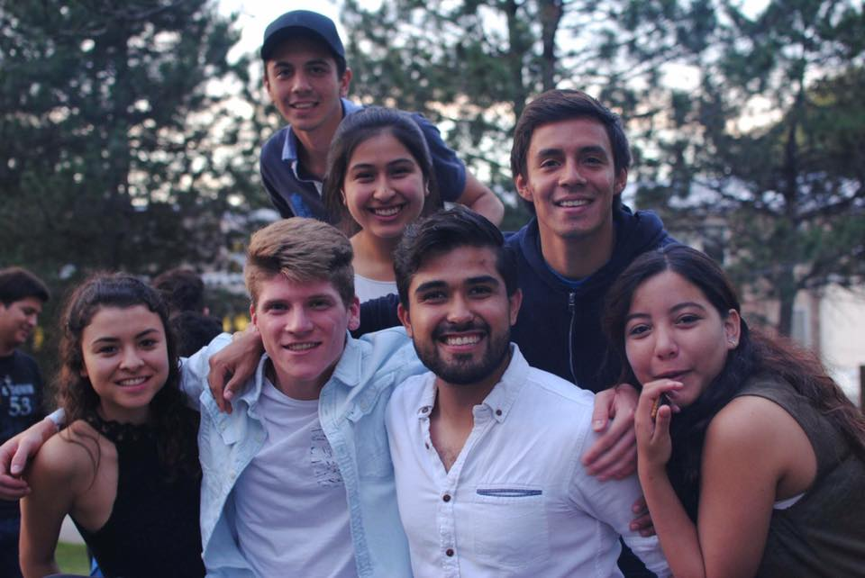
Student Belonging
Without a doubt, international students and English language learners are a very visible and important presence within our Renison community. Through consultation with our international students and English language learners, students shared descriptive words to illustrate the college, including “one sky over all”, “very quiet”, “second home”, “course selection” (variety of courses offered), and “it’s a place where I will meet someone”.
In relation to the subject of student belonging and the needs for the Link Student Lounge, students identified:
- Comfort is key: A physical space that allows students to be comfortable and connect would be useful. A consultation session participant identified, “Moose Room is not open to everyone, [so a space] that it is open for all non-residence students [would be useful]. A more comfortable space like the Ministry Centre where it is comfortable but bigger, but can have space where students can chill.”
- An inviting safe space that welcomes all: The physical space needs to be “warm”, a “safe space”, and a place where students can vent and relax with each other, and can easily chat with anybody about their day. It is recommended that the lounge space needs to be “more open”.
- Ensure access to resource learning: A survey respondent encouraged the value of a resource centre where students can access information about campus services, equity programs, mental health support, and cultural organizations: “Be aware of the cultural significance and appropriateness of the decor, artwork, and even the layout of the space to avoid cultural appropriation or insensitivity. While maximizing space is important, avoid cramming too many functions into the area, which can lead to a chaotic and unwelcoming environment.”
International students and English language learners expressed desire in removing the walls around the ping pong table presently in the Link Lounge, and considering glass doors on the study spaces to make them more inviting. Paintings on windows to make the space more inviting is encouraged. Comfortable couches, cup holders, bean bag chairs, plants, mural artwork, and warm colours were requested.
“Create a place where all students feel safe, valued and welcomed. Ensure that the space is accessible to everyone. The space reflects and respects the diversity of cultures, identities.”
- Survey respondent

Connection
Students described the value in Renison collaborating more with culture-based clubs on campus. In the consultation session, a student encouraged Renison to “Make more connection to Black and African background. It’s important that people see others like me. The Black Association Club [could] encourage more of their students to come to Renison.”
For international students and English language learners to build stronger connections together, food is an essential element to celebrate culture and unite students. However, gaps in authentic food from other cultures currently creates challenges to find comfort at Renison. One consultation session participant shared difficulty in finding culturally-authentic meals: “As international students, staff think that Korean or Japanese food is our food and that is promoted [like that], but the food is not actually our food, and we are disappointed.”
A desire exists to build more connections among international students and language learners, with one survey respondent requesting Renison “increase the interaction between each other.” More mentorship opportunities could be developed, one survey respondent suggested: “Pair students from equity-deserving communities with senior students or alumni who can provide guidance, support, and advice on navigating academic and social life.”

Support
Overall, Renison is complemented for providing a lot of support to international students. A consultation session participant shared a story of how they were welcomed into the Renison space: “Renison was actually my first stop and first memories [when I came to Canada]. On the first day for the don floor meeting, my don [name redacted] knocked on my door to invite me. Three years ago, my English was really bad and I was confused. I said sorry I don’t know what this is – it is my first day, I don’t know what you’re saying. The don said, ‘I am actually an international student’ and they reworded the question and this helped me to feel less confused and more welcomed.” Students continued to share other examples of how Renison has provided compassion and patience in supporting our international student and language learner community.
For missing supports, immigration consultant support at the college was identified as a gap. A consultation session participant reported: “I know that there used to be an immigration consultant. We have a lot of international students, and we need that, and it would be useful.” Another gap that exists is active programming during times when domestic students return home during holiday periods: “Not having a family here, I was thinking that as an international student, we should have more opportunities for Renison students that can’t go back to see their families at breaks because they have to stay here when other residence students can go home.” Additionally, concerns were expressed about how Renison Residence closes during the Winter break, which creates challenges for international students in residence. A consultation session participant shared: “I used to be kicked out at Renison during Winter break. I had to go to a random place or had to sleep in a friend’s living room on the couch.”
“They are kind, I like this family so much!”
- Survey respondent

Mature Students n

Student Belonging
Mature students described Renison with words such as “Home away from home and also work”, “comfortable”, and “belonging” during the consultation session and survey. When considering Renison’s role in supporting mature students, students encouraged Renison to continue to facilitate connection in the manner it has already been doing, while encouraging more opportunities for mature students to engage. Additionally, mature students shared how Renison’s role can be to help ease students into the “culture shock” of being a mature student in university.
For a physical space, there’s a desire to open the current lounge space up more by removing walls, re-purposing the ping pong table elsewhere, adding a water dispenser, bringing in lamps for softer lighting to reduce the need for the harsh fluorescent lighting. For mature students in particular, a kitchenette space would be very much welcomed; a participant complemented a kitchenette space they’ve seen in Environment 3 near the coffee shop on the first level as a positive space that is very useful. Wall plugs and access to outlet chargers is encouraged. A key priority for the mature students was ensuring that the space is sanitary, clean, and frequently tidied. Access to sanitation wipes to clean off surfaces was requested. A space that was still available for private meetings and one-on-one connections with support people was suggested. Consultation session participants and survey respondents described value in the Link Student Lounge being a space that is multi-purpose: it could host programming, be a space to study, as well as be a casual social space. An inventive idea given was to post a QR code in the space that would solicit ongoing feedback for the space to continuously improve to meet student’s needs.

Connection
Consultation session participants commend Renison as being a place where they have been able to connect with other mature students, thanks to events like the Mature Student Coffee Chat. Participants recognized the value of having distinct programming for equity-deserving communities. However, as the term progresses and members of each group begin feeling more comfortable, mature students expressed a desire to be able to see the communities come together for joint programming as “crossover events”. Such an approach would help to remove barriers while also embracing our student community’s intersectionality.
“I think Renison is doing a good job making [it] a friendly place to everyone.”
- Survey respondent

Support
Many mature students in attendance for the consultation session were able to reflect and compare on their experiences attending post-secondary institutions elsewhere. The students recognized that Renison already provides more in the way of supports and services than what they have seen elsewhere. Rather, students voiced that much of the support gaps exist within the University of Waterloo’s systems, such as a lack of counsellors and AccessAbility Services staff.
For mature students, Renison has been valuable in terms of attending events, accessing the library space, and receiving support from academic advisors: “They’re accessible and available to troubleshoot issues, talk things through, [with a] very open door.”
Lastly, an ongoing issue that mature students frequently face relates to finances. Ways to ensure mature students know about current funding opportunities, in addition to expanding and implementing more opportunities for mature students to work, to access scholarships and awards, and compensation/honourariums for teaching classes were identified.

Neurodivergent Students n

Student Belonging
Students attending the neurodivergent student consultation session described Renison as “community” and “small – but in a good way”. Particularly in the residence community, neurodivergent students recognize how easy it can be to build a sense of community.

“The word that immediately comes to my mind when I think of Renison is community. I feel like I finally found a place where I belong. When I think of how I would describe Renison to my loved ones, I know I would tell them about how I feel like I am finally apart of something bigger than myself and that I have finally met people who I connect with. It feels good to be able to be around so many wonderful and supportive people. It has made my university experience far less lonely.”
- Survey respondent
For a physical space that welcomes neurodivergent students, a strong desire is to create spaces where students are invited to engage and connect, but that the space does not need to be focused on discussing accessibility issues: “When I am in disability spaces, I find they are just discussing disability concerns, which it is nice to talk about those things and those concerns. But also, I don’t want to be complaining about how hard it is to be me all the time. If I have a space, I want a space that is centered around our shared experiences with other people, but also, I just can have a community of people who I can be comfortable around and can talk about Taylor Swift with. I want it to be more than just what makes my life hard.”
To make a lounge space more comfortable, colourful walls (but not neon) and open area is key. Efforts need to be made to reduce any “clinical” or “sterile” feel in the environment, while also considering lighting. Different types of lighting rather than fluorescent overhead lighting was recommended. Whiteboards were also welcomed. Recommendations from the survey for a physical space included ensuring there were no large games like billiards or ping pong in the space to be too distracting, a sensory room, books that showcase equity-deserving communities, fidget toys, and cleaning supplies for students to feel like they can care for the space themselves as well. A television that can connect to laptops and bean bag chairs were mentioned, as well as a sink. To summarize, a survey respondent shared “The primary goal of a physical space should be to make students feel included and accepted. It should be a place that can provide comfort for students and where they can meet and connect with other students who are similar to them.”

Connection
The residence community was commended for being very close-knit in comparison to other communities on campus. However, for non-residence students participating in events at Renison, it was mentioned that it can be difficult to integrate into the community in the same way at times: “I would say this to that note, but I have been isolated at Renison at times because so many of the events are focused on the residence. It is hard to feel like I belong here because of that.”
While there’s value in creating communities for various equity-deserving students, a student shared that self-identification of belonging to spaces and programming will be key: “I wouldn’t want it to be so limited where you can only go on the nights where you identify. But online I also see communities where certain people get kicked out because they aren’t a certain type of neurodivergence.”
When developing more programming to support neurodivergent students, a survey respondent encouraged: “I think it would be helpful to have more casual events to talk about how we feel and anything we are going through at the moment. It would be nice to have a group to talk to in order to feel supported.”
Another respondent also recommended event nights for equity-deserving students, game nights, talking nights, movie nights, and show and tell nights.
“Help us gain more comfortability. Give us a space to connect with other people similar to us.”
- Survey respondent

Support
Within the neurodivergent student consultation session, residence Dons are commended as being a key source of support for residents: “My main thing that comes to mind is [name redacted], who is my don. She is just amazing. Mine and [redacted]’s roommate are the first door, and she will come knock and see what’s up. Just having the support from the Dons, like [names redacted], the dons have all been very supportive with transitioning being away from home.”
Additionally, another student commends the approachability of all Renison staff: “I think the whole staff community is very supportive. I feel comfortable going to talk and see anybody if necessary.” While this is the case, navigating campus resources and services at the University of Waterloo for students with a disability continues to be very challenging. A consultation session participant shared: “Coming to university as someone who needs help with accessibility, you are sorting all of this out, and AccessAbility (Services) is great once you reach out to them. But I don’t know what Renison’s relationship is with AccessAbility or anything like that. I know we have workshops to help international students adjust to winter. But, if Renison could have a workshop about how to get connected with Accessibility Services [would be helpful]. Things can be pretty complicated and confusing at the beginning.”
Additional suggestions for support included having student staff knowledgeable on accessibility accommodations who can best point students in the right direction, as well as resource posters posted at Renison with information where to access supports.

All Students, including other-identified equity-deserving students n
In addition to specific equity-deserving consultation sessions, an ‘all students’ session was facilitated. Additionally, students who did not identify with the five above-mentioned equity-deserving student groups were also invited to complete the feedback survey.

Student Belonging
When asked to describe Renison in words, students contributed a variety of different words such as “innovation”, “money” (due to the university and country’s reliance on international students), “expensive to live here in Canada”, “friendly”, and “more comfortable and connected here”.
In terms of the Link Lounge physical space, a variety of seating options was encouraged, including couches, bean bag chairs, table seating, etc., with a focus on making the space more open for others to join. It’s recommended that the ping pong table should be removed, and while the private study room spaces are beneficial, it is thought that it’s not necessarily what is most useful for this space.
“Make sure they feel welcome and protect them from discrimination.”
- Survey respondent

Connection
Students who don’t live in Renison Residence did identify feelings of exclusion in the community. More efforts can be made to explain that events and supports are accessible to all students, not just residents: “There is a big concentration on the people living in Renison campus housing. There are already established friend groups from people who live on floors. I feel like I’m sitting on the outside of something I was never invited to.”
Events are a component of what the Link Lounge space should be host to; however, a consultation session participant shared that “It needs to not have events constantly happening all the time. There should be events but also times when people can just go and use that space.”
“When I think of Renison I think of a welcoming, engaging, and safe space filled with friendly staff and teachers.”
- Survey respondent

Support
Ultimately, more accessible ways to access support or knowing how to navigate the university community would be welcomed by students. A survey respondent shared: “Any sort of help, accommodation, accessibility, or even informational support would be useful for the community. specifically, any resources that fall under the topic of equity and different communities.” Another respondent also echoed a key recommendation for Renison: “Focusing on creating a welcoming environment and reaching out to students who may be too afraid or unable to reach for help of support.”
IN CLOSING
This report outlines an ambitious action plan that Renison’s Student Experience and Housing team will be working towards, with support from units within Student Affairs and Community Education at Renison.

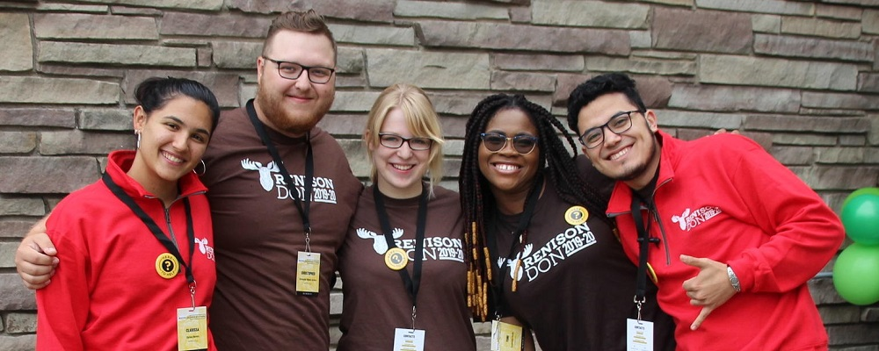
The community is invited to continue to share feedback and input to enhance the student experience by speaking with any member of the Student Experience and Housing team. In addition, a feedback form is available online.
APPENDIX A

All Students Consultation Session n

Date: Monday, January 29, 2024
Transcribed by Laura Mutton
Facilitated by Ryan Connell
INTRODUCTION
To begin, we are hoping to get a pulse of how you currently feel as a student at Renison.
- When you think of Renison currently, what words, phrases, or descriptions come to mind?
- Innovation. Velocity, start up in computers.
- Money. How the university and the country’s economy is reliant on international students’ tuition. Increase in tuition for international students. $6,000 compared to $55,000 for the same program yearly tuition. Associated with an immigrant based economy in a country like Canada.
  - New cap on the international students being issued visas by the government.
- Expensive to live here in Canada.
- Friendly, people smile when they make eye contact with you.
- “I would explain Renison very differently than Waterloo. They are not the same in my head.”
  - Waterloo is stuff you do at Waterloo
  - Renison is things that happen, experience. Easier to talk about specifics (i.e. events)
- International Students: Renison is a multicultural environment and a good for connecting students to a community.
  - More comfortable and connected here (ex. In the dining hall).
- What do you see missing from Renison that you feel is needed?
- There is a big concentration on the people living in Renison campus housing. There are already established friend groups from people who live on floors. “I feel like I’m sitting on the outside of something I was never invited to.”
  - How to be more intentional about events being open and welcoming to non-residents who are still Renison students.
  - Have gone to events and felt like people were wondering “why are you here”?
  - Not done intentionally but accidentally happens and is harder for people.
  - Want to be able to be friends with both in residence and non-residence students. Don’t want only friends who aren’t in residence.
  - Community focused and family oriented but this doesn’t always seem to extend to those who do not live here in residence.
- Differentiate themselves from the other university colleges.
  - Known for ELI on main campus but people don’t seem to know and realize about the other programs here.
- Would like to see more colour physically. Maybe some student art on the walls, comfortable and welcoming spaces. Looking somewhere where they can go “this is nice” while looking for a study space.
- We recognize that today’s consultation session is purposely asking for feedback from all students. What do you think Renison’s role is to support students who are from equity-deserving communities?
- The main programs are SDS and SW which are people helping programs. When you run programs like these it would be distasteful to not center equity deserving communities in both the academic spaces and who the students in these programs are going to go on to serve
- Provide a good opportunity and circumstance for international students in ELI and residence for the
- Easier to connect with others while in ELI and also living in residence due (build friendships and connections with people outside of BASE and home country).
STUDENT LOUNGE SPACE
Our Student Experience and Housing team is working towards the development of a physical space that could be shared in some form of a rotating schedule for students from equity-deserving communities to connect.
- What goals should we set for a physical space to accomplish?
- It needs to not have events constantly happening all the time. There should be events but also times when people can just go and use that space.
  - Ex. GLOW’s office space is technically a drop-in but feels like there’s always something going on.
- Would like the furniture to match. It’s a bit mismatched in there right now.
- Something you can do with other people (ex. The ping pong table is a good idea. Good way to meet people and get to know them).
- Variations in seating (couches, bean bags, tables and chairs, coffee table, etc.)
  - Mixed purpose space is good for helping connect people.
- Current space feels awkward, couches and space on the ground. More circular seating without having to move the furniture around.
- The way it is currently set up it makes it feel like you’re invading the space of anyone who is already in there even if there is seating available. Could be arranged to make it feel like it’s more of an open space. Feel like you interrupt the conversation when you walk in with furniture setup.
  - “More openness.”
- The repetition of asking for permission can reinforce a feeling of ownership.
  - Quite a Canadian idea that is not seen in other countries.
  - SJU has a “community table” for more social dining.

- What do you think the space should have?
- Feel like the ping pong table is weird because it’s the size of the room.
- Removing the walls to create openness?
- People like the study rooms. They are looking for spaces to go and just put there heads down and study. But do they need to be in the LINK lounge space? Is there somewhere else they could be?
SUPPORTS & RESOURCES
- What type of supports or ideas for events or resources could be useful for our community?
- Sometimes feels like academics take a back burner because Renison is so community and event oriented.
  - More academic focused events (ex. Study groups but not late at night). More community study nights or more workshops.
  - Meeting with profs and academic advisor-oriented events.
  - Would also help with people interacting with people in their program on an academic level not just a social level.
- Add an option for a meal plan for people who do not live in residence.
  - Not helpful for off campus students or students in other UW residences who have flex dollars or meal plan money.
  - Would be more financially attainable for students who spend time at Renison but do not live in the residence.
- The punch card kind of makes it feel like you have to plan out when you’re going to eat here rather than flex dollars would make it more casual and flexible.
- “I don’t like the university’s policy to applying for scholarships but that’s the University’s problem not Renison’s problem.”
- Back to back courses (10 minutes to get across campus) especially given the size of the campus and how winter makes getting it across campus.
  - Even some students having to go from MC here to Lazaridis Hall at Laurier on a completely different campus all in ten minutes.
- It shouldn’t feel like you’re jumping through hoops to access information.
  - Can take eighteen different steps just to find the person you’re supposed to be talking to. And you have to talk to so many different people to get from point A to point B. And no one has an answer on how you do those things.
- A resource guide for how a process works.
- Would a person role such as a “navigator” be helpful?
  - Yes. Is it a prof or accessibility or advisor question? Can feel bad about bothering someone with something that isn’t their issue.
- There are so many resources that people are unaware of even existing so having someone who’s whole job was knowing the resources could help.
  - Would be less daunting to ask for help if that was someone’s whole job was answering those questions.
- What advice could you offer to Renison as it finds more ways to support students?
- “Students have a lot of responsibilities.”
  - They have classes and clubs and committees that all act like they are the most important things. While also trying to have social lives. Respect for all the things they have going on from Renison.
- “We are tiny, small children.”
- Remember that the people who are using the resources are students.
- Would be nice for UW to hold sessions like these proactively rather than retroactively.
- “I think in general we have a negative perception of the school on how they treat student feedback.”
  - There is no easy way to provide feedback to the right person which makes it feel like they don’t care.
- Not taking any action because they can’t make everybody happy. You can’t make everyone happy 100% of the time so you still have to be willing to make changes that will help people.
- Not all events have to be identity focused (ex. LGBTQ+ events don’t have to be everyone sitting around talking about how gay they are all the time).
  - Acknowledging different needs and wants of people in different communities.

APPENDIX B

2SLGBTQIA+ Students Consultation Session n

Date: Tuesday, January 30, 2024
Transcribed by Allison Marlowe
Facilitated by Ryan Connell
INTRODUCTION
To begin, we are hoping to get a pulse of how you currently feel as a student at Renison.
1. When you think of Renison currently, what words, phrases, or descriptions come to mind?
- Small.
- Friendly. Most people have been friendly.
- Diverse.
- Home. Physical Home.
- Close-knit.
- Feels like I have a space here and I belong here.
- House and home are two different things.
- Made a home in Renison and I am grateful for this. [Sentiment echoed by many folks in the group].
- Safe space away from my actual home.
1. a) What makes Renison “home”?
- Events
- Community
- Connections
- People
- I’ve put in the personal work into making my space and room feel like home. I have lots of people coming in and out. It’s a safe space where friends can come. My home has always been a safe space for friends, having this translate to here further solidifies the home feeling.
- Familiarity of faces of both students and staff. (Ex. Scott – I’m not religious, but Scott’s a buddy, if I have a problem, I’ll go to Scott if my people aren’t here. He has a halo; I know he does.)
2. Are there examples of ways that Renison has supported you during your time as a student?
- Scott
  - I had a bad experience in a student run Christian club and left Christianity as a whole. Scott supported me through this crisis. It was comforting how he was not judgmental, was open to listening, not judgmental of people of other faiths, in the queer community, trying to figure stuff out, open-minded, I really appreciate that – especially coming from a chaplain. I was very glad that he was there for me during that time.
  - I had a religious upbringing and religious spaces feel unsafe/uncomfortable but I haven’t experienced that here, thank God.
  - I didn’t realize [Renison] was Anglican until arriving, but I never really felt like I was being forced into faith.
  - I didn’t know there was a chapel until I smelled something burning and found Scott in the chapel holding a ceremony.
- If I’m having a bad day, I can walk into Ryan’s office or Jen’s office. There’s always someone there. Bigger residences are like “you’re on your own, kid”, dons have 200 other students to deal with. [At Renison] other dons are there to support. Renison attracts, in general, these little bits of sunshine.
- At the college dinner last night, I wasn’t eating. I was just sitting with students, and I got to know two people I never met before. This young lady was planning to become a naturopathic doctor; I was so inspired, so impressed. These amazing people I am privileged to sit next to in class. There’s still hope for our society based on that generation. Little things of sunshine you just take out of your pocket and put it back.
- I was in Queen’s [University] residence last year. I had my residence check-in last night, but my don at Queen’s never checked in. Queer community at Queen’s was so non-existent. It was nice to meet so many queer people at Renison. It felt so isolating and alone. Here it feels like the dons care about you. I was able to slip through the cracks at Queen’s, but here everyone is checking in on you. It’s such an improvement.
- I’m on an all-dude floor and Danny tries to do events and build community, but he is the only person I really talk to on the floor. I don’t feel connectedness on my floor. It’s not anyone’s fault.
- I feel connectedness to Renison as a whole. Our peer leaders for example, I spent Saturday with Tisa and Karina, and we had adventures on the TTC.
- With my floor, if there’s somewhere on the floor if queer people would like to be [it’s] on co-ed floors.
3. What do you see missing from Renison that you feel is needed?
- When I applied, it said that I would be with someone who is the same gender as me, I’m non-binary, but that was a big fat lie. It said we only room people with the same gender, but then I was emailed and asked if I would rather be with a boy or a girl. I don’t want to be with either. Knowing that there are other non-binary people here, too, which I could have been paired with, I was pissed off.
- My roommate last term didn’t know I was gay. She asked me if my friend was my boyfriend. I can’t even come out to my roommate because she doesn’t know that this [a pride flag hanging in the student’s room] means gay.
- Food is good [another student: don’t lie]. Improvement for food.
- Rice is a little funny.
- Rice needs to be cooked.
- People who work there [in the cafeteria] work very hard. Maybe if they do half-days that could be helpful.
- They might not have the resources.
- Put out tiny cards saying what food is on. I look at the menu and I ask for curry and the lady says “beans?”.
- Food is missing the “oomph” factor.
- Take notes from United College and Conrad Grebel.
- I have to eat Halal food here. They said everything that isn’t pork is halal. I have a favourite lunch lady and she’s stopped me from eating pork. Having labels would help.
- Kosher and halal signs would be helpful. Maybe they forget to mention.
- For breakfast it used to be all pork. They started introducing turkey every couple days.
- Not sure if this is in the same question realm. I had a nightmare first year when it came to roommates. You know [to Ryan Connell]. Basically, I came in as a gay little SDS student in first year and I was so excited because Renison had put out the Living Learning Community. I thought I’d be with an SDS student. I was paired with a third-year Environmental Engineering student who was – how do I put this nicely – homophobic. Basically, she walked in, and her dad was moving her in, and her dad scoffed [when he saw my Pride flag]. I took down my flag because I didn’t want to make her uncomfortable. She was in third year and bossed me around. When I was sitting on my bed, she asked if I had a boyfriend. As much as it’s stereotypical, SDS students will be more tolerant. [I told my roommate that] I actually only date women, and my roommate said, “and they put you with a female roommate?” I joked about I joked about sleeping on a neighbour’s floor. I am a really resilient person, but if someone was less resilient than me, that can be dangerous – fully. Someone who hadn’t built up a community of people; if someone was closeted and was shut down like that. We should be more careful.
- Put down if we want to room with another queer person [re: floor requests].
- Probably scared for it being homophobic [re: Admin asking students if they wish to room with another queer person].
- [Story continuation] My roommate moved to co-op. I ended up having to live alone after rooming with a friend didn’t work. I remember thinking “how is it the only way I can feel safe in this space is when I am isolated and alone in my room?” I overtook that and said this is my chance to shine and grow and put my mark somewhere. No this is silly. I want to be more involved and I’m going to make safer spaces for people like me who felt unsafe.
- From last year to this year, I’ve felt so much more community in this space. Having the privilege to be involved in Queer & Cozy and make that safe space.
- More knowledge about LGBT+ to international students [is missing]. In BASE classes, we talk about LGBT and other people say “oh, you’re lesbian/gay?” and they don’t talk to us. They don’t understand us.
- How to bring education and conversation on safer spaces to international students.
- [One student to another] Now you have 7 allies. We love for it!
4. As students who identify as 2SLGBTQIA+, what do you think Renison’s role is to support students who identify as 2SLGBTQIA+?
- Hire staff/faculty that share LGBT+ friendly views.
- Add on that last year my don really helped me with coming to terms with me being aro/ace [aromantic/asexual] and that was really helpful. Without meeting them I don’t think I would have figure that out.
- This year, I found it really refreshing to see so many openly queer people just doing their stuff and me being part of a friend group that is mostly queer people is a breath of fresh air.
- I feel like sometimes, we get dirty looks from the straight people in Renison, or some comments from the straight people in Renison. I didn’t tell my friends because I didn’t want them to know.
- Educate others that this is a welcoming space and this [seeing openly 2SLGBTQIA+ students] isn’t unexpected.
- [When leaving Queer & Cozy one day], I overheard someone say, “why do gay people have to be so loud about it?”
- Renison does a great job at facilitating the community, but residence options is an important thing that Renison can do to reflect that. I understand complications of gender pairings, etc., I think that there might be something on the floor to say “queer/queer-friendly/ally.
- Age pairings – power dynamics. I had a similar issue, not related to homophobia, but he [the student’s roommate] was 27 and I was 18. I can’t say no to anything and when someone’s older than you, it’s difficult sometimes. It can always be difficult but finding a way to facilitate it [room pairings] to be more inclusive.
- At Queen’s, I didn’t come out. I used she/her pronouns for the first few months. They [friends], found out on Instagram. I felt more open to share here, but there are still some people. I regularly hear straight people fighting and there’s so much drama. Sometimes, I don’t know.
- My experience of being more comfortable with meeting queer people. Especially because I grew up religious, I internalized homophobia. In high school, I didn’t understand anything about it. Coming here and actually meeting queer people, it opened my eyes. My best friends [from high school] came out to me. It really helped me understand and educate myself to be more understanding. If we had the opportunity for education for people who didn’t have the chance before, it may help other people. If someone grew up in a religious community or in a foreign country and didn’t have the chance to know. Education is very important, especially with smaller identities like myself, aro/ace. My friend and I were kind of being pushed because there weren’t a lot of people back then, we felt very uncomfortable when people said we should date and were pressured to ask each other to Wind Out.
Lounge Space
5. What goals should we set for a physical space to accomplish?
- My biggest problem has been finding where the dons sit. Unless its immigration related, I don’t read long emails.
- I want to speak to someone, but I don’t know the timings or where to find people.
- Probably have an adult there who can answer questions, like a staff member with an office there who can help.
- Counsellor connections.
- Someone like Scott in that space – approachable, non-judgmental, minus the religious affiliation.
- Someone to act as a navigator.
- LGBT Youth Line – If anyone ever needs something, I [this one student] can get you connected.
- With a physical space, it’s outing people as Queer, etc.
  - Big concern
  - If there’s an hour put aside for an LGBT space, what can stop something negative from happening?
  - I was the face of my high school’s pride club for years. It was difficult. For confidentiality, we had to find ways to protect people.
- Allowing options for privacy.
- Potential for putting the curtain back up in the lounge to close and provide more privacy.
- Look at how we are reaching people who are less comfortable with being seen.
- How are we supporting students who are scared or have been told they have no one?
- Be more intentional in creating spaces where we’re not taking pictures and posting on Instagram.
- Have specific events advertised as closed doors and confidential.
- Confidential Lounge
- Love that we have a big social media presence, but if I go, will I be photographed and posted?
- I didn’t know Queer & Cozy was no pictures. That should be shared with students.
- Noticed from GLOW that queer-friendly spaces tend to be really loud. There’s nothing wrong with that, but some people get really uncomfortable (i.e. the neurodivergent community)
- Making sure there is a space if you just want to come hangout.
- Open a book and read together, just have the company.
- A place to cry to someone about being gay [said in jest]
- One on ones with dons
- Let people know that XYZ dons are queer.
- Advertise talking about queer issues, sexuality, etc. one-on-one so no one will know.
- Is there a list of LGBTQ friendly dons/peer leaders/etc.?
- Reference allies and queer staff on page.
- [note was made that all staff member is under the expectation that they are inclusive]
- As you identify residence dons, what about staff that doesn’t reside here that needs that community support? What about mature students, transfer students, all people coming on campus who are queer; how do they know who to go to?
  - Are these students slipping through the cracks?
  - 2-sided; you have to be receptive to reaching out to the community, but if there’s nothing to grasp onto, you’re missing the connection.
  - Who are safe people that these students can go to, to talk about LGBTQ issues? Allies, etc.?
  - Not that it’s outing them, but it’s insinuated. Issue at Renison, if you’re comfortable please come up and let us know if we can share these issues.
  - How could student leaders get together and formulate a mass-email to Renison students? Voluntarily, some folks might be okay to share.
  - In high school we had a support team for suicidal thoughts and had a poster with everyone who was trained so you could go to them if you see them.
- Desire to make allyship more explicit.
- Other connections explicitly stated.
- Something to grasp onto if students are willing to extend their hand.
- Thought – make a student council for queer people, like Renisix.
- Experience – microagression from a don when talking about going to wind out last year. Last year I wore a suit, and my don said “you should have wore a dress.” There are people who are not comfortable dressing more feminine or more masculine. Be more understanding. Even though I’m not on the non-binary spectrum, I’m more comfortable dressing how I want to dress. Just because I’m a woman doesn’t mean I have to dress in a dress.
- If reversed, [if a male presenting student showed up in a dress] would it be changed?
  - Other dudes would do it but they’d be laughing.
  - Boys wear dresses and girls wear suits when at camp for a dinner. Some children are accepting and some laugh about it.
  - If a queer guy was in a dress for Halloween, the reaction would be funny.
  - [example was brought up of a male don wearing a skirt for the “Deck a Don” or Halloween event last term]
Supports and Resources
5. What advice could you offer to Renison as it finds more ways to support students?
- I show up to a lot of things. It’s something I do. People should be more open to it. Sometimes I have hesitation about it. I definitely say go for more things. You’ll meet more people. Everyone should go and do a lot of stuff.
- Room thing – working on making it a more queer-friendly process for roommate pairing, floor pairings, is a Renison responsibility. It would be a big step to take.
- I’ll offer the word “intention”.
- This one’s difficult because I do understand, and as dons, we are encouraged to let people come and advocate for themselves. I think admin should understand that some people need someone to advocate for them. Instead of being like “if this is a person, have them come to me.” There have been issues because someone wasn’t comfortable in their bathroom, so they used another floor’s. Some people can’t advocate for themselves and sometimes it needs to be dons.
- I would say the roommate thing. I was really disappointed/upset. I was happy to be on a co-d floor, but sad about a female roommate.
- Bring up in general, the education thing. I’ve been through it. Also just having someone there as a resource – don or someone else, who has queer experiences. And perhaps, especially for me because there is a stark difference between people who are in the queer community and who are aro/ace, and while we can’t guarantee anyone in leadership, I think having people who are understanding of different people on the spectrum would really help. Having education in don and leadership training to let people be who they are, be welcoming and respectful without a heteronormative perspective.
- I didn’t have many suggestions because I always spend time in DC and study by myself. I heard all your experiences. When I wear hoops or rings some boys make faces at me. I feel discrimination and homophobia. I’m gay and if you are a boy and straight you need to find a girl. I’m taking away your competition. Why the homophobia? I’m helping you find a girlfriend.
- Some Chinese people don’t see gay people in public space. They don’t understand and make a negative face. Not very healthy in Renison. Maybe tell them it’s normal. When I go out with straight people, they are surprised when they see a lesbian. Normalize LGBTQ+.
- Lots of people can’t be out and proud in China - normalize it and show it more frequently. You’ll have to be okay with it. You can deal one way or another, but this is what’s expected of fellow students.
- A point about education and international students – One time, someone introduced their girlfriend to me, and I didn’t process that they meant partner. Unless you’re exposed to it often, it takes some time to understand. Same with using pronouns consistently. You can’t force international students into a workshop but there needs to be some more introduction. You can’t go and say mean things. It shouldn’t be a thing anymore at this point.
- One person who eats with us at every meal at our entirely queer table who keeps bringing up transphobic topics. We don’t know how to ask him to leave.
- I think that the straight people are too scared to call it out.
- [RE the Peer Leader/Don Spectrum workshop that was mentioned] - Two years in a row there was bystander training that everyone had to do. I feel like something like that but educating people on the systems of queer people - so they know its normal and queer people exist. I tried to educate my parents and we have a fam friend who’s trans and they don’t understand why this person is trans. Don’t say something that is not respectful just let people be who they are. Just let people be and do what they want to do. Having that strong message of respect. Knowing that these people exist. You don’t have to understand it’s a long process.
- Appreciating that this is the expectation for our environment.
- How do we educate people about those expectations?

APPENDIX C

Black, Indigenous, Racialized Students Consultation Session n

Date: Wednesday, January 31, 2024
Transcribed by Ryan Connell
Facilitated by Dr. Christine Logel

INTRODUCTION
To begin, we are hoping to get a pulse of how you currently feel as a student at Renison.
- When you think of Renison currently, what words, phrases, or descriptions come to mind?
- Welcoming.
- Welcoming, second
- Homely
- Really friendly
- There is a sense of community here and we’re all just trying to get through here together.
- Closeness. All that community closeness. I’ve heard people from other universities, I’ve had a friend come over, and wow. The community here is wild. Everyone feels everybody is in a neighborhood.
- Neighborhood. It feels like you’re in a neighbourhood and you can go to people who are nearby.
- When I was in residence, I felt the same way and I heard other people say that. Even as a student who doesn’t live here, it has a generally welcoming vibe. Someone will talk to you.
1. a) Follow-up: How would you describe Renison to friends or family?
- Same way. I describe it to my family as a neighbourhood. Very open to my friends. This may be an experience I have on my floor. I can knock on in front.
- There’s community here. My mom worries the most about me being isolated. There is community. A real ‘We understand your struggles and we are here for you’ vibe is how I would describe it. Like most places say ‘we care about students blah blah blah’, but you really feel it here.
- When I was in first year I was really introverted. I knew I had the option to go out, and that I knew people cared for me, that was so comforting. It was genuinely welcoming.

2. Are there examples of ways that Renison has supported you during your time as a student?
- The dons are really helpful. I can see myself in them. I can see them not only as leaders but as peers. Because they’re representatives of Renison, it’s really helpful.
- There’s an opportunity to vent with someone. The dons are my age group, but I can see that I can talk to them about any issue I’m having.
- With SDS profs or courses at Renison, the profs are always very welcoming and would always accommodate me. I genuinely felt like they care about you and doing well, that you’re not just another number. Maybe that’s because the numbers are smaller. I always feel supported as a prof.
- When working that way, I have felt that way as well. the student experience team are so accommodating.
- The student experience team really care about their students. Students all here have the similar mindset and we care about each other. I see it in the student team and the student experience team.
- It’s more on my religion, the reason I chose Renison was because there was a prayer room. There was halal. There was a feeling of belonging before I even came here. That was a #1 plus point.
- I’m just Spanish but I am very typically very passive. I like seeing students speaking their own languages and I appreciate that. I appreciate seeing people be the way they are. Sometimes I forget words in English and I forget words in Spanish, and I have people who I can say “wait how do you say that again?”
- When I am with my mom in a call, I try to speak in English. But when I sit in the caf, I can speak my own language and I don’t feel anyone will judge me.
- I think it helps that we have programs here for English language speakers. I think it’s so interesting that you are taking time to support people of different diversities.
We recognize that today’s consultation session is purposely bringing together students who identify as Black, Indigenous, and Racialized.
- As students who identify as Black, Indigenous, Racialized what do you think Renison’s role is to support students who identify in this way?
- For me, I think having a black student leader. When I was in first year, it was really comforting. I know you’re always a minority but knowing there was someone and you could see them. Not that they needed to be the representative of black students at Renison. But it was comforting I could see me in the student leaders at Renison.
- For me, that was the prayer space. Having it in a building and having it in space, it’s also convenient. The only time it isn’t when you’re in the BSW wing. The only thing I stressed about was during breaks.
- Representation was also another big one. Having people you don’t have to explain yourself to.
- It is a very nice place. When I came here and checked out the prayer space, I did not expect it to be that nice.
2. a) What ways do you not feel supported at Renison?
- There could be more events celebrating different type of identities. Even having culture specific food days instead of having just one cultural dish, maybe it’s a day of having that food. I really appreciate the movie nights, so maybe it’s Hispanic movie night or maybe something else movie night. That would be so interesting. It would help to celebrate diversity more.
- I really like the idea of the Queer & Cozy events. So maybe there’s an events for people of their own kind that kind of way so there’s connection and people can find each other. We can find people and get together at that certain time.
- I am in the queer and cozy group, and it’s so great that I have in this group who I can reach out to and connect with them to. It’s nice to build such a fast friendship. It would be nice to build such a group for racialized people.
- I think one of the things, and it’s not really specific to racialized people, but if you are having an issue with a prof, having an easier, less scarier way to report incidents. If there’s incidents of racism or homophobia, having someone that’s less scary. I know reporting that would make things scary. I know what’s stressful is having to associate your name to a complaint for it to be valid. I think that makes it intimidating for someone.
- Bringing up and someone being there with you, but a safe person or a safe staff member who could help advocate. It’s not that you’re nervous to speak out, but then you have to do more than just speak out. When you speak out, it feels like you’ve done something, it would make me hella anxious. If you’re anxious, it would be nice to have someone to say “I got your back”.
- I feel like it would be nice to speak to another student instead of faculty. It would be nice to have a peer.
- Yeah, like an informed peer leader who can help you through the process.
- Someone who can guide you. What’s scary to me is doing it alone. I am okay speaking out but doing it alone terrifies me, so having someone guide you through the process. Even if I have to speak out, if there’s someone there’s and guide me through it.
- If there were to be a student leader, that leader would need a lot of support to. Training, and support mentally.
- Just speaking personally here. It doesn’t need to be a peer leader. Even someone from the faculty but they are separate from the process. Someone who is not part of the department for example. Like even if it’s a faculty who can be on your side.
2. b) That makes me think, like, if it’s a psychology prof, would you be comfortable with them being someone who is a friend of your staff?
- I know the EDI-R office has some really good supports and can sit with you in a meeting. It would be nice even informally that you know this is a friendly and familiar resource.
- Maybe in classes yeah it would be nice to hear them and have them in the class.
- I also think it’s a good idea because it’s about building connections outside of Renison. Because even though it’s a close community, having access to the greater waterloo campus. IF you’re stuck in the mentality that everything is here, you struggle to not reach out outside of it. But if you stay only here, then it becomes hard to reach out.
- I was going to say that if we have more people who could come into Renison and we make space available at Renison. I was thinking about how we can do the cultural events here at Renison, but it’s hard to make things happen because we don’t have the population here. I don’t want to say we do things just because of the size. But if we can bring people into Renison and so we have more people in the community.
- Maybe if we can have them come and host their events within Renison too.
- The EDI-R office attended a booth here and it was really nice. We were able to come, chill, talk with them about their resources, they had a bunch of DYI study kits/ So even just something casual like that here and that they can come here.
- I think we can also do things on our own, but also to connect them to the wider community. I talk to international students for example and if you don’t know about these things then you don’t know. It would be nice if they came here maybe. Like when I came here in first year, I was struggling to find the community, and eventually I found out about the Black student association and through that I could meet so many friends. If I had known about it sooner and it was promoted here, then it would help.
- I am not thinking about negative stuff, but more just what we could add. It’s not that something negative is happening, but more that we should get more things. For me, food is a big thing culturally. I am stressing the importance of food. Sometimes I miss my mom’s food, and it would be nice if I could have a day where I could show my food. Food brings people together. Wouldn’t it be cool if we could have…
- When I came here, they had butter chicken for one time. But I got so excited because it was something that I knew back home. It is something like being home like back home. Food is a big one.
- I had a similar experience. I heard someone playing a song I liked, and it made me so happy. Even though it’s so simple, it made me so happy. Being able to see yourself in the community makes me so happy.
- I have a question, actually. And this is my brain being… are dons and peer leaders only the ones to run events? I’d love to make it more open that we can do that. Just being here we are in a leadership role, can a student put it together where it’s a listening party and everybody comes together.
- If you’re on RASC or Renisix, those are the ideas they would also love to hear and use those ideas.
- I feel like a lot of the time I worry that the schedule is going to make it hard.
- Maybe it’s something we make more known where people can share ideas and can give it.
- My courseload is a little crazy and I know I can’t take on more than that. Even though I want to do more, I know I just can’t. So, a thing where you can drop in and drop out and capture things.
STUDENT LOUNGE SPACE
Our Student Experience and Housing team is working towards the development of a physical space that could be shared in some form of a rotating schedule for students from equity-deserving communities to connect.
3. What goals should we set for a physical space to accomplish?
- Comfy couches. Snacks. A working TV. A box where you can put in suggestions.
- Probably but there would have to be a specific difference than a space than another space.
- In the Moose Room, as a queer person, there’s a lot of big strong men staring at you all the time because it’s near the guys floor. Sometimes there’s a vibe that it’s not for everyone, so there would need to be more steps and measures to make it to be a space that would be for everyone.
- I do agree about the Moose Room. It’s not that the people in it are doing something wrong, but there’s a feeling. I am trying to emphasize it’s not what the people are doing. But if there can be another space where you feel more welcome.
- I agree with you guys. I am just trying to look like what would that space be. I would wonder if it’s a space where there’s events, or just a chill space to hang out. Maybe sometimes I don’t always feel as welcome there.
- What if there was somewhere like the RAISE office? I don’t know how feasible this would be, but if there was a racialized peer leader who had office hours and then you have representation and leadership. You could have a racialized peer leader, a queer peer leader. And then a space where you can come chill.
- Office hours would sound good, so then it leaves up to the student and their schedule.
- And it helps to not establish rules in it, but there are people you know who can create this space.
- It could even be volunteers.
- It doesn’t have to be the peer leaders or dons but if there’s volunteers maybe?
4. What do you think the space should have?
- Games. Music.
- So maybe like Uno, board games.
- It could depend on the person to, whoever is arranging the space.
- But I think an important thing is there should be knowledge and Renison should give a list of racialized supports. I wouldn’t want it though that there would be huge training to make it overwhelming, but just having the resources.
- And de-briefs too, maybe, or at least knowing where they can go to de-brief.
- Comparing it to RAISE, I volunteered there, they have regular office volunteers who hang in the office, but they don’t provide peer support. You normally just sit in the office and hang there. It’s just very chill. So maybe it could be something like that. So maybe if you do provide peer support you can do that, or you can also have something like that.
- I feel having a dedicated space is nice, so that even if there’s no office hours, there’s at least a space you can come to.
- It’s like promoting to the general body as an inclusive space.
- On main campus there’s an office like GLOW, and can there be a space? Can there by stuff like that? Could we have signs and stickers and posters up.
- The only thing that could be tricky and so the only thing I think
5. What should we consider for the space for you to feel comfortable and safe?
- There are resources that are there for us. That there are even things that we can access. The Moose Room is more like a let’s play and hang out together, and have a place where you can feel included. And you can have a specific group with racialized students and queer students.
6. What advice could you offer to Renison as it finds more ways to support students?
- I think this consultation session in itself is very nice and that is great. SO maybe having these regularly and annually, as new students come in, then having that regularly too.
- Is it possible to get the prayer room more vacuumed more regularly?
- Having more care and cleaning taken to the social lounge. Appleyard is like that where it can really smell. But it just stops me from wanting to go down. Cleaning the room more frequently.
- For the equity space, it is important that it is student led. It should be led by equity-deserving groups and have the representation.

APPENDIX D

Mature Students Consultation Session n

Date: Thursday, February 1, 2024
Transcribed by Laura Mutton
Facilitated by Ryan Connell
INTRODUCTION
To begin, we are hoping to get a pulse of how you currently feel as a student at Renison.
1. When you think of Renison currently, what words, phrases, or descriptions come to mind?
- “Home away from home and also work”.
  - Comfortable walking in the doors
  - Able to connect early on due to mature student coffee chat to other mature students and helps feel less lonely.
- Comfortable
  - Felt out of place early “I’m the oldest one here” but made connections regardless of age and nationality.
- Starting uni in 40s made them feel very out of place at first and is still very aware of it when interacting with many of the younger students.
- Not the same experience as students who have come right from high school. Not necessarily a bad experience just a different one.
  - Not at the same place in life as the younger students but doesn’t mean they can’t connect.
- Belonging
  - Reminiscent of the European community college; a sense of community at Renison that is not felt in other buildings/around on other parts of campus.
  - More welcoming and less “stuck up” at Renison.
- Friendship can get past the age difference between mature students and the younger students.
  - Inspiration from them and hope for the future
- Intermingling of different programs and years here at Renison; comparable to off campus housing where people tend to make groups of same year/age.
2. Are there examples of ways that Renison has supported you during your time as a student?
- Going to the events
- Library is a good study space.
  - But not as much as St Jerome’s which is much bigger.
- The academic advisors have offered a lot of support.
  - They’re accessible and available to troubleshoot issues, talk things through, very open door.
  - Being able to build connections with the staff has granted not just access but feeling comfortable with bringing issues when they come up.
- The way they learn about not just Canadian culture but also Korean, Japanese, Taiwanese, Chinese, Saudia Arabia etc. as well by connecting with international students.
  - Provides new world view/perspectives.
  - Echoed by multiple attendants.
3. What do you see missing from Renison that you feel is needed?
- Babble café.
  - Defunct at UW now (was operating pre-COVID)
- Nothing missing, Renison providing more than previous institutes attended.
- Waiting list for counselling, accessibility issues
  - Seen from perspective as both a mature student and also while referring students to them as a student staff member.
  - Invest more in student services at the university level.
4. We recognize that today’s consultation session is purposely asking for feedback from mature students. What do you think Renison’s role is to support students who are from equity-deserving communities?
- Yes establishing/facilitating connection (ex. Casual hangouts or more formally)
  - Responsibility in creating a container and supporting a place in which connection can happen
- Appreciate peer leaders and RASC also having a part in the role of student support and events.
- Events such as mature student coffee chat helpful to provide connections especially at the beginning of programs of study for mature students.
  - Can help ease students in to the “culture shock” of being a mature student (which may be compounded by being an international student).
  - Helps people feel when they are less alone.
- Off campus/Student clubs which cater only to undergraduate students or younger students.
  - There just isn’t as much available for graduate students.
- Do sometimes feel like they are not privy to certain things or groups due to their age but it doesn’t hurt (they understand some younger students may not want to talk about certain things with someone their parents’ age)
  - Feel excluded rarely; know not to take it personality when they do feel excluded.
Our Student Experience and Housing team is working towards the development of a physical space that could be shared in some form of a rotating schedule for students from equity-deserving communities to connect.
5. What goals should we set for a physical space to accomplish?
- Open the space up (get rid of the walls around the ping pong room) and have movable furniture for flexibility of space
  - Keep the two offices for meetings/group work/studying
- A space that is not exclusive for a mature student but where they feel comfortable and welcome
6. What do you think the space should have?
- Get rid of the ping pong table.
- Comfortable seating in the form of couches, chairs, loveseats, that are light so they can be moved around. Flexibility in how the space can be used.
- A water dispenser
- Lamps – softer lighting for reading; compared to the harsher institution lighting
- A small kitchen/kitchenette similar to the one in EV3 (first floor) by the coffee shop
- Wall plugs/Outlets for charging devices
- Getting rid of the glass walls would allow more movement of furniture/flexibility of space.
- Frequent cleaning and trash is removed promptly.
  - Lysol wipes in the room.
- Space to exercise; weights, yoga matts, etc.
- Can one of the spaces/offices be soundproofed for confidential meetings.

7. What should we consider for the space for you to feel comfortable and safe?
- No pool table; no foosball; nothing to loud which would interfere with meetings/chats.
SUPPORTS & RESOURCES
8. What type of supports or ideas for events or resources could be useful for our community?
- Wellness events of some sort
  - Ex. Yoga instructor coming in to do yoga classes.
- Flexibility is the key to the space
  - Multipurpose (study space, and hangout space, and event space).
- One of those letter boards to show what event is happening or a schedule/calendar of events.

9. What advice could you offer to Renison as it finds more ways to support students?
- Mixing different groups that we have to try and get them together.
  - Understanding the need of as safe space for marginalized groups but also the option to mix groups/have an open door/safe environment.
  - Crossover events (ex. When RAISE and GLOW combine events); mature students and ELI students.
    - Name tags which can identify students as part of a marginalized group or not.
- After each event we could have a little survey for feedback to process and look at.
  - What do you think? How can we improve? What would you like to see?
  - Similar to the QR codes offered at end of the Friday workshops.
- QR Code: Are we missing something here? What are we missing?
  - Similar to Moose Tracks
  - Be open to suggestions; it’s going to be an evolving space and they should expect it to be an evolving space.
- Sending out an email to mature students when they start letting them know about the mature student coffee chat so they know about it rather than finding out about it later so they don’t feel so isolated/alone.
- First week of term important to connect so can have the groups hold events right off the bat (rather than later in the term).
- Food is an automatic show up.
- Money is a concern for all students, including mature students.
  - Is there funding for people who want to get involved in building and developing spaces?
  - More access to student job opportunities for mature students.
  - Access to scholarships and awards for mature students (but all students really).
  - Compensation/Honorariums for teaching classes.

APPENDIX E

Neurodivergent Students Consultation Session n

Date: Monday, February 5, 2024
Transcribed by Ryan Connell
Facilitated by Dr. Christine Logel
INTRODUCTION
To begin, we are hoping to get a pulse of how you currently feel as a student at Renison.
1. When you think of Renison currently, what words, phrases, or descriptions come to mind?
- Community for sure. I’ve made a very good friend group and it was quick and easy. We often have new people in the caf who we see who we can talk with easily. I think community is a key aspect of Renison.
- Small but in a good way. Compared to United or St. Jerome’s, I’ve been there, and it feels like an entire new world. At Renison, it feels everything is close together and that it’s tiny in a good way. I don’t feel boxed in, but I don’t feel there’s an overwhelming amount of space everywhere.
- I have friends in Campus Housing through Waterloo, and even just “GOTCHA”, I was walking around with my candy cane and my friend was like ‘what is that for?’ and she was like ‘you talk to people in your residence?!’
- I would say this to that note, but I have been isolated at Renison at times because so many of the events are focused on the residence. It is hard to feel like I belong here because of that.
- I had a friend who lived at United last year and they weren’t friends with anybody on their floor. At Renison, everybody knows each other for some reason. It’s really closeknit.
- At Campus Housing, it is very Don-dependent, but it is up to them what they do or don’t do. From Renison, what I hear of them, a lot of floor events and activities are run by a Renison team.
- We have the dons who organize floor events, but all of the floor events I think are joined with another floor. And then there are regular events by the peer leaders.
- I was going to agree with the community-oriented piece. At other colleges, we have events every day pretty much which is really unique because no other place does that. It helps people find that community, and build that family. It helps build the socializing aspect in the first place. There are some don dependency in the first place where me and the don are the only ones on my floor who go to events. And I can see where if you’re not in residence it would be hard to be part of the community, because they don’t have the same experience as residents do.
- Not to say nobody anybody has been rude or mean, but when somebody speaks to friends or anything, I have never shared that experience in Renison. Everybody living there would have it. It was just a product of circumstance – it’s not like anybody was intentionally trying to make me feel avoided.
- I wonder where posters are put up if more could be in that area. I know I mostly stay in the residence areas like the cafeteria or the floors. I wonder if there were more advertising where the classes are and in study spaces. I wonder if there’s ways to encourage it so that you know it’s not just for the residence.
- With my floor, we don’t do too many events or not too many show up, but other than my floor I don’t have the same experience with residence. It really does depend on your surroundings as well, so people who don’t live in Renison could be more isolated.
- It’s hard because what people feel comfortable with varies so much too. You can have some people who are a little more reserved and aren’t as comfortable with people, and it’s hard. I wonder “is this an appropriate thing to say? Would it not?” I have a hard time gauging what phase of the position they are comfortable in.
2. Are there examples of ways that Renison has supported you during your time as a student?
- My main thing that comes to mind is [name redacted], who is my don. She is just amazing. Mine and [name redacted] roommate are the first door, and she will come knock and see what’s up. Just having the support from the Dons, like [names redacted], the dons have all been very supportive with transitioning being away from home. Like the staff, I always smile and say ‘hi’. To go to Treetop, you have to walk past the advisors to say hi.
- I had a dance party with one at one point.
- I think the whole staff community is very supportive. I feel comfortable going to talk and see anybody if necessary.
- Being on a guy floor, I didn’t necessarily share this same experience. I felt like I was trying to make a connection with people on my floor like my don, but it didn’t end up panning out. I think with dons like Thalia and Andrew and then the peer leaders, I’m pretty cool with all of them. It could just be a guy floor and they can be more reserved. The guys are just not as easy to connect with.
- I was on Loft before. It’s a coed floor, which was pretty quiet. We didn’t really engage with people on the floor. I found that kind of weird because there’s also a peer leader on that floor. When there were events, I was the only person on the floor who would show up for things. Then I switched to Treetop, and then it changed.
- I feel like it’s not just events, but it’s also the people.
- I think it’s a lot about the don though. I was a camp counsellor… you just have to have the energy and do the things they want to enjoy. You can turn any grumpy straight guy into a flamboyant Renison superstar if you have the right Don. I really believe that.
- Andrew and Amanda have been successful in their communities. So, in the Don training, it could be helpful to have more of that in the don training where you can see approaches that are more successful and ones that have been less successful. And please try to implement these on the floors.
- Events were really good for community-building.
- The small class sizes have been very productive to go to my professors and know me for who I am not just as a student number. Okay, so my Mom just died, I had to email my profs and tell them and profs have gone up to me and asked “are you ok?”. They wanted to make sure I was okay. I feel like if my roommate who is a Comp Sci student. I feel it is helpful to have people who are like that where you can say ‘I am behind, I need help’, they are not just (blank stare). They know me, they know my name.
- What the teachers, the don, staff, and you Ryan. I would tell them I am going through something and they would help me. On the first day the academic advisor reached out to me.
- The leadership opportunities. I am on Renisix, the board of governors. So just having the opportunities to get closer to leadership, and even just in the caf, and going in the breakfast and I will hand the staff the plate and they will say “you want your two waffles?” and you just know. One day Tim saw I was very stressed and he asked “Okay what’s going on?” and I told him a test, and he was like “ooff!”.

3. What do you see missing from Renison that you feel is needed?
- One thing I came here with that is not very developed. But coming to university as someone who needs help with Accessibility. You are sorting all of this out, and Accessibility is great once you reach out to them. But I don’t know what Renison’s relationship is with Accessibility or anything like that. I know we have workshops to help international students adjust to winter. But if Renison could have a workshop about how to get connected with Accessibility Services. Things can be pretty complicated and confusing at the beginning.
- Maybe a ‘how to’ resources email with details?
- Yeah, something that lets me know.
- I had a friend who came in the past helped me to know what to expect for Access Ability Services, and so you can get it organized for the beginning… so, a resources page for Access Ability, and here’s info about what you need to do for accommodations.
- So, 1, I totally agree with you for the wait to get in. They cancelled a meeting with me…
- I went to the first meeting and I brought up about the relevant resources that you need to know. So then someone who can help you know where you need to go, and can ask questions. So somebody to help you with Accessibility Services that could help you.
- Like a human sign post that you could go to?
- You can always get bounced from person to person. So having somebody whose entire job is to help direct you to where to go, so somebody can point you where to go.
- I feel like that’s part of the don’s job too. But I feel like reaching out to the peer leader friends, so I feel like linking someone to someone who can help.
- Literally a couple weeks ago I had a thing where I had an exam conflict because of extra time on tests, so I emailed my case manager in access ability, and they said email your advisor, and they said you need to do. It would have been great who knew who to direct you to, because especially when it comes to accessibility stuff, it was so unnecessarily complicated. Because there are people who have so many different needs, and it can be so challenging to get an appointment. It’s not always feasible for you to go up to them to as your questions, because the case manager or accessibility may be the person to help you, but they’re just not available. Like, even if there was a big poster, where if you have THIS kind of question, THIS is who you go to. When I came here, I came from BC and from the other side of the country. But, here, I don’t know where to go.
- I feel like it happens with AccessAbility. Somehow, I submitted a late exam request but I didn’t mean to. Now you have to email your prof, so I sent an email to my prof and they said to contact AccessAbility Services and not them. So, someone who would know EXACTLY what to do and where to go.
- I needed an extension on this thing and I have it in my accommodation plan, and I went to my prof and said “I don’t know what to do”. I told them I have this thing and the AccessAbility consultant is booked all the time. The prof said “these are the steps you would go to”. So, even a page telling you how to navigate things. So, maybe the Dons have knowledge and then tell them ‘if you have this problem, these are the people who can help you’. It’s a flipping nightmare I’m telling you.
- That’s kind of scary and it can deter you from wanting help with AccessAbility.
- AccessAbility are amazing and they are helpful, but it’s just the initial thing. I don’t know this platform, I have these accommodations but how do I apply them? You have these accommodations for a reason, but you don’t have the ability to get them.
- I have found the consultants are so nice. I have gone over there and asked if I can speak with them for 2 minutes. They came out and then came out and helped me for 5-10 minutes.
- I cannot say enough good things with AccessAbility when I do get connected. As a residence, you have so many first-year students, and even just as an education place, you have so many people who could use the help. The navigation of the complicated set-up process is what really needs the support, whether that’s within Renison or within campus or on campus, to tell people in this community that ‘this is where you need to go’.
4. Anything else you feel is needed with Renison?
- The maps.
- The maps are hard to read and don’t make much too sense. I was feeling so confused.
- Getting from one building to the next is so unclear. It’s a nuisance. I usually come in through the atrium and I know ways where I can walk. I only know I know where to get anywhere is from the one place where I come from.
- If the map is a little bit more read-able and more clarity.
- If there were buildings were this way and buildings that way. IF you have more landmark pieces that would help you know where to go and where it would be.
- Also, more frequent navigation. You don’t know where things are.
- I didn’t even know the ELI wing existed before my first don meeting. I was so confused. I didn’t know areas existed.
- I feel like the signs need to be like the airports at the top of the ceiling to point you where you’re going.
- It would be nice if there was an app that could point you from Point A to Point B where to go.
- It would be nice if the words were more helpful. If the map was more visually appealing map so you can see the different pieces rather than ORANGE and not colour.

Our Student Experience and Housing team is working towards the development of a physical space that could be shared in some form of a rotating schedule for students from equity-deserving communities to connect.
5. What goals should we set for a physical space to accomplish?
- When I am in disability spaces, I find they are just discussing disability concerns, which it is nice to talk about those things and those concerns. But also, I don’t want to be complaining about how hard it is to be me all the time. If I have a space, I want a space that is centered around our shared experiences with other people, but also, I just can have a community of people who I can comfortable around and can talk about Taylor Swift with. I want it to be more than just what makes my life hard.
- So Queer and Cozy is an example. I got to drop in to the space very quickly, and it was a real welcoming space. I’m not even queer but it was just a welcoming space to come in and I think you guys were play 7-up? … I think it would be nice to just hang out.
- I like to be around other autistic people because they don’t care about certain things, but I don’t want to just be talking about autism the entire time.
- When I was younger, there has always been a sensory room, but I had never been considered neurodivergent-enough. I was told you could only go in there when an E.A. is there. I think it’s so cool to have a space like that. I think it would be nice to have a space like that.
- It would need to be a “please use this space only if you need to use this space”. Like don’t use the bean bag chair… but I don’t think there’s harm in saying “this space is for those who could use it”.
- Disability is one of the most diverse experiences of marginalized communities. Neurodivergence covers so may different things… it would be nice to have space where you have space that are for mood disorders, this space is for learning disabilities, this space is for neurodivergence.
- I wouldn’t want it to be so limited where you can only go on the nights where you identify. But online I also see communities where certain people get kicked out because they aren’t a certain type of neurodivergence.
7. What should we consider for the space for you to feel comfortable and safe?
- I did an Arts class for Social Justice and Social Change. At first, they had everybody come together as one, and then they separated us for queer justice, disability justice. At the first hang out, have one main group, but then divide up after you get folks to come together. Having people coming together in the communities.
- We need better colours. This wall disgusts me [referencing Dunker Family Lounge wall colours]. We need bright spaces. Open spaces. Coloured spaces. When you walk into that lounge space right now, you feel like you’re intruding in someone else’s space. The colour needs to be bright, it needs to be opens.
- Many of the spaces look quite clinical. Very white wall. Clean.
- You walk in and you don’t feel like you can share the space with someone. I think the installation of dimmable lights with overhead lights.
- That is quite a shared experience for a lot of people, with bright lights and bright projectors. You are in a very sterile, visually appealing environment would be appealing. Having light that is not too overstimulating.
- It needs to be calm but not boring.
- Instead of bright overhead lights, you can have fairy lights, lava lamps. Different lamps.
- Abby and I share a room and we DO NOT turn on those overhead lights ever. We only ever turn on the other lights, unless we are in work zone.
- I know the rooms have 2 little study rooms. I think people like having the open space and the 2 smaller spaces. Or maybe one of those rooms could turn into a sensory study room. So having a room that is a bookable study room with a table and a light and you could see and do the work is something you really nice.
- It is weird when you go into Link Lounge when you go in there, it feels like if you go in there you feel like you’re intruding. But otherwise keeping those other rooms private.
- I want bean bag chairs, but I also want to be able to put things in on a real table on a real chair.
- Take out the carpet, it’s disgusting. I like hard floors with rugs. Get rid of that. The texture.
- Bright colours. Not neon, not overwhelming.
- I think if you have colours that tie into whatever art and mural to tie it in. I know the geometry of Indigenous at and you can have. As a Science student, I would also say whiteboards.
- I like the whiteboard walls in QNC. They’re not obnoxious and they are so great
8. What type of supports or ideas for events or resources could be useful for our community?
- That resource poster. If there’s a person in that space, then they should have.
- I think it should be a ‘whatever you need it for’ space. You can be in there for a few minutes. It can be space for community events but you didn’t have to be there only for events.
- I would like there to be a space where people can ‘co-exist’.
- People can choose what to do in the space. And I like something where there’s other people around me.

APPENDIX F

International Students and English Language Learners Consultation Session n

Date: Tuesday, February 6, 2024
Transcribed by Stefany Kraft
Facilitated by Ryan Connell
INTRODUCTION
To begin, we are hoping to get a pulse of how you currently feel as a student at Renison.
1. When you think of Renison currently, what words, phrases, or descriptions come to mind?
- Renison for me is when I don’t know what to do for an hour between class. I can find a desk or chair, go to the Ministry Centre and talk to someone I know. It’s place to chill relax, it’s a place where I will meet someone.
- One sky over all. The first time I can came to Renison, I knew that there is a diverse amount of students.
- Course selection because there are so many different courses and cultures. When I came here, I like how different it is compared to main campus.
- I like to study in the cafeteria.
- There is a sense of calmness at Renison than Waterloo, everything is so fast paced there, tornado at main campus even when its calm, its busy.
- They are different places to sit and relax; intimate and cozy welcomes you to sit down and to breath.
- Second home – I did not have anything to do today but my legs just walked to Renison. Its a safe space.
- Renison is a friendly environment! I recently came in three months ago; this place is my second home. So many different international students very comfortable here.
- So comfy and comfortable; lots of international students. I can play and learn from the different students.
- “It is very quiet; it is a good place”.
1. b) How would you describe Renison to friends or family?
- Inclusive. Renison was actually my first stop and first memories. On the first day for the don floor meeting, my don [name redacted] knocked on my door to invite me. Three years ago, my English was really bad and I was confused, I said sorry I don’t know this is my first day, I don’t know what you’re saying. The don said, “I am actually an international student” and they reworded it question and this helped me to feel less confused and more welcomed.
- Helped to adjust my life to Canada.
- I was thinking and the only thing I can think about to explain to my family the place where I did my English practice.
- Place where you can find different culture or languages if you’re not able to find people similar to you and you find it at Renison.
- I don’t know if I have ever done that before. I think I would explain this to my family one of the things would be like is that it’s a big part of me, where I live and where I work. If other people, ask it’s a residence where you can meet different people and a community to find someone that you will make a connection with. The same personality but there are many options.
- I was reading a book recently there is this one quote that struck my soul. It’s something like a place where everyone is isolated in their own bubbles. It was like my first experience in Canada. Six to nine months I floated in the main campus and saw people, but it never clicked. It wasn’t that they weren’t nice, it was not an environment for long term relationships. When I stepped into Renison I had a family who was invested in me. The ‘how are you’ and I got that feeling of relationships that stick. Bubbles are not at Renison, the doors are always open for everyone to come in.
2. Are there examples of ways that Renison has supported you during your time as a student?
- A job.
- Moment to destress. Also, a job, but I don’t see it as a job because I see it as fun and don’t have to think about my studying.
- I am studying Math, but I can’t take languages and I can’t take courses that I like Korean and place to chill and study.
- Don’t want to do a lot of sports, so you can stay at Renison, you can study in my room, my office when I worked at moose tracks. If I want to play a game, I can do in the moose room. I can do everything here.
- Friends! When I work, I feel connected to peer leaders, dons, and the SEAH team. It has been really good here.
- I think it’s a good opportunity to learn and improve my English.
- Place to speak English and to learn and have more skills. I like to learn about countries and cultures to meet friends.
3. What do you see missing from Renison that you feel is needed?
- I know that there used to be an immigration consultant. We have a lot of international students, and we need that and it would be useful.
- I don’t think it was well promoted when they were here. It was confusing if they were with Renison or if they are still here.
- Maybe someone on main campus can assign one back here at Renison. Can they petition for it to come back to Renison?
- If you are BASE and EFAS they are not allowed to get these services so that it would be beneficial for someone to come to Renison.
- Food!
- Healthy snacks.
- As international students staff think that Korean or Japanese food our food and that is promoted but the food is not actually our food, and we are disappointed.
- Moose Room is not open to everyone and that it is open for all non-residence students. A more comfortable space but like the Ministry Centre where it is comfortable but bigger, but can have space where students can chill.
- Other spaces that are not beside offices cause students don’t want to be loud.
- Students that don’t know you in your office and that they might not feel comfortable in the Ministry Centre.
- Places could be crowed and that they don’t want to go into a such a small space.
- There is always a small corner that you can sit without people being there and If I am bored or I wanted to talk to someone I can find them.
- In the Ministry Centre I know I can walk into the and I will find Karina on the couch.
- More corners and more spaces.
- Link lounge is now becoming popular, so I am losing my spots to hide.
- Some people are introverted, and they don’t want to share it with others, so spaces that are quieter.
- Cave like room in Hagey Halls where there are study desk or windows and seats on it.
- Trying to think about this for GEAR and EFAS students and what to do they need. They have a Watcard but what resources can their access and how can we ensure they have that access.
- GEAR students who are interested in coming back to Canada and could we get someone to help with understanding the requirements or career counselling. Maybe we can help to explore the campus and what degrees they could get. Like what Yoshi did, he does not have to be at Renison but since he had such a good experience he wanted to come back and do his placement here.
We recognize that today’s consultation session is purposely bringing together students who identify as International students and English language learners.
4. As students who identify as an International Student what do you think Renison’s role is to support students who identify as International Students?
- Because as an International Student I did not have a safety net. When I am in need, I have a sub-group at Renison that I can build a safety net with.
- Not having a family here, I was thinking that as an International Student we should have more opportunities for Renison students that can’t go back to see their families at breaks because they have to stay here when other residence students can go home.
- Help to assign us to another resident when Renison close making that bridge clearer and that they care about us because we can’t see our family.
- I used to be kicked out at Renison during Winter break, I had to go to a random place or had to sleep in a friend living room on the couch.
- It’s difficult to find housing for two weeks and hotels are way too expensive. Two weeks really affects the options and its way to expensive and not easy to find.
- Home stay lol – you have to pay extra but still is not good.
- More food. There are a lot of Canadian food and hard to mange the food. All I was eating was potato and fries and I was very confused on the food and food restrictions was hard. I could not take pork; you are compelled then to take the potatoes which are not good and no halal food. I am concerned that it will be hard to manage Ramadan because it will be hard not eating from sunrise to sunset; we cannot eat. It is very hard, and I can’t focus on classes, no water nothing its tough and there should be more. My first-time experience alone and I am leaving my family, and I won’t see them for three years.
Our Student Experience and Housing team is working towards the development of a physical space that could be shared in some form of a rotating schedule for students from equity-deserving communities to connect.
5. What goals should we set for a physical space to accomplish?
- Warmth, safe space, and a place to study that is quiet. I do like people that can laugh and enjoy themselves but not a scary quiet place. More of a place to relax and chat about their day.
- A place to bitch, complain or have fun.
- Most important is to make it welcoming.
- Not encourage the cluster of your own groups (not just ELI student or REZ friends) if I come in and don’t know anyone I can sit down and feel comfortable.
- Like the Ministry Centre. I feel like I can sit down and be able to talk to anyone. It’s a space where strangers can connect.
- Natural small talk.
- Ping pong table can allow strangers to play together.

6. What do you think the space should have?
- Space should be bigger. Make the entrance where the ping pong table and knock down the walls. Leave the two small study spaces.
- Can we remove the doors because then students can seclude themselves. This lounge is more for promoting communication.
- The rooms that people that want to study we can have a glass door.
- Respect to the space and then people can’t trash it with the glass doors because you can’t hide.
- Board games because it’s a good way to get people to gather.
- I think it was last year Scott had stuff to paint on the windows maybe have that in the lounge.
- Bookshelf but not with books, maybe boards games and stuff. Not sure how it would work in terms of board games but make sure to ask what students want and making sure people are going to use the stuff.
- Tea or food.
- When I think of a home you need a center piece like a table like the kids at the library. They have kids can come in and colour. I think a activity to decompress and try something fun. Maybe movie poster and people can colour it.
- Board of sticky notes with a theme and add a note like ‘what is your favourite food’.
- Bean bag chairs.
- Different types of seating that is comfortable.
- Big plant or something nice during winter.
- Good couch = soft cushion.
- That you can sink in and relax.
- Not the arm rest couches so that more people can squish in.
- Cup holders.
- Colour have personality.
- “That funny looking room” or the “the colour room”.
- A phrase or inspirational quotes.
- Mural artwork on the wall.
- Nice lighting for a selfie room.
- Mirror shapes different designs to decorate.
- No monitors like computers but TV is okay.
- Printer for students maybe not in the lounge but easy for students to access.
- Not the Renison shield that doesn’t show official and not fun.
- Connect the DFL kitchen to the lounge.
7. What type of supports or ideas for events or resources could be useful for our community? What advice could you offer to Renison as it finds more ways to support students?
- I can’t think of one right now, but I think it’s important to ensure that you are supporting international students to practice and learn English like Speed Friending.
- Make more connection to Black and African background. It’s important that people see others like me. The Black Association club encourage more of their students to come to Renison.
- Bring different clubs to come to Renison and do an event/ fair for their clubs instead of us to going to main campus.
- Have different cultural days to promote African culture.
- Clubs at Renison but I don’t know which ones. Korean Culture club but I can’t find anything about different clubs.
- POSTER board for all posters for the week or month.
- The board in the cafeteria is not in a good position.
- One board in the atrium for students to stop by and look.
- I appreciate the sessions like this because it feels like students’ opinions are heard that the matter.
- Do this more to listen to what students are saying and follow through with what they say.

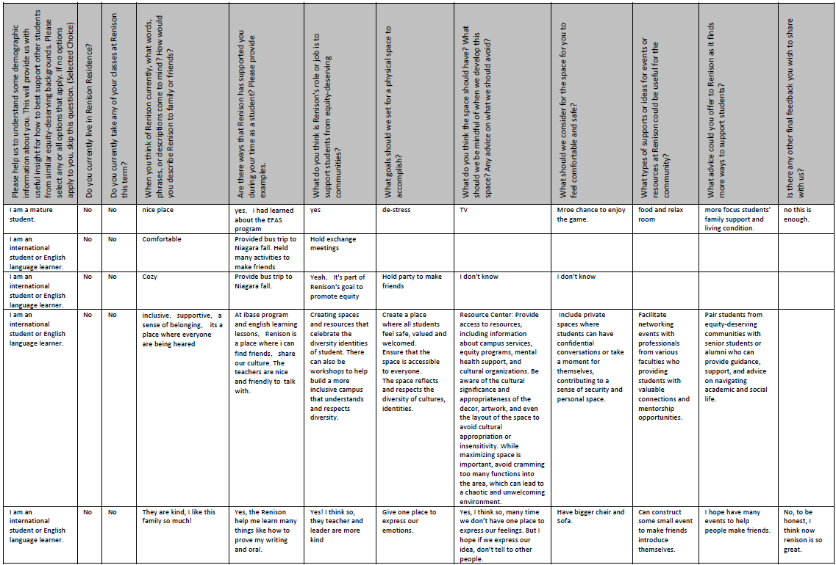
APPENDIX G

Equity-deserving Students Feedback Survey – Survey Results

