TABLE OF CONTENTS

TABLE OF CONTENTS

Acknowledgements 2
Introduction 3
The Consultation Process 5
In-Person Learning Support Consultation Sessions 5
Online Renison Learning Support Survey 7
In-Depth: What Students Told Us 7
Action Item 1: Increase awareness of the learning support services available to students in the Renison community through enhanced, peer-mediated communications and programming that assists with “service navigation”. 8
Action Item 2: Foster opportunities for structured and unstructured peer-led learning support at Renison. 10
Action Item 3: In consultation with the Student Affairs Advisory Committee, explore opportunities to enhance common spaces at Renison and improve access to learning tools to better support student learning. 12
Looking Ahead 13
Options for Implementation of Action Items 14
Conclusion 15
Appendix A: In-Person Learning Consultation Session – Presentation Slides 16
Appendix B: Full Notes from Learning Consultation Sessions 20
All Students Session – Monday, February 3, 2025 20
Renison Residence Students Session – Tuesday, February 4, 2025 23
International and English Language Learner Session – Wednesday, February 5, 2025 26
Appendix C: Further Reading 29
Appendix D: Renison Learning Support Survey Response Data 29

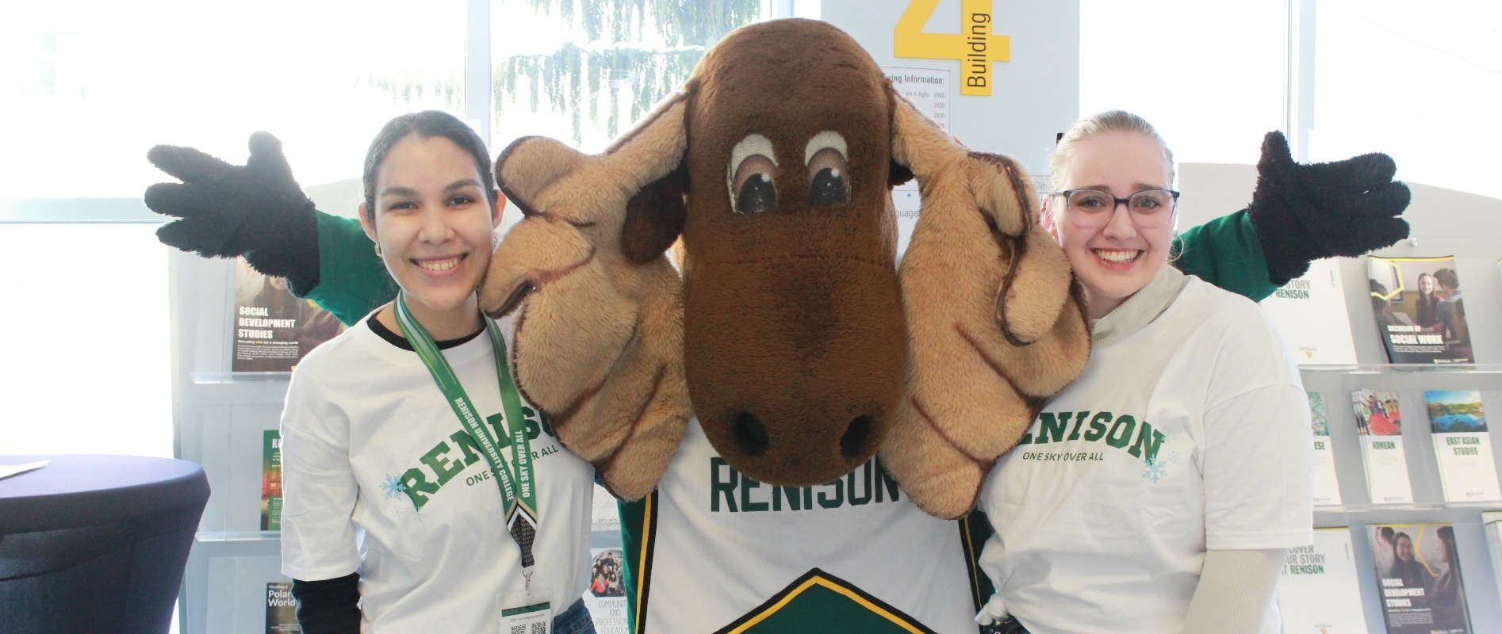

Acknowledgements
I associate Renison with a strong sense of community, so it’s fitting that the Renison Learning Support Project was very much a community effort. I would like to thank Ryan Connell, Assistant Director of Student Experience and Housing at Renison University College, for his encouragement, guidance, and knowledge - not to mention his logistical and editorial support! - throughout the project.
I would also like to thank Sibaal Jilani, Renison Programs Assistant and Peer Leader, for her assistance with the Learning Support Consultation Sessions and the review of existing scholarly research on post-secondary learning support.
In addition, I would like to thank Katie Damphouse, Manager of Academic Accommodations at the University of Waterloo’s AccessAbility Services, John Arnou, Upper-Year Student Advisor at St. Jerome’s University, and Angela Rooke, Manager of Academic Success and Retention at the University of Waterloo’s Student Success Office, for sharing their expertise and insights regarding learning assistance and student support.
Finally, I would like to thank all of the students who participated in the Learning Support Consultation Sessions and the Learning Support Survey; your feedback was invaluable for helping us gain a better understanding of how Renison can better support your learning.
A final thank you to everyone in the Renison community who works tirelessly to support our students. I sincerely appreciate your commitment to making Renison an even better place to learn and grow.

Andrew Dixon
Student Advisor
Renison Student Experience and Housing

Introduction
As an institution of higher learning, Renison University College is centred around the act of learning. This is reflected in the Mission Statement contained in Renison’s 2024-27 Strategic Plan:
“Renison aims to foster inclusive living, learning, and working communities empowered by excellence in teaching, scholarship, and service to educate and prepare highly skilled graduates for success and contribution to the world”.
Renison’s 2024-27 Strategic Plan identifies two priorities that especially relate to our institution’s ability to help students better learn and grow. These priorities, and the associated sub-priorities, are outlined below:

Priority 1: Nurture transformative student leaders
  - 1.2: Continuing to develop and improve student support systems which will enable Renison to nurture student success, health, and well-being, and reflect the needs of the diverse student population.
  - 1.3: Continuing to offer and enhance training opportunities for student leaders and opportunities for peer leadership and student employment at Renison University College.

Priority 4: Continue to be an inspirational place of teaching, research, and learning
  - 4.2: Adapting and refining programming responsive to the data-informed needs of students, both current and future, in keeping with our core academic strengths and expertise
  - 4.3: Continuing to strengthen institutional capacity toward excellence in teaching, learning, and research
These priorities recognize that students, faculty, staff, and members of the wider community come to Renison to not only learn about the wider world and our place within it, but also to learn more about how we can help each other. Specifically, Renison is a place where students learn how to work together, see things from the perspectives of others, and perhaps most important of all, support and serve one another. In a similar vein, post-secondary education often involves “learning how to learn” as we are introduced to ideas and methods of knowledge acquisition that may be difficult to grasp at first. As we work with others to expand our understanding, we are often learning how to help others learn in the process, while developing and refining strategies for sharing knowledge and working together.
This journey of discovery and development is rarely straightforward, and as many of us know, learning to succeed as a student often involves leaning on the support of others as we discover the strategies and tools that can help us achieve academic and professional success. This reality helps inform the definition of learning support that was used in the Renison Learning Support Project:

Learning support entails all the people and services outside
the classroom that help our students to succeed academically
and professionally.
The purpose of the Renison Learning Support Project was to develop a deeper understanding of the needs and wants of our Renison student community as it relates to learning support. To do this, Renison engaged with students through in-person, group-based consultation sessions, as well as through an online survey. In the sessions and subsequent survey, students were given the opportunity to share their feelings about their own learning, their experience with existing learning support services, and what services, tools, and facilities they would like to see Renison provide to support their learning. The data collected from the consultation sessions and surveys was reviewed by members of the Student Experience and Housing (SEAH) team to gain a better understanding of students’:
- Confidence (or lack thereof) in their ability to learn,
- Perceptions of utility about various learning support services at UWaterloo and Renison, and
- Desires in terms of services and resources that Renison could provide to support their learning
This data, in conjunction with insights drawn from scholarly research into post-secondary student learning support, was used to develop three key action items for enhancing student access to learning support services and resources:
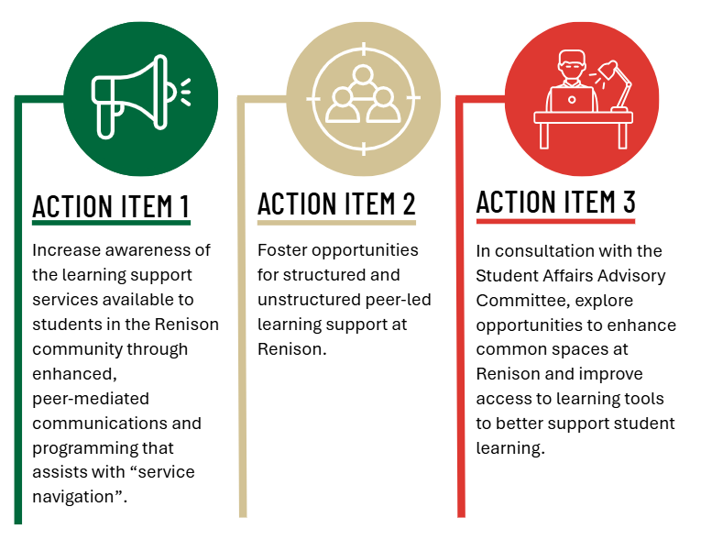

Subsequent sections of the report will describe the consultation process and action items in further detail, as well as provide suggested next steps for implementation of said action items. Appendices are provided for those seeking a deeper understanding of the scholarship and data that helped inform the conclusions of this report.
For the purposes of this report, the term “Renison students” is an umbrella term to include any students who are taking at least one course at Renison (regardless if the course is for credit or non-credit), or lives in Renison Residence, or is a University of Waterloo student who self-identifies as a member of our Renison community.

The Consultation Process
An essential component of the Renison Learning Support Project was the solicitation of students’ feedback regarding their perceptions of their own learning skills as well as the support available to them as members of the University of Waterloo and Renison student communities. The two primary means of obtaining said feedback were the In-Person Learning Support Consultation Sessions, which were held during the first week of February 2025, and the Learning Support Consultation Survey, which was launched the following month on the Renison website.
Associated communication campaigns were used to raise awareness for both consultation mechanisms. The communication campaigns consisted of a registration and informational pages on the SEAH website, advertising via SEAH’s social media channels, email reminders to the Renison community, and advertising posters on bulletin boards across Renison. Renison faculty members were also invited to share the survey with their students. As an incentive, students who participated in the In-Person Consultation Sessions and/or the Learning Support Survey were entered into a prize draw to win one of two $100 gift cards from a local retailer.
Further details regarding both the Consultation Sessions and the Survey follow.


In-Person Learning Support
Consultation Sessions
The In-Person Learning Consultation Sessions consisted of three group-based, workshop-style meetings with members of the Renison student community. The consultation sessions were held during the first week of February in Renison’s Dunker Family Lounge (DFL). The dates for the sessions and their associated demographics are listed below:
- Session 1 – Monday, February 3: All Students Welcome
- Session 2 – Tuesday, February 4: Renison Residence Students
- Session 3 – Wednesday, February 5: International and English Language Learner Students
The motivation for offering special sessions for Renison Residents and international and English Language Learner (ELL) students was to provide students with the option of attending a session with similar peers, which in turn could make the session more relatable and/or comfortable for the attendees. All told, 26 students participated in the Consultation Sessions, with 11 students participating in the All Students session, a further 11 students participating in the Renison Residence session, and four students participating in the International and English Language Learner session.
Each session followed the same format, where the facilitator (Andrew Dixon, ELI Student Advisor with SEAH) asked a series of questions for discussion in small groups (group sizes varied depending on the session, but was usually three to five participants per table). The questions the participants discussed were as follows:
- “How would you define learning skills?”
- “How confident are you that you have the learning skills necessary to succeed in your studies?”
- “What are some learning skills you would like to improve?”
- “What is learning support?”
- “Do you feel well-supported in your studies?”
- “What prevents you from getting the learning support you need?”
Participants would discuss each question for approximately three to seven minutes. During these discussions, the Programs Assistant, Sibaal Jilani, would record notes from the discussions to capture the ideas the participants shared. After each discussion, the meeting facilitator would ask the participants to share their ideas with everyone, with the facilitator recording their main ideas on a whiteboard. The facilitator and/or Programs Assistant would then take a picture of the whiteboard after each discussion to capture the feedback.
Once the discussion exercises concluded, participants were asked to engage in an activity where they were asked to arrange slips of paper with the names of various learning support services and/or strategies on them (students were also given an “Other” slip that they could use as a “wild card” to write in any service that wasn’t amongst the pre-printed slips). The participants were then asked to order the learning support services in order of their utility, with the most useful service being at the top of their list, and the least useful service being at the bottom of their list. A chart showing all of the slips provided can be found below:
1-ON-1 COURSE-SPECIFIC TUTORING
1-ON-1 SUCCESS COACHING FOR LEARNING STRATEGIES
COURSE-SPECIFIC GROUP STUDY SESSIONS
IN-PERSON LEARNING AND LIFE STRATEGIES WORKSHOPS
ONLINE, INTERACTIVE LEARNING AND LIFE STRATEGIES WORKSHOPS
ONLINE CONTENT (VIDEOS, ARTICLES) ABOUT LEARNING STRATEGIES
POP-UP INFORMATIONAL BOOTHS ABOUT LEARNING SUPPORT AND STRATEGIES
OTHER – PLEASE SPECIFY

Once students had ordered their slips, the Programs Assistant captured photographs of the participants’ slips. The feedback recorded from the discussion questions and the activity were analysed by the Student Advisor and helped determine the Action Items of this report. Selected feedback from the In-Person Consultation Sessions can be found in the section entitled “In-Depth: What Students Told Us”. Full notes from the Consultation Sessions can be found in Appendix B.

Online Renison Learning Support Survey

The Renison Learning Support Survey was administered online during March 2025 using Qualtrics XM survey software. Students in the Renison community were invited to answer a series of questions related to learning support. The questions were designed to evaluate:
- What learning support services at UWaterloo and Renison that participants were using,
- Participants’ satisfaction with the level of learning support provided by UWaterloo and/or Renison, and
- The utility of various learning support services
Students were also asked to indicate their study status (i.e. full or part-time studies, undergraduate or graduate, the number of courses they are enrolled in at Renison) as well as limited demographic information (for example, were they a domestic or international student, English Language Learner, mature student, etc.). Finally, students were asked to provide suggestions for services or support that Renison could provide to better support their learning.
In total, 141 responses were recorded for the survey, with the majority of respondents indicating they were full-time, undergraduate students. In addition, 15% of respondents indicated they were Renison Residence students, 12% indicated they were international students, 10% indicated they were online students, and 10% indicated they were mature students. As well, 80% of respondents indicated they typically enrol in at least one course at Renison per term overall, with 31% of respondents indicated they typically take one course at Renison, 27% indicating they take 2 to 3 courses at Renison, and 22% indicating they take 3 to 5 courses at Renison. Selected feedback from the Renison Learning Support Survey can be found in the section entitled “In-Depth: What Students Told Us”, while full results from the survey can be found in Appendix C.

In-Depth: What Students Told Us
In this section, we will explore the feedback that informed the creation of the report’s action items, with excerpts from the consultation sessions and survey used to illustrate the reasoning behind each action item. We will also touch on research that supports the suggestions offered by consultation session and survey participants for enhancing student learning and learning support services at Renison University College.

Action Item 1: Increase awareness of the learning support services available to students in the Renison community through enhanced peer-mediated communications and programming that assists
with “service navigation”.

When analysing the feedback from the Learning Support Consultation Sessions and Renison Learning Support Survey, one of the themes that became apparent was some participants’ lack of awareness of the learning support services available to them. Some students noted that they were not even aware that some services existed, while others may have been vaguely aware of some services, but lacked a thorough understanding of how said services could support their learning. 52% of survey participants also noted that they “don’t normally use” formal learning supports at the University of Waterloo and/or Renison University College, although it should be noted that this many not necessarily be due to lack of awareness of said services. Selected feedback that illustrates this point follows.
Student feedback regarding issues that prevent them from getting the learning support they need:
- “Bridging the gap between finding what sources are offered and what I need specifically”
- “(Learning support services) not advertised enough / not promoted”
- “…I feel the problem is you have to reach out on your own, and that’s where I struggled. I also didn’t know about any resources for the first two years”
- “At UW, there are many resources that I knew about, but I do agree that its harder to figure out the resources on your own”
- “Lack of information is a barrier / not knowing where to go and who to find”

Consultation Session and Survey participants also provided suggestions regarding ways Renison could increase awareness of existing learning support services. Selected feedback containing these suggestions follows.
Student suggestions for increasing student awareness of learning services/accessing these services:
- “I think that a greater promotion of some of the services that are offered to students through Main Campus might be helpful. I know as a Renison student there can be times where it is very isolating and you aren't aware of the resources that you can utilize. The promoting piece is necessary.”
- “I think everything is all good but I hope it way more easier find what kind of program they have”
- “More supports for part-time students specifically. I get lost at the main campus. I would love weekend drop in sessions at Renison. This would assist with focusing and learning life skills hands on. Due to work schedule it is hard to do the daytime virtual and night time is with my children.”
- “Help navigating services / how to use the writing centre / how to navigate accessibility services”
Recent scholarship also supports the notion that students’ awareness of post-secondary learning support services can be increased through peer support and peer-mediated knowledge sharing. For example, Cameron and Rideout note in their article “’It’s been a challenge finding new ways to learn’: first-year students’ perceptions of adapting to learning in a university environment,” that students will observe and mimic peers’ learning strategies in order to develop and enhance their own learning skills (2020). Citing research by Clark (2005), Cameron and Rideout note that “first-year students often turn to peers to provide them with knowledge in unfamiliar situations”, and that this process of learning from one’s peers can help students build their identity as a post-secondary learner (2020). While first-year students are but one of many student demographics served at Renison, it should be noted that many of our non-credit Renison International Programs students, as well as our mature and online students, face similar challenges in regard to navigating an institutional environment that may be unfamiliar or otherwise significantly different than their past experiences with post-secondary education. As such, it seems reasonable to suggest that these students would benefit from peer-led learning opportunities as they seek to adapt to their new educational environment.
The feedback expressed by our consultation session and survey participants, combined with the conclusions drawn from the aforementioned research, suggests there is an opportunity for Renison to enhance our students’ awareness of the available learning supports via peers/near-peers, enhanced communication, and personalized assistance to aid students when accessing services to support their learning. This could take a variety of forms, but possible options include:
- Enhancing existing student leader training modules to increase leaders’ understanding of the learning support services available in the Renison/University of Waterloo campus community.
- Taking advantage of existing peer support programming (peer leader/don-facilitated events, SDS Study Sessions) to promote additional learning strategies and resources.
- Using social media testimonials and/or informational videos by peers/near-pears (such as peer leaders or peer mentors) to share learning strategies and resources they used to be successful.
- Having peers/near-peers visit course lectures to promote learning support services at Renison and in the wider University of Waterloo community.
- Offering in-person and virtual (online) “service navigator” appointments where students can request personal, 1-on-1 assistance from a peer leader or a member of SEAH’s full-time staff when accessing a support service for the first time.
Potential avenues for the implementation of these suggestions within the Renison community will be discussed in the section entitled “Looking Ahead”.

Action Item 2: Foster opportunities for structured and
unstructured peer-led learning support at Renison.

Our second action item centres around the concept of peer-led learning support. As discussed, peers can play an important role in supporting the learning of their fellow students. Feedback received from our Consultation Sessions and Surveys also supports this notion. During the February 3 Consultation Session for All Students, our recorder, Programs Assistant Sibaal Jilani, observed that the students emphasized the importance of peers (including students from outside their program) in supporting their own learning. Having said this, some students noted that there is often a “disconnect” when it comes to engaging with students in an academic/classroom setting, with one student noting that “I don’t know anyone in my program, and I’ve been here for four years.”

Similarly, students in the February 4 Consultation Session for Renison Residence Students shared that they found peer support and collaborative knowledge-sharing to be very useful in supporting their own learning. One student remarked that peer support “…doesn’t need to be with students in my program” and that they found value in having peers available to act as a “sounding board” as they made sense of the content they were learning. While students noted that they often formed these study groups on their own, they would appreciate it if Renison offered a variety of study sessions for different learning styles. One consultation session participant suggested these sessions could be “vibe based”; in other words, sessions could be offered for students who valued lively conversation and background noise, while other sessions could cater to students who preferred a quieter study environment. Other participants noted that students with ADHD or other forms of neurodivergence could benefit from the opportunity for “body doubling” (working alongside someone in order to maintain focus and motivation) – something in which group study sessions can provide.
The responses from the Learning Support Survey also bear witness to the value students place on opportunities to learn with peers. In fact:
57%
of participants felt course-specific group study and support sessions to be either “very useful” or “somewhat useful”.
48%
of participants felt non-course specific, study hall-style sessions to be “very useful” or “somewhat useful”.
57%
of participants also felt that one-on-one course support/tutoring would be either “very useful” or “somewhat useful”.
44%
of participants indicated that one-on-one coaching for study skills or life skills” would be “very useful” or “somewhat useful”.
This suggests that, in addition to group-mediated peer support, there is also a strong appetite for personalized support (particularly if this support takes the form of course-specific tutoring, although a large minority of respondents noted that coaching to aid with study skills or life skills would also be useful). Related to this, one student noted that the support provided by their peer leaders was “very helpful” and that they appreciated having access to an upper-year student who was “highly involved in learning” and who shared “constructive study methods”.
Some survey participants also shared that they would appreciate opportunities to connect with support during evenings and weekends, with one participant sharing that “online and after-hours supports are super appreciated for mature students!”, and another saying “…I would love weekend drop-in sessions at Renison. This would assist with focusing and learning life skills hands on. Due to (my) work schedule it is hard to do the daytime virtual and night time is with my children.”
The value of peer support can also be seen in structured learning support programs, such as Supplemental Instruction. Supplemental Instruction (SI) is a formalized program of peer support where students receive course-specific help from a “near peer” – usually, a trained student facilitator who recently completed the course successfully - in structured group study sessions outside of class time. In “Inside Supplemental Instruction Sessions: One Model of What Happens that Improves Grades and Retention”, Congoes and Shoeps noted that “…SI students had significantly higher final course grades than non-SI students”…in the biology course studied, even though the SI students’ SAT scores and “predicted grade point average” were not “significantly different” from the non-SI students (1998). This suggests that post-secondary students’ learning can be deepened through collaboration with peers in a structured, group-based study environment with peers.
Given the preceding feedback and supporting scholarship, Action Item 2 proposes that Renison finds ways to foster opportunities for structured and unstructured peer-led learning support. Some possibilities for implementing these action item include:
- Expanding existing peer-led learning support programs, such as the SDS Study Sessions, to other courses offered by Renison faculty and instructors, providing additional opportunities for students to learn from peers or near-peers who are either currently enrolled in the course or who recently completed the course.
- Adapting practices and training methods developed for Supplemental Instruction programs for course-based study sessions led by student leaders at Renison.
- Offering a variety of group study events, from quieter study halls to more animated “study socials” to online study support, encouraging student engagement and connection between peers.
- Exploring opportunities to expand programs like the peer mentor program developed by SEAH for BASE and EFAS program students to Renison’s credit programs and students living in Renison Residence, helping students build in-person and virtual connections with peers in their program before and during their studies.
- Offering evening and weekend peer support, both in-person and online, to students who may not be able to access existing support services due to the constraints imposed by time or distance.
As with the previous action item, possible methods for the implementation of said suggestions will be offered in the section entitled “Looking Ahead”.

Action Item 3: In consultation with the Student Affairs Advisory Committee, explore opportunities to enhance common spaces at Renison and improve access to learning tools to better support student learning.
Another theme that became apparent when analyzing the feedback provided by the consultation session and survey participants was the desire for enhanced spaces for studying, as well as improved access to tools and resources to improve student learning. While this was especially noticeable in the Consultation Session for Renison Residence Students, students from the other in-person sessions as well as the survey also expressed a desire for enhanced spaces for studying and easier access to learning tools. An excerpt of said suggestions can be found below.
Student suggestions for enhancing common spaces at Renison to support student learning:
- “Study spots / good learning environment”
- “Spaces/sessions of different levels of productivity (like the DP library – each floor is a different “quiet level”)”
- “More study spaces / rooms that is cozy, comfortable (coffee shop vibes)”
- “Flexible seating / standing desks”
- “Docking stations / outlets”
- “Individual study spaces / having a larger quiet study space that is available at all hours”
- “Always good to have more options when it comes to places to study on campus. Especially those with an electrical outlet and stable internet for my laptop.”
- “I wish library hours were longer and classrooms were not that cold to study in”
Student suggestions for additional tools and resources at Renison to support student learning:
- “Create a public archive for courses that have been around for a long time (commonly recurring courses) to draw upon = Online recordings”
- “Phone jails / facilitators to ensure productivity”
- “Having tools for success / GLEAN AI (allows student to record lectures and give transcripts) = speech-to-text”
- “More AI tools: Brain fuse; Notebook LM”
- “Printing room / stationary room / whiteboard markers / office supplies more accessible”
- “Mobile whiteboards”
Recognizing that there are many stakeholders involved when it comes to the provision of physical spaces and resources at Renison University College, it would be advisable for Renison Student Experience and Housing to work with Renison’s Student Affairs Advisory Committee to determine:
- What work the SAAC has already pursued related to the aforementioned suggestions regarding enhanced learning spaces and resources, and how that may align with the suggestions provided by the consultation session and survey participants.
- Where there may be opportunities for collaboration and/or joint advocacy for pursuing enhancements to Renison’s spaces for studying and learning, as well as the provision of additional learning tools and resources.
- How the suggested enhancements could be prioritized to provide the greatest benefit to the Renison student community in the short, medium, and long term.
In the section entitled “Looking Ahead”, this Report will explore potential options for enhancing Renison’s existing study spaces and expanding access to learning tools while remaining cognizant of budgetary and resource constraints.

Looking Ahead
The Renison Learning Support Project has provided us with an important opportunity to gain deeper insights into the types of services, supports, and resources that could benefit our Renison student community. The feedback provided by our consultation and survey participants informed the creation of our three main action items, which can help us focus our efforts as we determine what concrete steps we can take to improve how we support our students’ learning. In this section, we will explore what near-term, medium-term, and long-term opportunities may exist for enhancing learning support at Renison University College.

Options for implementation of Action Items
In the following table, we will outline some ways Renison Student Experience and Housing (SEAH) can proceed with the implementation of our three action items. The table is divided into three sections, with the first column outlining services, programming, resources, or strategies that target the implementation of one or more action items (which are specified in the second column). The third column suggests the timeframe for implementation.
SUGGESTED ACTIVITY, SERVICE, OR RESOURCE | TARGETED  ACTION ITEM(S) | TIMEFRAME FOR IMPLEMENTATION
Developing in-depth training modules for student leaders (peer leaders and residence dons) to deepen their knowledge of existing campus learning support services. | Action Item 1, Action Item 2 | 1 to 3 months
Enhance student leader mediated communications regarding campus learning support services, including testimonials over social media, peer-facilitated informational videos, and in-person promotion opportunities. | Action Item 1, Action Item 2 | 1 to 3 months
Approach the Student Affairs Advisory Committee regarding collaboration on initiatives that could provide enhanced common spaces and tools to members of the Renison student community to support their learning. | Action Item 3 | 1 to 3 months
Provide additional peer-led programming (both in-person and online), such as information sessions and workshops, that focus on accessing campus learning support services for the first time (for example, AccessAbility Services, Writing & Communication Centre, UWaterloo and Renison Libraries). | Action Item 1, Action Item 2 | 3 to 6 months
Specify designated peer leaders and members of SEAH full-time staff as “service navigators”, helping students access existing services and programming through personalized, step-by-step appointments (primarily the new Student Experience Peer Leader for Learning Skills and Online/Mature Learners), both in-person and online. | Action Item 1, Action Item 2 | 3 to 6 months
Support and expand the successful SDS Study Sessions, with the possibility of providing additional training informed by practices associated with Supplemental Instruction (SI). Explore options for online study sessions. | Action Item 1, Action Item 2 | 3 to 6 months
Offer non-course specific group study sessions, overseen by a student leader, that offer different types of “ambiance” or “vibes”, with some offering more social learning spaces with higher levels of background noise, while others offer quieter, study hall-style sessions for students who prefer to work primarily on their own. Explore options for online sessions. | Action Item 2 | 3 to 6 months
Collaborate with Renison faculty and instructors to determine if additional programs and/or courses could benefit from a group study model similar to the SDS Study Sessions. Determine what mix of in-person and online programming may be desirable. | Action Item 1, Action Item 2 | 6 to 12 months
Develop additional peer-led learning support programming, such as Peer Mentorship programs targeting students by faculty, program, or demography. | Action Item 2 | 12 to 18 months

In the coming weeks and months, Renison Student Experience and Housing will develop plans for implementing the suggested programming and resources outlined in the table, with a near-term (1 to 3 month) implementation timeframe taking priority. Much of the planning will be designed to support the on-boarding of SEAH’s Learning Skills Peer Leader and Student Experience Peer Leader (Mature and Online Learner) roles that will launch in Fall 2025. While all student leadership staff will benefit from some of the enhanced training components surrounding knowledge of on-campus learning support services, these two Peer Leaders’ roles have a particular focus on supporting students who are wanting to develop their learning skills and/or enhance their existing skillset to better suit a new learning context.

Conclusion
Renison Student Experience and Housing is committed to supporting Renison’s mission of making Renison an inclusive community that fosters student learning and prepares them for personal and professional success. The Renison Learning Support Project has given students an opportunity to voice what services, programming, and resources would be most useful in terms of supporting and enhancing their learning.
Through the Project, our students have provided us with concrete, practical suggestions for enhanced learning support at Renison. The fact that the vast majority of the suggestions provided by our student participants are in alignment with Renison’s Strategic Priorities validates our institution’s approach to student-centred support.
As we implement the three action items contained in this report, Renison Student Experience and Housing will continue to solicit input and feedback from students, faculty, staff, and instructors to ensure that our work continues to adapt to the diverse needs of our student population. Through a collaborative, adaptive approach to learning support, Renison Student Experience and Housing will strive to make Renison University College an even better place for our students to learn and grow.


Appendix A:
In-Person Learning Consultation Session – Presentation Slides



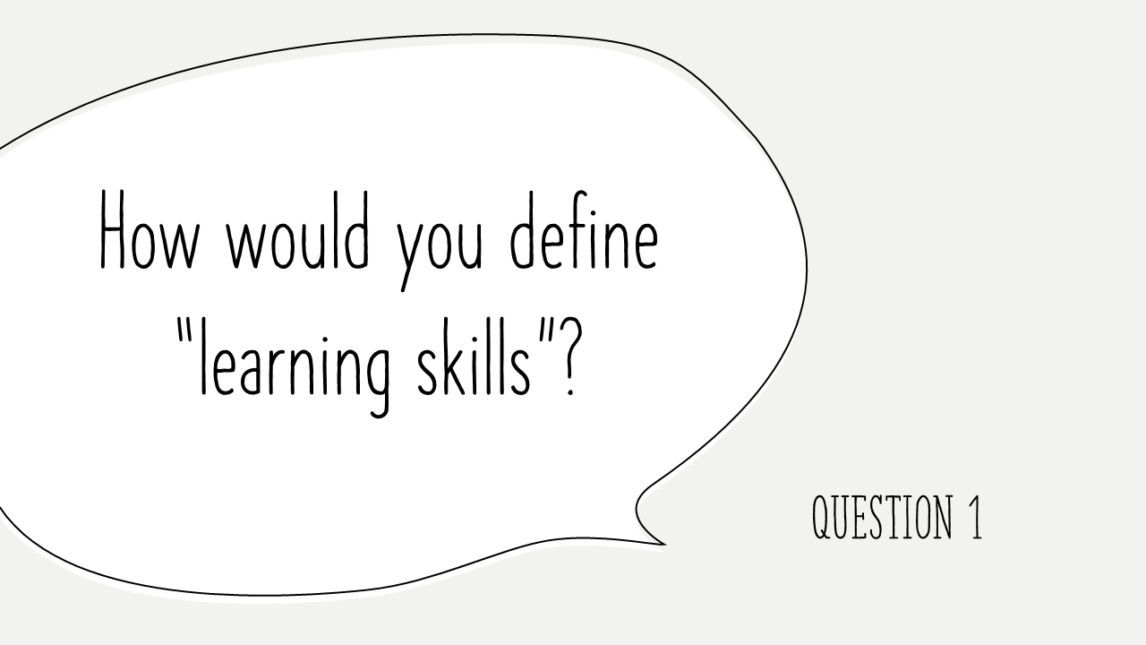

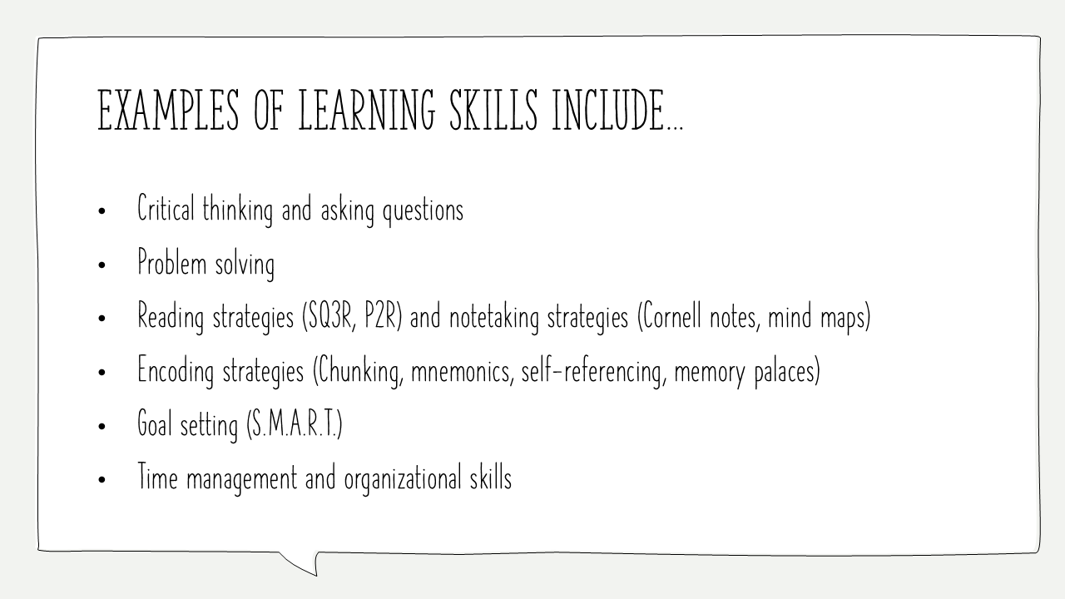
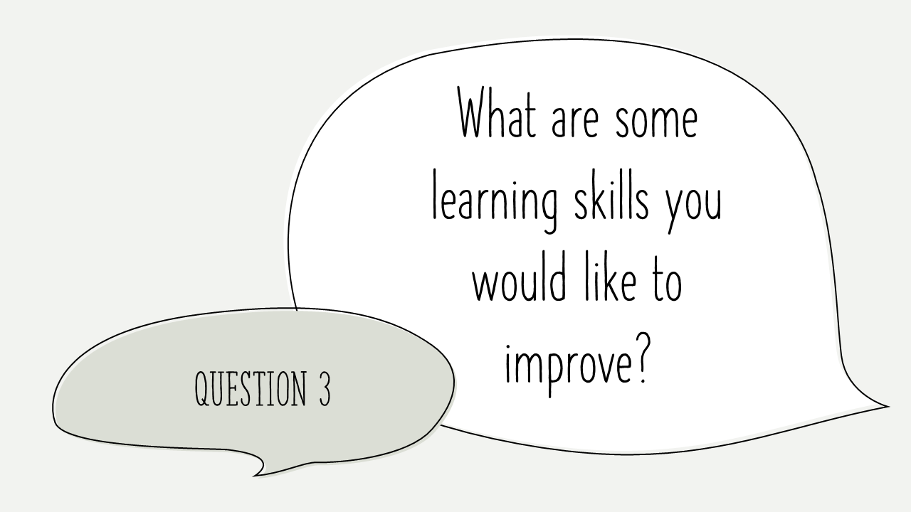

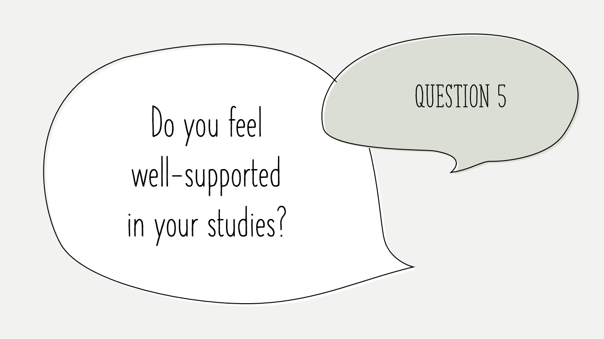

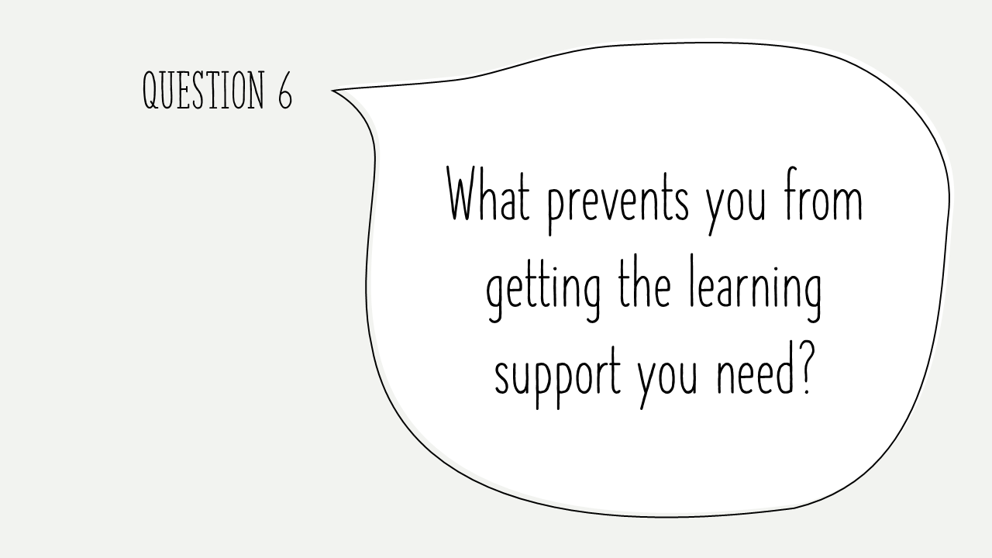
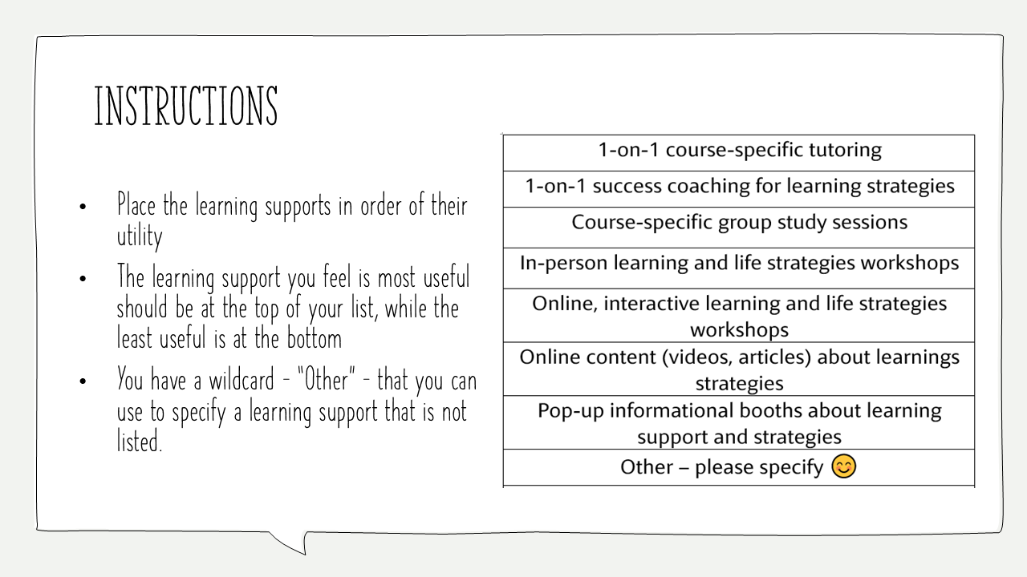
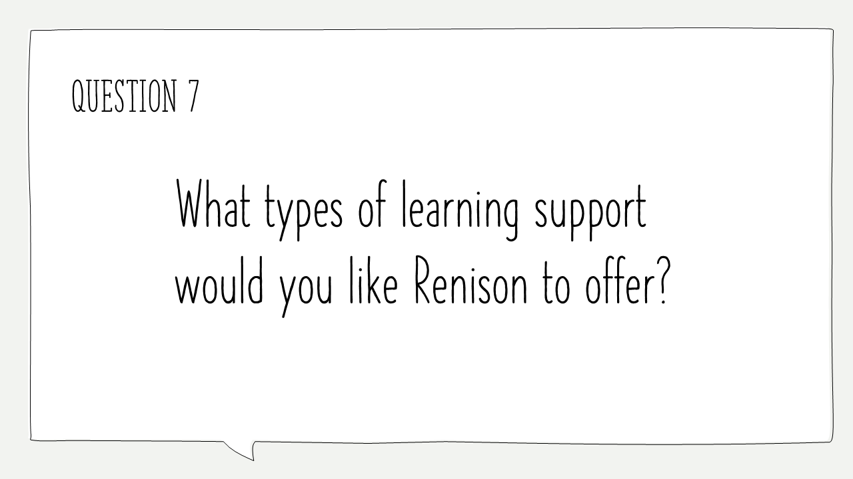
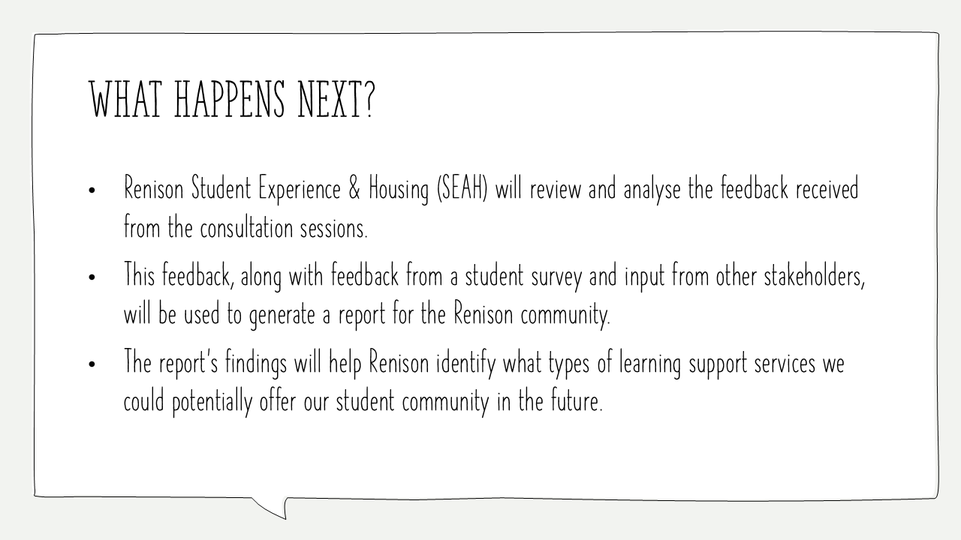

Appendix B:
Full Notes from Learning Consultation Sessions

All Students Session – Monday, February 3, 2025
Transcribed by Sibaal Jilani
Facilitated by Andrew Dixon
- How would you define learning skills?
- Examples provided:
  - Critical thinking and asking questions​
  - Problem solving​
  - Reading strategies (SQ3R, P2R) and notetaking strategies (Cornell notes, mind maps)​
  - Encoding strategies (Chunking, mnemonics, self-referencing, memory palaces)​
  - Goal setting (S.M.A.R.T.)​
  - Time management and organizational skills​

- Transferable skills
- “Tools that allow you to make connections in your brain” like self-referencing
- Learning habits (examples: like looking for patterns, or physical actions) and skills learnt through life experiences
- Process/filter/consolidate information into memory
- ELABORATION, REPITITION, INTER-LEAVING (taking disparate information and combining them together)

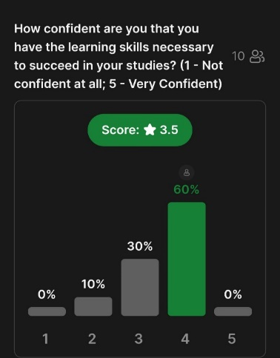
- How confident are you that you have the learning skills necessary to succeed in your studies?
- What does it take to be confident?
  - There is always room to improvement
  - “Using grades to see where I am and where I want to be”
    - Every class is different, and so there is different consideration for each class
- Gained with experience (in the case of mature students, they feel more equipped with learning skills necessary to succeed in your studies)

- What are some learning skills you would like to improve?
- Time management came about as the most struggled
- Being more attentive/more productive
- Engage with reading more (especially in case with dense readings)
- Engaging with studies in general
- Following through with schedules and to-do lists

- What is learning support?
- Examples provided:
  - Instructor office hours
  - Drop-in tutorial centres (Math Tutoring Centre, Physics Tutorial Centre)
  - Personalized academic accommodations (AccessAbility Services)
  - Scheduled and drop-in writing support (Writing & Communication Centre)
  - Drop-in study sessions (Academics in Residence at Village 1)
  - 1-on-1 meet-ups and success coaching (Renison and Student Success Office)
  - In-person learning and life strategies workshops
  - 1-on-1 private tutor (TutorConnect)
  - Course-specific drop-in tutorials and study sessions (SDS Study Sessions, SDS 250R Tutoring)
  - Online Workshops and Support Guides (Student Success Office)
- Community support AND tools support
- Knowing what kind of learner you are
- the environment where you learn
  - Study rooms and spaces
- “Extra tools besides myself” / flash cards / summaries
“Talking (venting/debrief) with others is extremely helpful” / support through friends and peers
- Guidance and advice/office hours
- Students talked about how there seems to be a disconnect with peers in classrooms / “I don’t know anyone in my program, and I’ve been here for four years”
- AccessAbility Services

Note afterwards:
Students emphasized that peer support, particularly from friends—often other university students outside their program—and family, is an integral and effective form of learning support throughout their university experience. However, many highlighted a noticeable disconnect with peers they encounter in academic settings. As one student candidly shared, 'I don’t know anyone in my program, and I’ve been here for four years,' reflecting the challenges in building meaningful connections within the classroom environment.
- Do you feel well-supported in your studies? / What prevents you from getting the learning support you need?
- Student staff feel well-supported because we are more aware of support
- Commuting students feel more disconnect
- Feeling discouraged to get support because it hasn’t worked before
  - Lots of barriers
  - Previous bad experiences
- Feels like instructors/TA are not providing enough support (they don’t answer emails, they don’t have the right answers)
  - Could be a question of funding or staffing that there is not enough support because of the growing number of students
  - Students in smaller class sizes feel more supported and feel like they can ask questions compared to students in larger class sizes
  - Logistics (work, family, commute)
- Bridging the gap between “Finding what sources are offered and what I need specifically”
- Counselling services = didn’t feel heard because of the short time of the session and so don’t want to try again

- What type of learning support would you like Renison to offer?
- create a public archive for courses that have been around for a long time (commonly recurring courses) to draw upon = Online recordings
- Tutoring service for SDS courses
- Have both evening sessions and morning sessions (to cater to more needs – give access to more students)
  - Being more aware of time conflicts for some students
- Writing and communication centre (drop-in sessions) at Renison

- Activity
Thoughts
- Putting online INTERACTIVE on top of online content
- Struggling with talking in large groups so would prefer one-on-one
- Struggle with making time (busy schedules, course loads) and so would likely not go to workshops/or check out information booths
- Practical applications than just be informed about learning skills through an information session
- Every student has different learning strategies based on their preferences

Renison Residence Students Session – Tuesday, February 4, 2025
Transcribed by Sibaal Jilani
Facilitated by Andrew Dixon
- How would you define learning skills?
- Examples provided:
  - Critical thinking and asking questions​
  - Problem solving​
  - Reading strategies (SQ3R, P2R) and notetaking strategies (Cornell notes, mind maps)​
  - Encoding strategies (Chunking, mnemonics, self-referencing, memory palaces)​
  - Goal setting (S.M.A.R.T.)​
  - Time management and organizational skills​

- Skills that help you prepare for studies
- Understanding yourself (“your own cognitive process”) and how you learn to aid in knowledge gathering
- Understanding how Neurodivergent and Neurotypical learn differently
  - Learning skills are INDIVIDUALISTIC and COMPLEX
- It’s about cultural preferences and considerations / environmental
- Growth mindset / improve one’s skillset
- Skills that help you understand / process / apply information
- Not just for learning/studying but in practical situations
  - It’s also about time management / how to speak in a professional setting
- Ability to take in and comprehend knowledge
- Strategies and routines that aid in understanding
- Another learning strategy: teaching / peer teaching

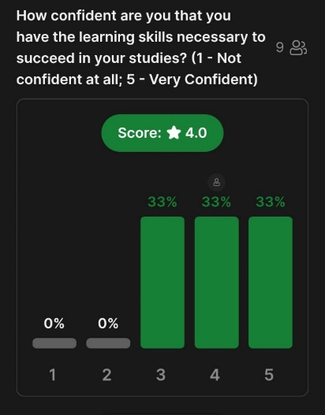
- How confident are you that you have the learning skills necessary to succeed in your studies?
- More way to improve / more learning skills to learn
- “Getting diagnosed [with a neurodivergent condition] in high school helped me understand that I learn differently from other people and so, I could identify and figure out what works for me” / “having to advocate for myself taught me important skills”

- What are some learning skills you would like to improve?
- Learning what gets me started (learning how to get work done in advance) / pacing work / time management / overcoming procrastination (unanimously agreed by majority of the people)
- Rote memorization

- What is learning support?
- Examples provided:
  - Instructor office hours
  - Drop-in tutorial centres (Math Tutoring Centre, Physics Tutorial Centre)
  - Personalized academic accommodations (AccessAbility Services)
  - Scheduled and drop-in writing support (Writing & Communication Centre)
  - Drop-in study sessions (Academics in Residence at Village 1)
  - 1-on-1 meet-ups and success coaching (Renison and Student Success Office)
  - In-person learning and life strategies workshops
  - 1-on-1 private tutor (TutorConnect)
  - Course-specific drop-in tutorials and study sessions (SDS Study Sessions, SDS 250R Tutoring)
  - Online Workshops and Support Guides (Student Success Office)
- Having conversations with professors / connecting with professors / office hours
- Study spots / good learning environment
- Having tools for success / GLEAN AI (allows student to record lectures and give transcripts) = speech-to-text
- Educators should understand that people have different learning styles / providing resources to support students in ways beneficial to them – that caters to their learning / accommodate to different forms of learning
- Educators being able to adapt to different methods of learning / empathetic understanding
- Supportive classroom environment
- Peer support / talking with others and collaborative sharing of knowledge
  - “it doesn’t need to be with students in my programs / just have a discussion with people / explaining it to people”
  - Peers acting as a sound board
- More AI tools
  - Brain fuse
  - Notebook LM
- Do you feel well-supported in your studies? / What prevents you from getting the learning support you need?
- Not having adequate accessibility services
  - More staffing
  - Better interface / website is confusing / not knowing what supports are available to me until after the fact / not knowing how to use the supports
- “I would rate it a 3.5/5 – there is good resources, and it’s much better than other universities but it could be greatly improved”
- Not advertised enough / not promoted
- Learning support needs to be extended to all programs
- Academic advisors could be more helpful
- Needs more funding / some services are not free / expensive
- Stigma in approaching help / resources / instructors

- What type of learning support would you like Renison to offer?
- Non-course specific study sessions / more generalized group sessions
  - Broader range of course study sessions
  - Phone jails / facilitators to ensure productivity
- Spaces/sessions of different levels of productivity (like the DP library – each floor is a different “quiet level”)
  - “Vibes” based
  - Study sessions that cater to different needs and interests
- Help navigating services / how to use the writing centre / how to navigate accessibility services
- Study halls
- Flexible seating / Standing desks
- Docking stations / outlets
- Individual study spaces / having a larger quiet study space that is available at all hours
- Better library marketing
- Printing room / stationary room / whiteboard markers / office supplies more accessible
- Mobile whiteboards

International and English Language Learner Session – Wednesday, February 5, 2025
Transcribed by Sibaal Jilani
Facilitated by Andrew Dixon
- How would you define learning skills?
- Examples provided:
  - Critical thinking and asking questions​
  - Problem solving​
  - Reading strategies (SQ3R, P2R) and notetaking strategies (Cornell notes, mind maps)​
  - Encoding strategies (Chunking, mnemonics, self-referencing, memory palaces)​
  - Goal setting (S.M.A.R.T.)​
  - Time management and organizational skills​

- Memory, writing
- “Cognitive process which transforms information into structural system to adapt”
- Skills we use to understand knowledge and add to our system
- Filtering/synthesizing information à communicate / send info
- Strategies we use for collecting information + making decisions + understanding what is important

- How confident are you that you have the learning skills necessary to succeed in your studies?
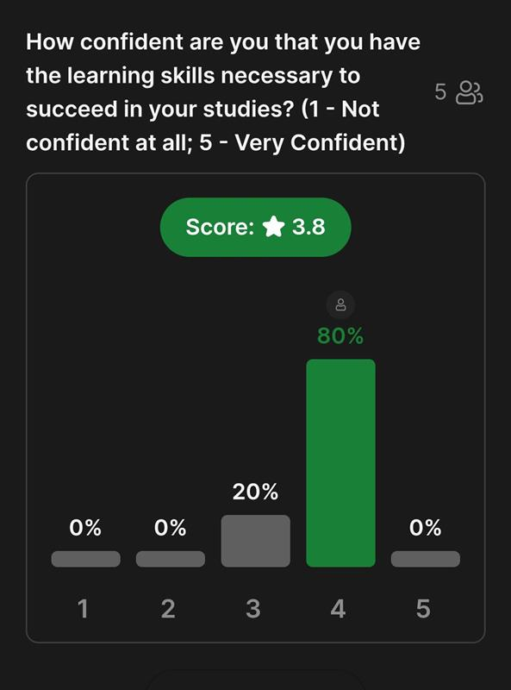
Comments
- “I struggle with writing – I think tangentially, so I write tangentially which I want to improve”
- “I feel like I’ve adjusted well to university style, because I feel comfortable and a part of the Waterloo community, so I know (or how to find out) what my professors are looking for”
- “I feel like I’ve adjusted well, but there’s always room for improvement. I feel like I struggle with my learning system/learning skills when I come across subjects that I am not familiar with”

- What are some learning skills you would like to improve?
- Time management (unanimously agreed by most people)
- Rote memorization
- Critical thinking

- What is learning support?
- Examples provided:
  - Instructor office hours
  - Drop-in tutorial centres (Math Tutoring Centre, Physics Tutorial Centre)
  - Personalized academic accommodations (AccessAbility Services)
  - Scheduled and drop-in writing support (Writing & Communication Centre)
  - Drop-in study sessions (Academics in Residence at Village 1)
  - 1-on-1 meet-ups and success coaching (Renison and Student Success Office)
  - In-person learning and life strategies workshops
  - 1-on-1 private tutor (TutorConnect)
  - Course-specific drop-in tutorials and study sessions (SDS Study Sessions, SDS 250R Tutoring)
  - Online Workshops and Support Guides (Student Success Office)
- Attending academic workshops (AJ) à life skills, learning skills, time management
- Peer support
- Writing and communication centre
  - One-on-one support
- Studying with other people

- Do you feel well-supported in your studies? / What prevents you from getting the learning support you need?
- “It depends on the course but I often feel it lacking (in terms of UWaterloo)”
- “At Renison English language programs, I felt well-supported but when I went to UWaterloo, I feel the problem is you have to reach out on your own, and that’s where I struggled. I also didn’t know about any resources for the first two years.”
- “I feel well-supported both at Renison and UW. At Renison, I felt connected and felt like I belonged because of my peers, teachers and peer leaders. At UW, there are many resources that I knew about, but I do agree that it’s harder to figure out the resources on your own” (unanimously agreed).
- “I feel the professors and TAs in my program (Economics) are well-supportive and accommodating.”
- “I didn’t have enough time, especially when it comes to talking with my academic advisors when I wanted to talk about changing faculties because all the sessions were online, and online format doesn’t really work with me.”
- Lack of information is a barrier / not knowing where to go and who to find
- “When there are lines for office hours, I would prefer not to”
- “I felt ashamed about talking my problems, because I felt like I had to be a good student”

- What type of learning support would you like Renison to offer?
- Mental health supports
  - One-on-one / group support
- Group study sessions à more accessibility / awareness
- Coffee chats with professors after class
- IF BUDGET, second library w/ big windows
- More study spaces / rooms that are cozy, comfortable (coffee shop vibes)
- Meditation and mindfulness and encouraging student engagement in these events.
- Need more connections and collaboration with on-campus resources / promotion using on-campus clubs or Instagram because “Renison is a small niche and so promoting to the wider community would be really helpful”.

- Activity
Comments:
- “I prefer one-on-one sessions, and I would like consultation sessions that would coach you through APPLYING learning skills, because I feel like, despite being educated about learning skills and I still sometimes not able to apply them, maybe due to some internal block.”
- “I like using online course-specific resources because most of the university courses are based on textbooks that can be found online as well as other online lectures and it’s sometimes even better than the professors’ lectures.”
- “I prefer one-to-one course-specific interactions where you get face to face interactions and it's course specific so you can ask questions about what you're wondering and what strategies could work for you personally.”
- “I prefer workshops over booths because the workshops are more interactive.”
- “I like optional un-scored quizzes because they are good practices” / “I prefer re-caps are really helpful because then you really understand how each part of the course relates on one another” / “I also prefer specific feedback”.
- “I prefer in-person over online (unanimously agreed), especially after covid”

Appendix C: Further Reading
Cameron, R.B. & Riedout, C.A. (2020). It’s been a challenge finding new ways to learn’: first-year students’ perceptions of adapting to learning in a university environment. Studies in Higher Education, 47(3), 668-682. https://doi.org/10.1080/03075079.2020.1783525
Carr, B.B. & London, R.A. (2019). The Role of Learning Support Services in University Students’ Educational Outcome. Journal of College Student Retention: Research, Theory & Practice, 21(1), 78-104. https://doi.org/10.1177/1521025117690159
Congos, D.H. & Schoeps, N. (Fall 1998). Inside Supplemental Instruction sessions: One model of what happens that improves grades and retention revisited. Research and Teaching in Developmental Education, 15 (1), 47-61.
Ecochard, S. & Fotheringham, J. (2017). International Students’ Unique Challenges – Why Understanding International Transitions to Higher Education Matters. Journal of Perspectives in Applied Academic Practice, 5 (2), 100-108. https://doi.org/10.14297/jpaap.v5i2.261
Räisänen, M., Postareff, L., Mattsson, M., & Lindblom-Ylänne, S. (2020). Study-related exhaustion:First-year students’ use of self-regulation of learning and peer learning and perceived value of peer support. Active Learning in Higher Education, 21 (3), 173-188. https://doi.org/10.1177/1469787418798517
Winograd, G. & Rust, J.P. (Fall 2014). Stigma, Awareness of Support Services, and Academic Help-Seeking Among Historically Underrepresented First-Year College Students. Learning Assistance Review, 19 (2), 19-43.

Appendix D: Renison Learning Support Survey Response Data

What formal learning support services do you use on the UWaterloo main campus? Select all that apply. - Selected Choice | Faculty provided services (Math Tutoring Centre, Physics Tutorial Centre, etc.); please specify: - Text | What formal learning support services do you use on the UWaterloo main campus? Select all that apply.  - Other; please specify: - Text | What formal learning support services at Renison do you use? Select all that apply.  - Selected Choice | - Academic and Life Skills Workshops (Time Management, Study and Test Preparation, Resume Writing Skills, etc.); please specify: - Text | What formal learning support services at Renison do you use? Select all that apply. - Other; please specify: - Text | What self-scheduled, informal, or private learning support services/strategies do you use? Select all that apply:  - Selected Choice | What self-scheduled, informal, or private learning support services/strategies do you use? Select all that apply: - Other; please specify - Text | How often do you access formal, on-campus (UWaterloo or Renison) learning support services? | How would you rate the learning support services you receive on the UWaterloo main campus? | How would you rate the learning support services you receive at Renison University College? | How confident are you that you have the learning skills and strategies necessary to succeed in your studies? | Please rate the following learning support services in terms of how helpful (or unhelpful) they would be to you?  - Course-specific group study/support sessions (for example, SDS 130R or PSYCH 101 group study sessions) | - General learning and life skills support workshops (Time Management, Note-taking, Exam Preparation) | - 1-on-1 (individual) course support/tutoring | - 1-on-1 (individual) coaching and support to develop study and life skills (time management, note-taking, organization) | - Group study hall (not course specific) | Are there any additional supports or services that you feel would help you or other students with their learning? If yes, please type your suggestions here: | If you have any additional comments or concerns about learning support services at Renison, we welcome you to share your feedback here: | How would you describe yourself as a student? Select all that apply. - Selected Choice | How would you describe yourself as a student? Select all that apply. - Other, please specify: - Text | How many courses do you specifically take at Renison in a typical term?
None |  |  | None |  |  | Self-organized study groups with friends or classmates |  | I don't normally use campus learning support services | No opinion | No opinion | Somewhat confident | Somewhat helpful | Somewhat helpful | No opinion | No opinion | Very helpful |  |  | Full-time UWaterloo student |  | 1 course
Online workshops with the Student Success Office |  |  | None |  |  | Office hour meetings with an instructor or TA,Meetings with an academic advisor or student advisor,Self-organized study groups with friends or classmates |  | 3 to 6 times per term | Good - I feel supported in my studies | Good - I feel supported in my studies | Somewhat confident | Very helpful | Somewhat helpful | Very helpful | Very helpful | Somewhat helpful |  |  | Full-time UWaterloo student |  | 1 course
None |  |  | None |  |  | Office hour meetings with an instructor or TA,Meetings with an academic advisor or student advisor,Self-organized study groups with friends or classmates |  | I don't normally use campus learning support services | Poor - I feel unsupported in my studies | Neutral - I feel neither supported nor unsupported in my studies | Somewhat confident | Somewhat helpful | Somewhat helpful | Very helpful | Very helpful | Somewhat helpful |  |  | Full-time UWaterloo student,Undergraduate student |  | 2-3 courses
None |  |  | Academic and Life Skills Workshops (Time Management, Study and Test Preparation, Resume Writing Skills, etc.); please specify: |  |  | Office hour meetings with an instructor or TA,Self-organized study groups with friends or classmates |  | I don't normally use campus learning support services | Good - I feel supported in my studies | Neutral - I feel neither supported nor unsupported in my studies | Somewhat confident | No opinion | Somewhat helpful | No opinion | No opinion | Very helpful |  |  | Full-time UWaterloo student,Undergraduate student,Renison Residence student |  | 1 course
None |  |  | None |  |  | Office hour meetings with an instructor or TA,Self-organized study groups with friends or classmates |  | I don't normally use campus learning support services | Poor - I feel unsupported in my studies | Neutral - I feel neither supported nor unsupported in my studies | Somewhat confident | Somewhat helpful | Somewhat helpful | Very helpful | Very helpful | Somewhat helpful |  |  | Full-time UWaterloo student,Undergraduate student |  | 2-3 courses
AccessAbility Services |  |  | SDS Group Study Sessions |  |  | Office hour meetings with an instructor or TA,Meetings with an academic advisor or student advisor,Self-organized study groups with friends or classmates,Other; please specify | Therapist | 1 to 3 times per term | Neutral - I feel neither supported nor unsupported in my studies | Neutral - I feel neither supported nor unsupported in my studies | Neither confident nor unconfident | Somewhat helpful | Neither helpful nor unhelpful | Neither helpful nor unhelpful | Neither helpful nor unhelpful | Somewhat helpful |  |  | Full-time UWaterloo student |  | 2-3 courses
AccessAbility Services |  |  | SDS Group Study Sessions |  |  | Self-organized study groups with friends or classmates |  | I don't normally use campus learning support services | Great - I feel very well supported in my studies | Great - I feel very well supported in my studies | Very confident | Very helpful | Neither helpful nor unhelpful | Somewhat helpful | Neither helpful nor unhelpful | Neither helpful nor unhelpful |  |  | Full-time UWaterloo student,Undergraduate student |  | 2-3 courses
None |  |  | None |  |  | Self-organized study groups with friends or classmates |  | I don't normally use campus learning support services | Unsure/prefer not to answer | Unsure/prefer not to answer | Somewhat confident | Somewhat helpful | Very unhelpful | Somewhat helpful | Somewhat helpful | Very unhelpful |  |  | Full-time UWaterloo student |  | 2-3 courses
None |  |  | None |  |  | Office hour meetings with an instructor or TA,Meetings with an academic advisor or student advisor,Self-organized study groups with friends or classmates |  | I don't normally use campus learning support services | Good - I feel supported in my studies | No opinion | Somewhat confident | Very unhelpful | Somewhat unhelpful | Very unhelpful | Somewhat unhelpful | Very unhelpful |  |  | Full-time UWaterloo student,Undergraduate student |  | 1 course
Drop-in group student sessions at Village 1 (Academics in Residence Program) |  |  | None |  |  | Office hour meetings with an instructor or TA,Meetings with an academic advisor or student advisor,Self-organized study groups with friends or classmates |  | 1 to 3 times per term | Great - I feel very well supported in my studies | Great - I feel very well supported in my studies | Very confident | Very helpful | Very helpful | Very helpful | Very helpful | Neither helpful nor unhelpful |  |  | Full-time UWaterloo student,Undergraduate student,International student |  | 1 course
None |  |  | None |  |  | Meetings with an academic advisor or student advisor |  | I don't normally use campus learning support services | No opinion | Good - I feel supported in my studies | Very unconfident | No opinion | No opinion | No opinion | No opinion | No opinion |  |  | Full-time UWaterloo student |  | 3-5 courses
Workshops with the Writing and Communication Centre,Other; please specify: |  | Office hours | None |  |  | Office hour meetings with an instructor or TA,Meetings with an academic advisor or student advisor |  | 3 to 6 times per term | Good - I feel supported in my studies | No opinion | Neither confident nor unconfident | No opinion | Somewhat unhelpful | No opinion | No opinion | Somewhat helpful | N/A | Some pushback from rubric use among adjunct lecturers | Full-time UWaterloo student,Undergraduate student |  | 0 (zero)
None |  |  | None |  |  | Office hour meetings with an instructor or TA,Meetings with an academic advisor or student advisor,Self-organized study groups with friends or classmates |  | 1 to 3 times per term | Good - I feel supported in my studies | Good - I feel supported in my studies | Somewhat confident | Somewhat helpful | Neither helpful nor unhelpful | Somewhat helpful | Neither helpful nor unhelpful | Somewhat unhelpful |  |  | Full-time UWaterloo student,Undergraduate student |  | 1 course
AccessAbility Services |  |  | None |  |  | Office hour meetings with an instructor or TA,Meetings with an academic advisor or student advisor,Self-organized study groups with friends or classmates |  | I don't normally use campus learning support services | No opinion | No opinion | Somewhat confident | Somewhat helpful | Somewhat unhelpful | Somewhat helpful | Somewhat helpful | Neither helpful nor unhelpful | Stress relieving events (like arts & crafts, therapy animals, etc.) |  | Full-time UWaterloo student,Undergraduate student |  | 1 course
AccessAbility Services |  |  | None |  |  | Office hour meetings with an instructor or TA,Meetings with an academic advisor or student advisor,Self-organized study groups with friends or classmates |  | 1 to 3 times per term | Good - I feel supported in my studies | Unsure/prefer not to answer | Somewhat confident | Very helpful | Somewhat helpful | Somewhat helpful | No opinion | Somewhat helpful |  |  | Full-time UWaterloo student,Undergraduate student,International student |  | 1 course
1-on-1 Peer Success Coaching with the Student Success Office,AccessAbility Services |  |  | SDS Group Study Sessions |  |  | Meetings with an academic advisor or student advisor,Self-organized study groups with friends or classmates |  | 1 to 3 times per term | Good - I feel supported in my studies | Good - I feel supported in my studies | Somewhat confident | Very helpful | Somewhat helpful | Somewhat helpful | Somewhat helpful | Somewhat unhelpful |  |  | Full-time UWaterloo student |  | 2-3 courses
None |  |  | None |  |  | Self-organized study groups with friends or classmates |  | I don't normally use campus learning support services | No opinion | No opinion | Somewhat confident | No opinion | Somewhat helpful | No opinion | No opinion | Somewhat helpful |  |  | Full-time UWaterloo student,Undergraduate student,Renison Residence student |  | 0 (zero)
None |  |  | None |  |  | Office hour meetings with an instructor or TA,Scheduled 1-on-1 meetings with Renison Peer Leaders, Dons, or Student Experience and Housing (SEAH) staff,Meetings with an academic advisor or student advisor,Self-organized study groups with friends or classmates |  | I don't normally use campus learning support services | Poor - I feel unsupported in my studies | Poor - I feel unsupported in my studies | Somewhat confident | No opinion | No opinion | Very helpful | Somewhat helpful | No opinion | Feedback of some kind, or a rubric, something, for papers written for Rension courses. Even the big U of W courses offer some kind of feedback or rationale for grades. There is no excuse for a Renison instructor not to offer any feedback of any kind on anything- Dr. J. Simpson. | Instructors at a university college should at a minimum be offering the amount of engagement one would expect from a huge university lecture hall, not less. | Undergraduate student |  | 2-3 courses
Faculty provided services (Math Tutoring Centre, Physics Tutorial Centre, etc.); please specify: |  |  | None |  |  | Office hour meetings with an instructor or TA,Meetings with an academic advisor or student advisor,Self-organized study groups with friends or classmates |  | 1 to 3 times per term | Good - I feel supported in my studies | No opinion | Somewhat confident | Somewhat helpful | Somewhat helpful | Unsure/prefer not to answer | No opinion | Very helpful |  |  | Full-time UWaterloo student |  | 1 course
None |  |  | SDS Group Study Sessions |  |  | Office hour meetings with an instructor or TA,Meetings with an academic advisor or student advisor |  | I don't normally use campus learning support services | Good - I feel supported in my studies | Good - I feel supported in my studies | Very confident | Very helpful | Neither helpful nor unhelpful | Very helpful | Very helpful | Somewhat helpful |  |  | Part-time UWaterloo student |  | 1 course
Drop-in appointments with the Writing and Communication Centre |  |  | None |  |  | None |  | I don't normally use campus learning support services | No opinion | No opinion | Very confident | Very helpful | No opinion | Very helpful | No opinion | No opinion | Online and after-hours supports are super appreciated for mature students! |  | Part-time UWaterloo student,Undergraduate student,Online student,Mature student |  | 2-3 courses
None |  |  | None |  |  | Office hour meetings with an instructor or TA,Meetings with an academic advisor or student advisor,Self-organized study groups with friends or classmates |  | I don't normally use campus learning support services | Good - I feel supported in my studies | No opinion | Somewhat confident | Neither helpful nor unhelpful | Somewhat helpful | No opinion | Somewhat unhelpful | No opinion |  |  | Full-time UWaterloo student |  | 0 (zero)
None |  |  | None |  |  | Meetings with an academic advisor or student advisor |  | I don't normally use campus learning support services | No opinion | No opinion | Very confident | Somewhat helpful | No opinion | No opinion | No opinion | No opinion |  |  | Full-time UWaterloo student |  | 1 course
None |  |  | None |  |  | Meetings with an academic advisor or student advisor,Self-organized study groups with friends or classmates |  | 1 to 3 times per term | Terrible - I feel very unsupported in my studies | Neutral - I feel neither supported nor unsupported in my studies | Very unconfident | Very helpful | Somewhat helpful | Very helpful | Very helpful | Very helpful | Supervised studying | I wish library hours were longer and classrooms were not that cold to study in | Full-time UWaterloo student,Renison Residence student |  | 0 (zero)
Workshops with the Writing and Communication Centre |  |  | Unsure/prefer not to answer |  |  | Office hour meetings with an instructor or TA,Self-organized study groups with friends or classmates |  | 1 to 3 times per term | Good - I feel supported in my studies | Good - I feel supported in my studies | Very confident | Very helpful | Very helpful | Very helpful | Very helpful | Very helpful |  |  | Full-time UWaterloo student,Renison Residence student |  | 1 course
None |  |  | None |  |  | None |  | I don't normally use campus learning support services | No opinion | No opinion | Very unconfident | No opinion | No opinion | Very helpful | No opinion | No opinion |  |  | Online student,Mature student |  | 1 course
Drop-in appointments with the Writing and Communication Centre,1-on-1 Peer Success Coaching with the Student Success Office,AccessAbility Services |  |  | None |  |  | Office hour meetings with an instructor or TA,Scheduled 1-on-1 meetings with Renison Peer Leaders, Dons, or Student Experience and Housing (SEAH) staff,Meetings with an academic advisor or student advisor,Self-organized study groups with friends or classmates,Private tutor(s) |  | 11 or more times per term | Great - I feel very well supported in my studies | Great - I feel very well supported in my studies | Somewhat confident | Very helpful | Somewhat helpful | Very helpful | Very helpful | Somewhat helpful |  |  | Full-time UWaterloo student |  | 2-3 courses
Workshops with the Writing and Communication Centre,1-on-1 Peer Success Coaching with the Student Success Office |  |  | None |  |  | Office hour meetings with an instructor or TA,Meetings with an academic advisor or student advisor |  | I don't normally use campus learning support services | No opinion | Good - I feel supported in my studies | Very confident | No opinion | No opinion | No opinion | No opinion | Very unhelpful |  |  | Full-time UWaterloo student,Undergraduate student |  | 2-3 courses
Online workshops with the Student Success Office |  |  | Other; please specify: |  | I study online only at this time. Knowing textbooks that are needed before the semester starts would help. | Meetings with an academic advisor or student advisor |  | I don't normally use campus learning support services | No opinion | Good - I feel supported in my studies | Somewhat confident | Somewhat helpful | Very helpful | Somewhat helpful | Somewhat helpful | No opinion | Not sure at this time |  | Part-time UWaterloo student,Undergraduate student,Online student,Mature student |  | 2-3 courses
Online workshops with the Student Success Office,Hired tutor(s) through Tutor Connect on UW Portal,Drop-in group student sessions at Village 1 (Academics in Residence Program),Other; please specify: |  | Other languages tutors for language classes | None |  |  | Private tutor(s) |  | 3 to 6 times per term | Poor - I feel unsupported in my studies | Poor - I feel unsupported in my studies | Somewhat unconfident | Very helpful | Very helpful | Somewhat unhelpful | Somewhat helpful | No opinion | The arts credit in a language study is not introductory and therefore drops averages down. We need two language credits and as an only English speaking person I still could never go into the county I am studying and have a conversation because the focus is to much on grammar rather than actual dialect. For a student who already has a learning disability this puts us over the edge. |  | Part-time UWaterloo student,Undergraduate student,Mature student |  | 2-3 courses
Drop-in group student sessions at Village 1 (Academics in Residence Program),Faculty provided services (Math Tutoring Centre, Physics Tutorial Centre, etc.); please specify:,Other; please specify: |  | Exam review session with uw clubs | None |  |  | Office hour meetings with an instructor or TA,Meetings with an academic advisor or student advisor |  | 1 to 3 times per term | Good - I feel supported in my studies | Good - I feel supported in my studies | Somewhat confident | Somewhat unhelpful | Somewhat helpful | Somewhat helpful | No opinion | Somewhat helpful |  |  | Full-time UWaterloo student,Undergraduate student |  | 0 (zero)
Drop-in appointments with the Writing and Communication Centre,Workshops with the Writing and Communication Centre |  |  | None |  |  | Office hour meetings with an instructor or TA,Self-organized study groups with friends or classmates |  | I don't normally use campus learning support services | Neutral - I feel neither supported nor unsupported in my studies | No opinion | Somewhat unconfident | Very helpful | No opinion | No opinion | No opinion | No opinion |  |  | Full-time UWaterloo student,Undergraduate student |  | 0 (zero)
None |  |  | None |  |  | Office hour meetings with an instructor or TA |  | I don't normally use campus learning support services | Neutral - I feel neither supported nor unsupported in my studies | Neutral - I feel neither supported nor unsupported in my studies | Somewhat confident | No opinion | No opinion | Unsure/prefer not to answer | Unsure/prefer not to answer | No opinion |  |  | Part-time UWaterloo student,Mature student |  | 2-3 courses
Drop-in appointments with the Writing and Communication Centre,Workshops with the Writing and Communication Centre |  |  | Unsure/prefer not to answer |  |  | Meetings with an academic advisor or student advisor,Self-organized study groups with friends or classmates |  | 1 to 3 times per term | Good - I feel supported in my studies | Good - I feel supported in my studies | Neither confident nor unconfident | Somewhat helpful | Somewhat helpful | Very helpful | Somewhat helpful | Somewhat helpful |  |  | Undergraduate student,Renison Residence student |  | 2-3 courses
Online workshops with the Student Success Office |  |  | SDS Group Study Sessions |  |  | Scheduled 1-on-1 meetings with Renison Peer Leaders, Dons, or Student Experience and Housing (SEAH) staff |  | I don't normally use campus learning support services | Poor - I feel unsupported in my studies | Neutral - I feel neither supported nor unsupported in my studies | Unsure/prefer not to answer | Somewhat helpful | Neither helpful nor unhelpful | Neither helpful nor unhelpful | Somewhat helpful | Somewhat unhelpful |  |  | Undergraduate student |  | 0 (zero)
Hired tutor(s) through Tutor Connect on UW Portal |  |  | None |  |  | None |  | I don't normally use campus learning support services | Neutral - I feel neither supported nor unsupported in my studies | Neutral - I feel neither supported nor unsupported in my studies | Neither confident nor unconfident | Somewhat helpful | Neither helpful nor unhelpful | Somewhat helpful | Neither helpful nor unhelpful | Neither helpful nor unhelpful |  | I feel that having tutoring sessions were nice | Full-time UWaterloo student |  | 1 course
None |  |  | None |  |  | None |  | I don't normally use campus learning support services | No opinion | No opinion | Very confident | No opinion | Very unhelpful | Somewhat helpful | No opinion | Very unhelpful |  |  | Full-time UWaterloo student,Online student |  | 3-5 courses
Drop-in appointments with the Writing and Communication Centre,Workshops with the Writing and Communication Centre,Online workshops with the Student Success Office |  |  | None |  |  | Office hour meetings with an instructor or TA,Self-organized study groups with friends or classmates |  | 3 to 6 times per term | Neutral - I feel neither supported nor unsupported in my studies | Good - I feel supported in my studies | Somewhat confident | Neither helpful nor unhelpful | Somewhat helpful | Somewhat helpful | Neither helpful nor unhelpful | Neither helpful nor unhelpful |  |  | Full-time UWaterloo student |  | 3-5 courses
Hired tutor(s) through Tutor Connect on UW Portal,Drop-in group student sessions at Village 1 (Academics in Residence Program) |  |  | SDS Group Study Sessions,Academic and Life Skills Workshops (Time Management, Study and Test Preparation, Resume Writing Skills, etc.); please specify: |  |  | Office hour meetings with an instructor or TA,Scheduled 1-on-1 meetings with Renison Peer Leaders, Dons, or Student Experience and Housing (SEAH) staff |  | 3 to 6 times per term | Good - I feel supported in my studies | Good - I feel supported in my studies | Somewhat confident | Somewhat helpful | Very helpful | Very helpful | Very helpful | Very helpful |  |  | Full-time UWaterloo student |  | 2-3 courses
Other; please specify: |  | CDC workshops | None |  |  | Meetings with an academic advisor or student advisor |  | I don't normally use campus learning support services | Good - I feel supported in my studies | Good - I feel supported in my studies | Somewhat confident | Very helpful | Very helpful | Very helpful | Very helpful | Very helpful |  |  | Full-time UWaterloo student |  | 1 course
AccessAbility Services,Other; please specify: |  | Counselling Services | Unsure/prefer not to answer |  |  | Office hour meetings with an instructor or TA,Meetings with an academic advisor or student advisor,Self-organized study groups with friends or classmates |  | 3 to 6 times per term | Neutral - I feel neither supported nor unsupported in my studies | No opinion | Somewhat unconfident | Somewhat helpful | Very unhelpful | Somewhat helpful | Neither helpful nor unhelpful | Somewhat helpful |  |  | Full-time UWaterloo student,Undergraduate student,International student |  | 1 course
Drop-in appointments with the Writing and Communication Centre |  |  | None |  |  | Office hour meetings with an instructor or TA,Self-organized study groups with friends or classmates |  | 1 to 3 times per term | Good - I feel supported in my studies | Neutral - I feel neither supported nor unsupported in my studies | Somewhat confident | No opinion | No opinion | No opinion | No opinion | No opinion |  |  | Full-time UWaterloo student,Undergraduate student,Renison Residence student |  | 0 (zero)
AccessAbility Services |  |  | None |  |  | Self-organized study groups with friends or classmates |  | 1 to 3 times per term | Neutral - I feel neither supported nor unsupported in my studies | Neutral - I feel neither supported nor unsupported in my studies | Somewhat confident | Neither helpful nor unhelpful | Somewhat unhelpful | Somewhat helpful | Neither helpful nor unhelpful | No opinion | more support should be offered by teachers |  | Full-time UWaterloo student,Undergraduate student |  | 3-5 courses
Drop-in appointments with the Writing and Communication Centre,Workshops with the Writing and Communication Centre,Online workshops with the Student Success Office |  |  | Academic and Life Skills Workshops (Time Management, Study and Test Preparation, Resume Writing Skills, etc.); please specify: |  |  | Office hour meetings with an instructor or TA,Meetings with an academic advisor or student advisor |  | 1 to 3 times per term | Good - I feel supported in my studies | Great - I feel very well supported in my studies | Somewhat confident | Somewhat helpful | Very helpful | Neither helpful nor unhelpful | Neither helpful nor unhelpful | Somewhat helpful |  |  | Full-time UWaterloo student,Undergraduate student,Online student,Mature student |  | 3-5 courses
Workshops with the Writing and Communication Centre,Faculty provided services (Math Tutoring Centre, Physics Tutorial Centre, etc.); please specify: | TA Office Hours |  | SDS Group Study Sessions,Other; please specify: |  | SDS 250R Tutor; Faculty Office Hours | Office hour meetings with an instructor or TA,Meetings with an academic advisor or student advisor,Self-organized study groups with friends or classmates,Private tutor(s) |  | 1 to 3 times per term | Good - I feel supported in my studies | Great - I feel very well supported in my studies | Very confident | Very helpful | Neither helpful nor unhelpful | Very helpful | Somewhat helpful | Neither helpful nor unhelpful | Maybe a few workshops on how to navigate the library, especially for students who are not in the Arts faculty, but are taking an Arts faculty course. |  | Full-time UWaterloo student,Undergraduate student |  | 2-3 courses
Other; please specify: |  | Hired Tutors for Stats class | None |  |  | Office hour meetings with an instructor or TA,Meetings with an academic advisor or student advisor,Self-organized study groups with friends or classmates |  | 1 to 3 times per term | Poor - I feel unsupported in my studies | Good - I feel supported in my studies | Very confident | Unsure/prefer not to answer | No opinion | Very helpful | No opinion | Somewhat helpful | I found that when I was struggling the TA's in a lot of my courses are unresponsive and when they do respond it doesn't address the issues I have. I honestly like when there's drop in times with the TA to actually speak to them especially when taking an online course. |  | Full-time UWaterloo student,Other, please specify: | Co-registered with Renison | 3-5 courses
AccessAbility Services,Other; please specify: |  | I am a remote student. Most services are not available for me | Other; please specify: |  | Again - none of this is available to me. Ryan has shared that they will no longer make attempts to be hybrid | None |  | I don't normally use campus learning support services | Terrible - I feel very unsupported in my studies | Terrible - I feel very unsupported in my studies | Very unconfident | Very unhelpful | Very unhelpful | Very unhelpful | Very unhelpful | Very unhelpful | Services for online students! | Please stop excluding online students | Full-time UWaterloo student,Online student |  | 3-5 courses
None |  |  | None |  |  | None |  | I don't normally use campus learning support services | No opinion | No opinion | Very confident | No opinion | No opinion | No opinion | No opinion | No opinion |  |  | Part-time UWaterloo student |  | 2-3 courses
1-on-1 Peer Success Coaching with the Student Success Office |  |  | None |  |  | Office hour meetings with an instructor or TA |  | 1 to 3 times per term | Great - I feel very well supported in my studies | Great - I feel very well supported in my studies | Very confident | Very helpful | Very helpful | Very helpful | Very helpful | Very helpful |  |  | Full-time UWaterloo student |  | 3-5 courses
None |  |  | SDS Group Study Sessions |  |  | Office hour meetings with an instructor or TA,Self-organized study groups with friends or classmates |  | 1 to 3 times per term | Good - I feel supported in my studies | Great - I feel very well supported in my studies | Very confident | Very helpful | No opinion | Very helpful | Very helpful | Very helpful | I think that a greater promotion of some of the services that are offered to students through Main Campus might be helpful. I know as a Renison student there can be times where it is very isolating and you aren't aware of the resources that you can utilize. The promoting piece is necessary. | I think that Renison does a fantastic job overall with supporting their students | Full-time UWaterloo student |  | 2-3 courses
Drop-in appointments with the Writing and Communication Centre,Workshops with the Writing and Communication Centre,Online workshops with the Student Success Office,AccessAbility Services |  |  | SDS Group Study Sessions,Academic and Life Skills Workshops (Time Management, Study and Test Preparation, Resume Writing Skills, etc.); please specify: |  |  | Scheduled 1-on-1 meetings with Renison Peer Leaders, Dons, or Student Experience and Housing (SEAH) staff,Meetings with an academic advisor or student advisor,Self-organized study groups with friends or classmates |  | 3 to 6 times per term | Neutral - I feel neither supported nor unsupported in my studies | Good - I feel supported in my studies | Very unconfident | Somewhat helpful | Neither helpful nor unhelpful | Somewhat helpful | Very helpful | Somewhat helpful | Course specific study sessions. Or just a general study sessions for SDS students. To meet others of different years. | N/A. | Undergraduate student |  | 2-3 courses
None |  |  | None |  |  | Self-organized study groups with friends or classmates |  | I don't normally use campus learning support services | No opinion | No opinion | No opinion | No opinion | No opinion | No opinion | No opinion | No opinion |  |  | Part-time UWaterloo student |  | 2-3 courses
AccessAbility Services |  |  |  |  |  | Office hour meetings with an instructor or TA,Meetings with an academic advisor or student advisor,Self-organized study groups with friends or classmates |  | I don't normally use campus learning support services | Poor - I feel unsupported in my studies | Good - I feel supported in my studies | Somewhat confident | Somewhat helpful | Neither helpful nor unhelpful | Very helpful | Very helpful | Neither helpful nor unhelpful |  |  | Full-time UWaterloo student,Undergraduate student |  | 3-5 courses
AccessAbility Services |  |  | SDS Group Study Sessions |  |  | Office hour meetings with an instructor or TA,Scheduled 1-on-1 meetings with Renison Peer Leaders, Dons, or Student Experience and Housing (SEAH) staff,Meetings with an academic advisor or student advisor,Self-organized study groups with friends or classmates |  | 1 to 3 times per term | Good - I feel supported in my studies | Neutral - I feel neither supported nor unsupported in my studies | Neither confident nor unconfident | Somewhat helpful | Somewhat helpful | Unsure/prefer not to answer | Unsure/prefer not to answer | Somewhat helpful |  |  | Full-time UWaterloo student |  | 3-5 courses
Online workshops with the Student Success Office,AccessAbility Services |  |  | None |  |  | Office hour meetings with an instructor or TA |  | 1 to 3 times per term | Good - I feel supported in my studies | No opinion | Somewhat confident | No opinion | Somewhat unhelpful | No opinion | Very helpful | No opinion |  |  | Full-time UWaterloo student,Undergraduate student,Mature student |  | 1 course
None |  |  | None |  |  | Office hour meetings with an instructor or TA,Self-organized study groups with friends or classmates |  | I don't normally use campus learning support services | No opinion | No opinion | Neither confident nor unconfident | Somewhat helpful | Somewhat unhelpful | Somewhat helpful | Somewhat helpful | Somewhat helpful | N/A | Good options I've just never used them | Full-time UWaterloo student,Undergraduate student,Renison Residence student |  | 3-5 courses
Drop-in appointments with the Writing and Communication Centre,AccessAbility Services |  |  | None |  |  | Office hour meetings with an instructor or TA,Meetings with an academic advisor or student advisor,Self-organized study groups with friends or classmates |  | 1 to 3 times per term | Good - I feel supported in my studies | Neutral - I feel neither supported nor unsupported in my studies | Somewhat confident | Very helpful | Very helpful | Very helpful | Very helpful | Somewhat helpful | Offering supports with a language translator or alternative material with additional languages. |  | Full-time UWaterloo student |  | 3-5 courses
None |  |  | None |  |  | Office hour meetings with an instructor or TA,Meetings with an academic advisor or student advisor |  | I don't normally use campus learning support services | No opinion | No opinion | Somewhat confident | Unsure/prefer not to answer | No opinion |  | No opinion |  |  |  | Full-time UWaterloo student |  | 0 (zero)
None |  |  | None |  |  | Office hour meetings with an instructor or TA,Meetings with an academic advisor or student advisor,Self-organized study groups with friends or classmates |  | Unsure/prefer not to answer | Good - I feel supported in my studies | Good - I feel supported in my studies | Somewhat confident | Unsure/prefer not to answer | Neither helpful nor unhelpful | Somewhat helpful | No opinion | Somewhat helpful |  |  | Full-time UWaterloo student,Undergraduate student |  | 1 course
None |  |  | None |  |  | None |  | I don't normally use campus learning support services | Terrible - I feel very unsupported in my studies | Neutral - I feel neither supported nor unsupported in my studies | Somewhat confident | No opinion | No opinion | No opinion | No opinion | No opinion |  |  | Full-time UWaterloo student |  | 1 course
None |  |  | None |  |  | Office hour meetings with an instructor or TA,Meetings with an academic advisor or student advisor,Self-organized study groups with friends or classmates |  | I don't normally use campus learning support services | No opinion | No opinion | Very confident | Very helpful | Somewhat helpful | Very helpful | Very helpful | Somewhat unhelpful |  |  | Full-time UWaterloo student,International student |  | 1 course
Drop-in appointments with the Writing and Communication Centre |  |  | Unsure/prefer not to answer |  |  | Unsure/prefer not to answer |  | Unsure/prefer not to answer | Neutral - I feel neither supported nor unsupported in my studies | Neutral - I feel neither supported nor unsupported in my studies | Neither confident nor unconfident | Neither helpful nor unhelpful | Neither helpful nor unhelpful | Neither helpful nor unhelpful | Neither helpful nor unhelpful | Neither helpful nor unhelpful |  |  | Full-time UWaterloo student,Undergraduate student,Mature student |  | 1 course
None |  |  | None |  |  | Meetings with an academic advisor or student advisor |  | I don't normally use campus learning support services | No opinion | No opinion | Very confident | Somewhat helpful | Somewhat helpful | Very helpful | Very helpful | Somewhat helpful |  |  | Full-time UWaterloo student |  | 2-3 courses
None |  |  | None |  |  | Self-organized study groups with friends or classmates |  | I don't normally use campus learning support services | No opinion | No opinion | Somewhat confident | No opinion | No opinion | No opinion | No opinion | No opinion |  |  | Full-time UWaterloo student,Undergraduate student |  | 1 course
None |  |  | None |  |  | Self-organized study groups with friends or classmates |  | I don't normally use campus learning support services | No opinion | No opinion | Somewhat confident | Very helpful | Very unhelpful | Somewhat helpful | Somewhat helpful | Somewhat helpful |  |  | Full-time UWaterloo student |  | 0 (zero)
None |  |  | None |  |  | Office hour meetings with an instructor or TA,Self-organized study groups with friends or classmates |  | I don't normally use campus learning support services | No opinion | No opinion | Neither confident nor unconfident | Somewhat helpful | Somewhat helpful | Very helpful | Neither helpful nor unhelpful | Somewhat unhelpful |  |  | Full-time UWaterloo student,Undergraduate student |  | 3-5 courses
Workshops with the Writing and Communication Centre |  |  | SDS Group Study Sessions |  |  | Office hour meetings with an instructor or TA |  | I don't normally use campus learning support services | Neutral - I feel neither supported nor unsupported in my studies | Neutral - I feel neither supported nor unsupported in my studies | Somewhat confident | Neither helpful nor unhelpful | Neither helpful nor unhelpful | Neither helpful nor unhelpful | Neither helpful nor unhelpful | Neither helpful nor unhelpful | I think everything is all good but I hope it way more easier find what kind of program they have | I think everything else is all good | Full-time UWaterloo student |  | 1 course
None |  |  | None |  |  | Office hour meetings with an instructor or TA,Meetings with an academic advisor or student advisor,Self-organized study groups with friends or classmates |  | I don't normally use campus learning support services | Neutral - I feel neither supported nor unsupported in my studies | Good - I feel supported in my studies | Somewhat confident | Very helpful | Somewhat helpful | Very helpful | Somewhat helpful | Neither helpful nor unhelpful |  |  | Full-time UWaterloo student,Undergraduate student,International student |  | 1 course
Workshops with the Writing and Communication Centre,1-on-1 Peer Success Coaching with the Student Success Office,Hired tutor(s) through Tutor Connect on UW Portal,AccessAbility Services,Drop-in group student sessions at Village 1 (Academics in Residence Program) |  |  | SDS Group Study Sessions,Academic and Life Skills Workshops (Time Management, Study and Test Preparation, Resume Writing Skills, etc.); please specify: |  |  | Office hour meetings with an instructor or TA,Scheduled 1-on-1 meetings with Renison Peer Leaders, Dons, or Student Experience and Housing (SEAH) staff,Meetings with an academic advisor or student advisor |  | I don't normally use campus learning support services | Good - I feel supported in my studies | Good - I feel supported in my studies | Neither confident nor unconfident | Somewhat helpful | Somewhat helpful | Somewhat helpful | Neither helpful nor unhelpful | Somewhat helpful |  |  | Full-time UWaterloo student,Undergraduate student |  | 3-5 courses
AccessAbility Services,Other; please specify: |  | Counselling services, SV pro | None |  |  | Office hour meetings with an instructor or TA,Meetings with an academic advisor or student advisor |  | 11 or more times per term | Great - I feel very well supported in my studies | No opinion | Very confident | No opinion | No opinion | No opinion | No opinion | No opinion |  |  | Full-time UWaterloo student,Undergraduate student |  | 0 (zero)
AccessAbility Services |  |  | None |  |  | Office hour meetings with an instructor or TA,Meetings with an academic advisor or student advisor,Self-organized study groups with friends or classmates |  | I don't normally use campus learning support services | No opinion | Unsure/prefer not to answer | Neither confident nor unconfident | Somewhat helpful | Very unhelpful | Very unhelpful | Somewhat unhelpful | Somewhat unhelpful |  |  | Full-time UWaterloo student,Undergraduate student |  | 1 course
None |  |  | SDS Group Study Sessions,Academic and Life Skills Workshops (Time Management, Study and Test Preparation, Resume Writing Skills, etc.); please specify: |  |  | Office hour meetings with an instructor or TA,Scheduled 1-on-1 meetings with Renison Peer Leaders, Dons, or Student Experience and Housing (SEAH) staff,Meetings with an academic advisor or student advisor,Self-organized study groups with friends or classmates |  | 7 to 10 times per term | Good - I feel supported in my studies | Good - I feel supported in my studies | Somewhat confident | Somewhat helpful | Somewhat helpful | Somewhat helpful | Somewhat helpful | Somewhat helpful |  |  | Full-time UWaterloo student,Undergraduate student,Renison Residence student |  | 2-3 courses
Drop-in appointments with the Writing and Communication Centre |  |  |  |  |  |  |  |  |  |  |  |  |  |  |  |  |  |  | Full-time UWaterloo student |  | 0 (zero)
None |  |  | None |  |  | Office hour meetings with an instructor or TA,Meetings with an academic advisor or student advisor,Self-organized study groups with friends or classmates |  | I don't normally use campus learning support services | Neutral - I feel neither supported nor unsupported in my studies | Neutral - I feel neither supported nor unsupported in my studies | Somewhat confident | Somewhat helpful | Somewhat helpful | Somewhat helpful | Somewhat helpful | Somewhat helpful |  |  | Full-time UWaterloo student |  | 1 course
Drop-in appointments with the Writing and Communication Centre,AccessAbility Services |  |  | None |  |  | Office hour meetings with an instructor or TA,Self-organized study groups with friends or classmates |  | 1 to 3 times per term | Great - I feel very well supported in my studies | Great - I feel very well supported in my studies | Very confident | Very helpful | Very helpful | Very helpful | Very helpful | Very helpful |  |  | Full-time UWaterloo student,Undergraduate student,Mature student |  | 3-5 courses
Online workshops with the Student Success Office |  |  | Academic and Life Skills Workshops (Time Management, Study and Test Preparation, Resume Writing Skills, etc.); please specify: |  |  | Meetings with an academic advisor or student advisor |  | 1 to 3 times per term | Good - I feel supported in my studies | Good - I feel supported in my studies | Somewhat confident | Somewhat helpful | Very helpful | Somewhat helpful | Somewhat helpful | Somewhat helpful | Unsure at this time. It is somewhat challenging with online learning. | In the past I found 1:1 tutoring, meeting with academic advisors, writing centre advisors, and with instructors very helpful. It is also helpful when making a connection with classmates to help support one another. | Part-time UWaterloo student,Undergraduate student,Online student,Mature student |  | 2-3 courses
None |  |  | None |  |  | Meetings with an academic advisor or student advisor |  | 3 to 6 times per term | Good - I feel supported in my studies | Good - I feel supported in my studies | Very unconfident | No opinion | No opinion | No opinion | No opinion | No opinion |  |  | English Language Institute (ELI) program student (for example, BASE, EFAS, and GEAR) |  | 1 course
Unsure/prefer not to answer |  |  | Academic and Life Skills Workshops (Time Management, Study and Test Preparation, Resume Writing Skills, etc.); please specify: | MBTI workshop |  | Office hour meetings with an instructor or TA |  | 1 to 3 times per term | Unsure/prefer not to answer | Great - I feel very well supported in my studies | Somewhat confident | Unsure/prefer not to answer | Somewhat helpful | Somewhat helpful | Somewhat helpful | Unsure/prefer not to answer |  |  | English Language Institute (ELI) program student (for example, BASE, EFAS, and GEAR) |  | 2-3 courses
None |  |  | SDS Group Study Sessions |  |  | Office hour meetings with an instructor or TA,Scheduled 1-on-1 meetings with Renison Peer Leaders, Dons, or Student Experience and Housing (SEAH) staff,Meetings with an academic advisor or student advisor,Self-organized study groups with friends or classmates |  | I don't normally use campus learning support services | Poor - I feel unsupported in my studies | Neutral - I feel neither supported nor unsupported in my studies | Very confident | Very helpful | Neither helpful nor unhelpful | Neither helpful nor unhelpful | Somewhat unhelpful | Very helpful |  |  | Full-time UWaterloo student |  | 3-5 courses
Workshops with the Writing and Communication Centre,AccessAbility Services |  |  | None |  |  | Meetings with an academic advisor or student advisor,Self-organized study groups with friends or classmates |  | 1 to 3 times per term | Poor - I feel unsupported in my studies | Neutral - I feel neither supported nor unsupported in my studies | Very unconfident | Somewhat unhelpful | Somewhat helpful | Very unhelpful | Somewhat helpful | Very helpful |  |  | Full-time UWaterloo student,Renison Residence student |  | 0 (zero)
None |  |  | None |  |  | Self-organized study groups with friends or classmates |  | I don't normally use campus learning support services | Good - I feel supported in my studies | No opinion | Somewhat unconfident | No opinion | Somewhat helpful | No opinion | Somewhat helpful | Very helpful |  |  | Full-time UWaterloo student,Undergraduate student,International student |  | 1 course
Online workshops with the Student Success Office,AccessAbility Services |  |  | None |  |  | Meetings with an academic advisor or student advisor,Self-organized study groups with friends or classmates |  | 3 to 6 times per term | No opinion | No opinion | Somewhat unconfident | No opinion | Somewhat helpful | No opinion | No opinion | No opinion | Better support when profs do not honour accomidations put forward by accessability office. | More supports for part-time students specificly. I get lost at the main campus. I would love weekend drop in sessions at Renison. This would assist with focusing and learning life skills hannds on. Due to work schedule it is hard to do the daytime virtual and night time is with my children. | Part-time UWaterloo student,Online student,Mature student |  | 2-3 courses
None |  |  | None |  |  | Self-organized study groups with friends or classmates |  | I don't normally use campus learning support services | No opinion | No opinion | Neither confident nor unconfident | Somewhat unhelpful | Somewhat helpful | Somewhat helpful | Somewhat helpful | Neither helpful nor unhelpful |  |  | Full-time UWaterloo student,Undergraduate student,International student |  | 1 course
None |  |  | None |  |  | Meetings with an academic advisor or student advisor |  | I don't normally use campus learning support services | Good - I feel supported in my studies | Neutral - I feel neither supported nor unsupported in my studies | Somewhat confident | Neither helpful nor unhelpful | Neither helpful nor unhelpful | Somewhat helpful | Somewhat helpful | Neither helpful nor unhelpful |  |  | Full-time UWaterloo student,Undergraduate student |  | 2-3 courses
Drop-in appointments with the Writing and Communication Centre,1-on-1 Peer Success Coaching with the Student Success Office,Online workshops with the Student Success Office,AccessAbility Services |  |  | SDS Group Study Sessions |  |  | Office hour meetings with an instructor or TA |  | 1 to 3 times per term | Poor - I feel unsupported in my studies | Neutral - I feel neither supported nor unsupported in my studies | Somewhat unconfident | Very helpful | Neither helpful nor unhelpful | Unsure/prefer not to answer | Very unhelpful | Very unhelpful |  |  | Full-time UWaterloo student,Undergraduate student |  | 2-3 courses
None |  |  | None |  |  | Self-organized study groups with friends or classmates |  | I don't normally use campus learning support services | No opinion | No opinion | Neither confident nor unconfident | Somewhat helpful | Neither helpful nor unhelpful | Very helpful | Somewhat helpful | Somewhat helpful |  |  | Full-time UWaterloo student,Undergraduate student |  | 1 course
AccessAbility Services |  |  |  |  |  |  |  |  |  |  |  |  |  |  |  |  |  |  | Full-time UWaterloo student,Undergraduate student |  | 0 (zero)
AccessAbility Services,Other; please specify: |  | counselling | None |  |  | Meetings with an academic advisor or student advisor |  | 3 to 6 times per term | Good - I feel supported in my studies | No opinion | Somewhat confident | Very helpful | Neither helpful nor unhelpful | Very helpful | Very helpful | Somewhat helpful |  |  | Full-time UWaterloo student,Undergraduate student |  | 1 course
Online workshops with the Student Success Office |  |  | None |  |  | Meetings with an academic advisor or student advisor,Other; please specify | Independent Studying | I don't normally use campus learning support services | Neutral - I feel neither supported nor unsupported in my studies | No opinion | Very confident | Very unhelpful | Very unhelpful | Neither helpful nor unhelpful | Neither helpful nor unhelpful | Somewhat unhelpful |  |  | Full-time UWaterloo student,Undergraduate student,Online student |  | 1 course
None |  |  | SDS Group Study Sessions |  |  | Meetings with an academic advisor or student advisor,Self-organized study groups with friends or classmates |  | 1 to 3 times per term | No opinion | Good - I feel supported in my studies | Somewhat confident | Very helpful | No opinion | Somewhat helpful | No opinion | Very helpful |  |  | Full-time UWaterloo student,Undergraduate student,Renison Residence student |  | 3-5 courses
None |  |  | None |  |  | Office hour meetings with an instructor or TA,Self-organized study groups with friends or classmates |  | 1 to 3 times per term | No opinion | Great - I feel very well supported in my studies | Very confident | No opinion | No opinion | No opinion | No opinion | No opinion |  |  | Part-time UWaterloo student,Online student |  | 1 course
None |  |  | None |  |  | None |  | I don't normally use campus learning support services | No opinion | Great - I feel very well supported in my studies | Very confident | Somewhat helpful | Somewhat helpful | Somewhat helpful | Very helpful | Somewhat helpful |  |  | Other, please specify: | Part time Graduate in Online program | 1 course
Faculty provided services (Math Tutoring Centre, Physics Tutorial Centre, etc.); please specify: |  |  | Academic and Life Skills Workshops (Time Management, Study and Test Preparation, Resume Writing Skills, etc.); please specify: |  |  | Scheduled 1-on-1 meetings with Renison Peer Leaders, Dons, or Student Experience and Housing (SEAH) staff |  | 1 to 3 times per term | Good - I feel supported in my studies | Good - I feel supported in my studies | Somewhat confident | Neither helpful nor unhelpful | Somewhat helpful | Somewhat helpful | Neither helpful nor unhelpful | Somewhat helpful |  |  | Part-time UWaterloo student |  | 3-5 courses
None |  |  | None |  |  | Office hour meetings with an instructor or TA |  | I don't normally use campus learning support services | Good - I feel supported in my studies | Good - I feel supported in my studies | Neither confident nor unconfident | Somewhat helpful | Very helpful | Very helpful | Very helpful | Somewhat helpful |  |  | Undergraduate student,International student |  | 0 (zero)
Drop-in appointments with the Writing and Communication Centre,Workshops with the Writing and Communication Centre,1-on-1 Peer Success Coaching with the Student Success Office,Online workshops with the Student Success Office |  |  | SDS Group Study Sessions |  |  | Scheduled 1-on-1 meetings with Renison Peer Leaders, Dons, or Student Experience and Housing (SEAH) staff,Meetings with an academic advisor or student advisor |  | 1 to 3 times per term | Good - I feel supported in my studies | Good - I feel supported in my studies | Neither confident nor unconfident | Neither helpful nor unhelpful | Somewhat helpful | Somewhat helpful | Neither helpful nor unhelpful | Somewhat helpful |  |  |  |  | 2-3 courses
None |  |  | None |  |  | Office hour meetings with an instructor or TA |  | I don't normally use campus learning support services | No opinion | No opinion | No opinion | Somewhat helpful | Somewhat helpful | Somewhat helpful | Neither helpful nor unhelpful | Neither helpful nor unhelpful |  |  | Full-time UWaterloo student,Undergraduate student |  | 3-5 courses
AccessAbility Services |  |  | None |  |  | Office hour meetings with an instructor or TA,Meetings with an academic advisor or student advisor |  | 1 to 3 times per term | Poor - I feel unsupported in my studies | Good - I feel supported in my studies | Somewhat unconfident | Somewhat helpful | Very helpful | Neither helpful nor unhelpful | Somewhat helpful | No opinion |  |  | Full-time UWaterloo student,Undergraduate student |  | 2-3 courses
None |  |  | None |  |  | Office hour meetings with an instructor or TA,Meetings with an academic advisor or student advisor |  | I don't normally use campus learning support services | Neutral - I feel neither supported nor unsupported in my studies | Neutral - I feel neither supported nor unsupported in my studies | Neither confident nor unconfident | Neither helpful nor unhelpful | Neither helpful nor unhelpful | Neither helpful nor unhelpful | Neither helpful nor unhelpful | Neither helpful nor unhelpful |  |  | Full-time UWaterloo student,International student |  | 1 course
None |  |  | Unsure/prefer not to answer |  |  | Office hour meetings with an instructor or TA,Scheduled 1-on-1 meetings with Renison Peer Leaders, Dons, or Student Experience and Housing (SEAH) staff |  | I don't normally use campus learning support services | No opinion | Great - I feel very well supported in my studies | Very confident | Somewhat unhelpful | Somewhat helpful | Very helpful | Very helpful | Neither helpful nor unhelpful |  |  | Full-time UWaterloo student,English Language Institute (ELI) program student (for example, BASE, EFAS, and GEAR) |  | 2-3 courses
None |  |  | None |  |  | Self-organized study groups with friends or classmates |  | I don't normally use campus learning support services | No opinion | Good - I feel supported in my studies | Very confident | No opinion | Somewhat helpful | Somewhat unhelpful | Somewhat unhelpful | Somewhat helpful |  |  | Full-time UWaterloo student,Undergraduate student,International student |  | 0 (zero)
AccessAbility Services |  |  | None |  |  | Office hour meetings with an instructor or TA,Meetings with an academic advisor or student advisor,Self-organized study groups with friends or classmates |  | I don't normally use campus learning support services | Good - I feel supported in my studies | Good - I feel supported in my studies | Very confident | Very helpful | No opinion | No opinion | No opinion | Very helpful |  |  | Full-time UWaterloo student |  | 2-3 courses
None |  |  | None |  |  | None |  | I don't normally use campus learning support services | No opinion | Neutral - I feel neither supported nor unsupported in my studies | No opinion | No opinion | No opinion | No opinion | No opinion | No opinion |  |  | Full-time UWaterloo student,Undergraduate student |  | 0 (zero)
Drop-in appointments with the Writing and Communication Centre,Hired tutor(s) through Tutor Connect on UW Portal,AccessAbility Services |  |  | SDS Group Study Sessions |  |  | Meetings with an academic advisor or student advisor,Self-organized study groups with friends or classmates |  | 1 to 3 times per term | Neutral - I feel neither supported nor unsupported in my studies | Neutral - I feel neither supported nor unsupported in my studies | Somewhat confident | Very helpful | Neither helpful nor unhelpful | Very helpful | Somewhat helpful | Very helpful |  |  | Full-time UWaterloo student,Undergraduate student,Renison Residence student |  | 3-5 courses
Drop-in appointments with the Writing and Communication Centre,1-on-1 Peer Success Coaching with the Student Success Office,AccessAbility Services |  |  | None |  |  | Self-organized study groups with friends or classmates |  | 1 to 3 times per term | Good - I feel supported in my studies | Good - I feel supported in my studies | Somewhat confident | No opinion | Very helpful | Very helpful | Somewhat helpful | No opinion |  |  | Full-time UWaterloo student,Undergraduate student,Renison Residence student |  | 3-5 courses
None |  |  | None |  |  | Office hour meetings with an instructor or TA,Meetings with an academic advisor or student advisor |  | I don't normally use campus learning support services | Good - I feel supported in my studies | No opinion | Somewhat confident | No opinion | No opinion | No opinion | No opinion | Somewhat helpful |  |  | Full-time UWaterloo student,Undergraduate student,Renison Residence student |  | 0 (zero)
None |  |  | None |  |  | Self-organized study groups with friends or classmates |  | I don't normally use campus learning support services | No opinion | No opinion | Somewhat confident | No opinion | No opinion | No opinion | No opinion | No opinion |  |  | Full-time UWaterloo student |  | 0 (zero)
Drop-in appointments with the Writing and Communication Centre,Online workshops with the Student Success Office,AccessAbility Services,Faculty provided services (Math Tutoring Centre, Physics Tutorial Centre, etc.); please specify:,Other; please specify: | Math/CS Tutoring | MATES, CAPS | Other; please specify: |  | MATES | Office hour meetings with an instructor or TA,Meetings with an academic advisor or student advisor |  | 7 to 10 times per term | Neutral - I feel neither supported nor unsupported in my studies | Neutral - I feel neither supported nor unsupported in my studies | Very unconfident | Somewhat helpful | Neither helpful nor unhelpful | Somewhat helpful | Neither helpful nor unhelpful | Neither helpful nor unhelpful |  |  | Full-time UWaterloo student,International student,Other, please specify: | Online and in-person | 3-5 courses
None |  |  | None |  |  | None |  | I don't normally use campus learning support services | No opinion | No opinion | Somewhat confident | No opinion | No opinion | No opinion | No opinion | No opinion |  |  | Part-time UWaterloo student,Graduate student,Online student,Mature student |  | 1 course
None |  |  | None |  |  | None |  | I don't normally use campus learning support services | No opinion | No opinion | Neither confident nor unconfident | Very helpful | Very helpful | Very helpful | Very helpful | Neither helpful nor unhelpful |  |  | Part-time UWaterloo student,Graduate student,Online student |  | 1 course
AccessAbility Services |  |  | Academic and Life Skills Workshops (Time Management, Study and Test Preparation, Resume Writing Skills, etc.); please specify: |  |  | Self-organized study groups with friends or classmates |  | 1 to 3 times per term | Neutral - I feel neither supported nor unsupported in my studies | Good - I feel supported in my studies | Somewhat confident | Somewhat helpful | Somewhat helpful | Very helpful | Somewhat helpful | Somewhat unhelpful | Maybe group study to support and supervise each other | follow up with the individual improvement. provide clear degree of achievement that each student could achieve for each course very term | Part-time UWaterloo student |  | 2-3 courses
AccessAbility Services |  |  | None |  |  | Office hour meetings with an instructor or TA |  | 3 to 6 times per term | Neutral - I feel neither supported nor unsupported in my studies | No opinion | Somewhat confident | No opinion | Somewhat helpful | Very helpful | Very helpful | Somewhat unhelpful |  |  | Full-time UWaterloo student,Undergraduate student |  | 1 course
None |  |  | SDS Group Study Sessions |  |  | Office hour meetings with an instructor or TA,Meetings with an academic advisor or student advisor |  | I don't normally use campus learning support services | Neutral - I feel neither supported nor unsupported in my studies | Great - I feel very well supported in my studies | Somewhat confident | Very helpful | Neither helpful nor unhelpful | Neither helpful nor unhelpful | Neither helpful nor unhelpful | Neither helpful nor unhelpful |  |  | Full-time UWaterloo student,Undergraduate student |  | 3-5 courses
Faculty provided services (Math Tutoring Centre, Physics Tutorial Centre, etc.); please specify:,Other; please specify: |  | Academic Advisors | None |  |  | None |  | 1 to 3 times per term | Poor - I feel unsupported in my studies | No opinion | Very unconfident | No opinion | No opinion | No opinion | No opinion | No opinion |  |  | Full-time UWaterloo student |  | 3-5 courses
Online workshops with the Student Success Office |  |  | SDS Group Study Sessions,Academic and Life Skills Workshops (Time Management, Study and Test Preparation, Resume Writing Skills, etc.); please specify: |  |  | Office hour meetings with an instructor or TA,Meetings with an academic advisor or student advisor,Self-organized study groups with friends or classmates |  | 1 to 3 times per term | Good - I feel supported in my studies | Good - I feel supported in my studies | Neither confident nor unconfident | Very helpful | Somewhat helpful | Very helpful | Neither helpful nor unhelpful | Somewhat helpful | Not really, I feel that study session are the best |  | Full-time UWaterloo student,Undergraduate student,Renison Residence student |  | 2-3 courses
None |  |  | None |  |  | Office hour meetings with an instructor or TA,Self-organized study groups with friends or classmates |  | 1 to 3 times per term | Great - I feel very well supported in my studies | No opinion | Very confident | Very helpful | Somewhat helpful | Somewhat helpful | Somewhat helpful | Somewhat helpful |  |  | Full-time UWaterloo student,Undergraduate student,Renison Residence student |  | 0 (zero)
AccessAbility Services |  |  | SDS Group Study Sessions |  |  | Office hour meetings with an instructor or TA,Scheduled 1-on-1 meetings with Renison Peer Leaders, Dons, or Student Experience and Housing (SEAH) staff,Meetings with an academic advisor or student advisor,Self-organized study groups with friends or classmates |  | 1 to 3 times per term | Good - I feel supported in my studies | Good - I feel supported in my studies | Somewhat confident | Very helpful | Somewhat helpful | Somewhat helpful | Somewhat helpful | Very helpful |  |  | Full-time UWaterloo student,Undergraduate student,Renison Residence student |  | 3-5 courses
AccessAbility Services,Faculty provided services (Math Tutoring Centre, Physics Tutorial Centre, etc.); please specify: |  |  | Unsure/prefer not to answer |  |  | Office hour meetings with an instructor or TA,Meetings with an academic advisor or student advisor |  | 7 to 10 times per term | Good - I feel supported in my studies | Good - I feel supported in my studies | Somewhat confident | Somewhat unhelpful | No opinion | Very helpful | No opinion | Very unhelpful |  |  | Full-time UWaterloo student |  | 2-3 courses
1-on-1 Peer Success Coaching with the Student Success Office |  |  | SDS Group Study Sessions |  |  | Scheduled 1-on-1 meetings with Renison Peer Leaders, Dons, or Student Experience and Housing (SEAH) staff |  | 3 to 6 times per term | Neutral - I feel neither supported nor unsupported in my studies | Neutral - I feel neither supported nor unsupported in my studies | Neither confident nor unconfident | Somewhat unhelpful | Very unhelpful | Neither helpful nor unhelpful | Neither helpful nor unhelpful | Very helpful | Peer leader program is very helpful when I was in the school, the upper year student is highly involved in learning and shared constructive study methods. | I think time management skills is really needed in learning. Anything related to this program is highly appreciated. | International student |  | 3-5 courses
Drop-in appointments with the Writing and Communication Centre |  |  | SDS Group Study Sessions |  |  | Self-organized study groups with friends or classmates |  | 7 to 10 times per term | Neutral - I feel neither supported nor unsupported in my studies | Good - I feel supported in my studies | Neither confident nor unconfident | Neither helpful nor unhelpful | Very helpful | Very helpful | Very helpful | Very helpful |  |  | Full-time UWaterloo student |  | 2-3 courses
None |  |  | None |  |  | Self-organized study groups with friends or classmates |  | I don't normally use campus learning support services | No opinion | No opinion | Somewhat confident | No opinion | Somewhat helpful | Somewhat helpful | Somewhat helpful | Very helpful |  |  | Full-time UWaterloo student,International student,English Language Institute (ELI) program student (for example, BASE, EFAS, and GEAR) |  | 0 (zero)
Online workshops with the Student Success Office |  |  | None |  |  | Self-organized study groups with friends or classmates |  | I don't normally use campus learning support services | No opinion | Great - I feel very well supported in my studies | Somewhat confident | No opinion | Somewhat helpful | Very helpful | Very helpful | Neither helpful nor unhelpful |  |  | Part-time UWaterloo student,Undergraduate student,Mature student |  | 3-5 courses
None |  |  | None |  |  | Office hour meetings with an instructor or TA,Meetings with an academic advisor or student advisor,Self-organized study groups with friends or classmates |  | I don't normally use campus learning support services | No opinion | No opinion | Very confident | Somewhat helpful | No opinion | No opinion | No opinion | Very helpful | Always good to have more options when it comes to places to study on campus. Especially those with an electrical outlet and stable internet for my laptop. |  | Full-time UWaterloo student,Undergraduate student |  | 1 course
Online workshops with the Student Success Office,Hired tutor(s) through Tutor Connect on UW Portal,Drop-in group student sessions at Village 1 (Academics in Residence Program) |  |  | SDS Group Study Sessions |  |  | Office hour meetings with an instructor or TA |  | 7 to 10 times per term | Neutral - I feel neither supported nor unsupported in my studies | Good - I feel supported in my studies | Somewhat confident | Very helpful | Somewhat unhelpful | Very unhelpful | Neither helpful nor unhelpful | Neither helpful nor unhelpful | No | No | Part-time UWaterloo student,Graduate student |  | 0 (zero)
Hired tutor(s) through Tutor Connect on UW Portal,AccessAbility Services |  |  | None |  |  | Office hour meetings with an instructor or TA,Meetings with an academic advisor or student advisor,Private tutor(s) |  | I don't normally use campus learning support services | Good - I feel supported in my studies | Good - I feel supported in my studies | Very confident | No opinion | No opinion |  | No opinion | No opinion |  |  | Full-time UWaterloo student |  | 3-5 courses
Faculty provided services (Math Tutoring Centre, Physics Tutorial Centre, etc.); please specify: | Math Tutoring Centre |  | None |  |  | Self-organized study groups with friends or classmates |  | 1 to 3 times per term | Neutral - I feel neither supported nor unsupported in my studies | No opinion | Somewhat unconfident | Somewhat helpful | Neither helpful nor unhelpful | Somewhat helpful | Neither helpful nor unhelpful | Somewhat helpful |  |  | Full-time UWaterloo student |  | 1 course
Other; please specify: |  | a summer online school | None,Unsure/prefer not to answer |  |  | None |  | I don't normally use campus learning support services | Good - I feel supported in my studies | Great - I feel very well supported in my studies | Very confident | Somewhat helpful | Very helpful | Somewhat helpful | Somewhat helpful | Very helpful |  |  | Online student |  | 0 (zero)
AccessAbility Services |  |  | None |  |  | Office hour meetings with an instructor or TA,Meetings with an academic advisor or student advisor,Self-organized study groups with friends or classmates |  | 3 to 6 times per term | Neutral - I feel neither supported nor unsupported in my studies | Unsure/prefer not to answer | Somewhat unconfident | Somewhat helpful | Somewhat helpful | Neither helpful nor unhelpful | Neither helpful nor unhelpful | Somewhat helpful |  |  | Full-time UWaterloo student,Undergraduate student |  | 1 course
Faculty provided services (Math Tutoring Centre, Physics Tutorial Centre, etc.); please specify: | Physics Tutorial Centre |  | None |  |  | Meetings with an academic advisor or student advisor,Self-organized study groups with friends or classmates |  | I don't normally use campus learning support services | Good - I feel supported in my studies | No opinion | Very confident | Very helpful | No opinion | No opinion | No opinion | Somewhat helpful | It was difficult to find people in my program to study with in my first year. I wish there was a way to easily find people in my program that lived within my residence. |  | Full-time UWaterloo student,Undergraduate student,International student,Renison Residence student |  | 0 (zero)
Hired tutor(s) through Tutor Connect on UW Portal,AccessAbility Services |  |  | SDS Group Study Sessions |  |  | Meetings with an academic advisor or student advisor,Self-organized study groups with friends or classmates |  | I don't normally use campus learning support services | Neutral - I feel neither supported nor unsupported in my studies | Neutral - I feel neither supported nor unsupported in my studies | Somewhat confident | Somewhat helpful | Somewhat helpful | Somewhat helpful | Somewhat helpful | Somewhat helpful | N/A | N/A | Full-time UWaterloo student |  | 3-5 courses
Drop-in appointments with the Writing and Communication Centre,1-on-1 Peer Success Coaching with the Student Success Office |  |  | None |  |  | Meetings with an academic advisor or student advisor |  | 1 to 3 times per term | Good - I feel supported in my studies | Great - I feel very well supported in my studies | Somewhat confident | Very helpful | Somewhat helpful | Neither helpful nor unhelpful | Very helpful | Somewhat helpful | no | no | Undergraduate student,International student |  | 0 (zero)
AccessAbility Services |  |  | None |  |  | Office hour meetings with an instructor or TA,Meetings with an academic advisor or student advisor |  | Unsure/prefer not to answer | Unsure/prefer not to answer | No opinion | Unsure/prefer not to answer | No opinion | Somewhat unhelpful | No opinion | Somewhat unhelpful | Neither helpful nor unhelpful |  |  | Full-time UWaterloo student,Undergraduate student,International student,Renison Residence student |  | 0 (zero)
Other; please specify: |  | career planning appointment | Academic and Life Skills Workshops (Time Management, Study and Test Preparation, Resume Writing Skills, etc.); please specify: | study skills workshop |  | Scheduled 1-on-1 meetings with Renison Peer Leaders, Dons, or Student Experience and Housing (SEAH) staff,Self-organized study groups with friends or classmates |  | 1 to 3 times per term | Neutral - I feel neither supported nor unsupported in my studies | Good - I feel supported in my studies | Somewhat unconfident | No opinion | Somewhat helpful | No opinion | No opinion | Somewhat helpful | co-op experience sharing | one on one peer leader meeting is helpful.  sometimes wanted to join the workshop but because of heavy workload I don’t have time. | Full-time UWaterloo student,Undergraduate student,Renison Residence student |  | 3-5 courses
None |  |  | None |  |  | Self-organized study groups with friends or classmates |  | I don't normally use campus learning support services | Neutral - I feel neither supported nor unsupported in my studies | No opinion | Somewhat confident | No opinion | No opinion | No opinion | No opinion | No opinion |  |  | Full-time UWaterloo student,Undergraduate student,Renison Residence student |  | 0 (zero)
Workshops with the Writing and Communication Centre |  |  | Academic and Life Skills Workshops (Time Management, Study and Test Preparation, Resume Writing Skills, etc.); please specify:,Other; please specify: |  | leadership workshop | Office hour meetings with an instructor or TA |  | 1 to 3 times per term | Great - I feel very well supported in my studies | Great - I feel very well supported in my studies | Somewhat confident | Very helpful | Very helpful | Somewhat helpful | Somewhat helpful | Very helpful |  |  | Full-time UWaterloo student,Undergraduate student |  | 2-3 courses

