Social Development Studies Anonymous Scale

Instructions: Circle your answer, then add up your score for each pair of statements
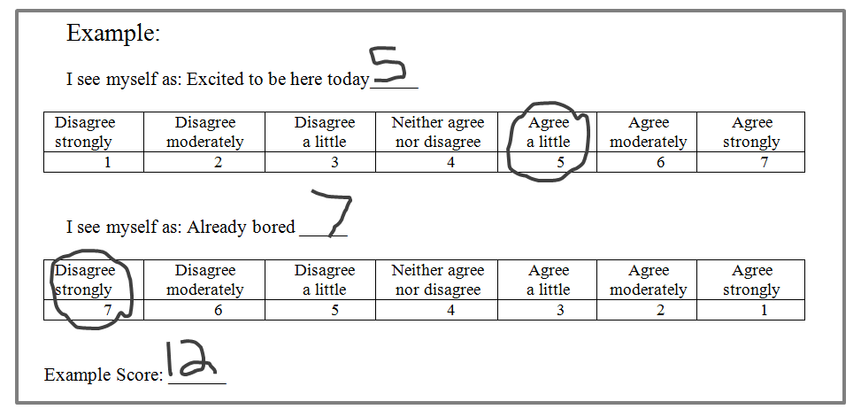

I see myself as: Extraverted, Enthusiastic. _____

Disagree strongly | Disagree moderately | Disagree  a little | Neither agree nor disagree | Agree  a little | Agree moderately | Agree strongly
1 | 2 | 3 | 4 | 5 | 6 | 7

I see myself as: Quiet, Reserved. ______

Disagree strongly | Disagree moderately | Disagree  a little | Neither agree nor disagree | Agree  a little | Agree moderately | Agree strongly
7 | 6 | 5 | 4 | 3 | 2 | 1

E score: _____

I see myself as: Sympathetic, Warm. _____

Disagree strongly | Disagree moderately | Disagree  a little | Neither agree nor disagree | Agree  a little | Agree moderately | Agree strongly
1 | 2 | 3 | 4 | 5 | 6 | 7

I see myself as: Critical, Quarrelsome.______

Disagree strongly | Disagree moderately | Disagree  a little | Neither agree nor disagree | Agree  a little | Agree moderately | Agree strongly
7 | 6 | 5 | 4 | 3 | 2 | 1

A score: _____
More on the reverse side

I see myself as: Anxious, Easily Upset. _____

Disagree strongly | Disagree moderately | Disagree  a little | Neither agree nor disagree | Agree  a little | Agree moderately | Agree strongly
1 | 2 | 3 | 4 | 5 | 6 | 7

I see myself as: Calm, Emotionally Stable.______

Disagree strongly | Disagree moderately | Disagree  a little | Neither agree nor disagree | Agree  a little | Agree moderately | Agree strongly
7 | 6 | 5 | 4 | 3 | 2 | 1

N score: _____

I see myself as: Dependable, Self-Disciplined. _____

Disagree strongly | Disagree moderately | Disagree  a little | Neither agree nor disagree | Agree  a little | Agree moderately | Agree strongly
1 | 2 | 3 | 4 | 5 | 6 | 7

I see myself as: Disorganized, Careless. ______

Disagree strongly | Disagree moderately | Disagree  a little | Neither agree nor disagree | Agree  a little | Agree moderately | Agree strongly
7 | 6 | 5 | 4 | 3 | 2 | 1

C score: _____

I see myself as: Open to New Experiences, Complex. _____

Disagree strongly | Disagree moderately | Disagree  a little | Neither agree nor disagree | Agree  a little | Agree moderately | Agree strongly
1 | 2 | 3 | 4 | 5 | 6 | 7

I see myself as: Conventional, Uncreative. ______

Disagree strongly | Disagree moderately | Disagree  a little | Neither agree nor disagree | Agree  a little | Agree moderately | Agree strongly
7 | 6 | 5 | 4 | 3 | 2 | 1

O score: _____

Citation: Gosling, S. D., Rentfrow, P. J., & Swann, W. B., Jr. (2003). A Very Brief Measure of the Big Five Personality Domains. Journal of Research in Personality, 37, 504-528.

