This sample is for researchers to use as a guide in developing their study materials. Instructions to the researchers are written in [square brackets in bold italics] and should be deleted. Instructions that are in [square brackets, bold italics, and are blue] need to be replaced with details specific to the study and changed to black, un-bolded, un-italicized, and removed from square brackets before uploading the material to the research ethics application. Please also delete this instructional paragraph.

**Please review the Guide to Creating an Information Letter and Consent Form for additional details**

Date: [insert date]
Study Title: [insert title]
Faculty Supervisor: [insert name, Department, 519-888-4567 ext. [insert ext.], University of Waterloo email address]
Student Investigator: [insert name, Department, University of Waterloo email address]

This letter explains what the study is about, possible risks and benefits, and your rights as a research participant. You may print/save a copy for your records. If you do not understand something in the letter, please ask one of the researchers before consenting to participate.

Study Purpose:
This study is being conducted to model two parts of the human body involved in tremulous elbow movement. These two parts are elbow muscles that produce the force, and brain-CNS that produce neuro-signals to control the muscles. CNS stands for Central Nervous System. The human elbow is a joint capable of two different motions, flexion-extension, and pronation-supination. We are interested in the first movement illustrated in the picture:

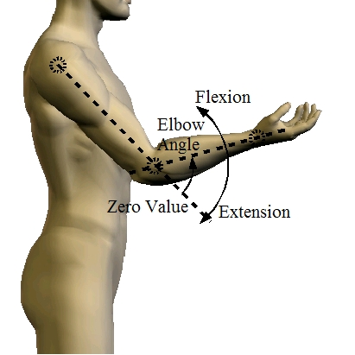

What you will be asked to do:
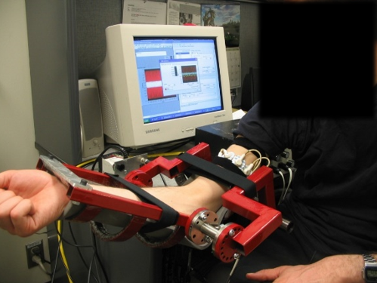
As a participant in this study, you will be asked to sit at a table and secure your elbow and lower arm, using two straps, to the experimental apparatus. You will be asked to apply some forces on the apparatus. The level of the required force and what you are applying will be shown to you on the computer screen. The required force level will change in a random pattern, and you will try to follow it. During the experiment two sets of EMG (electromyography) electrodes will be attached to your upper arm to measure muscle activity. If you do not have any problem moving your elbow and applying forces, there will be no discomfort. To avoid fatigue, we are going to have 2-3 minutes of rest between every two sets of measurements, and this break could be extended if needed. The experiment consists of a 30-minute orientation and preparation and then 60-minute data collection.

To be able to place the electrodes, please wear short sleeves. Before placing the electrodes, we are going to use rubbing alcohol to clean the skin. The electrodes are disposable, will stick to your skin, and can be easily removed. To hold down the electrodes we will use elastic tape. If your skin is hairy enough to impede electrode attachment, we will ask you to shave two small areas (of 5x3 cm) on the middle of your Biceps and Triceps, or you can do it here using disposable shavers.

Study Procedures:
During the first part of the study session, we will calibrate the equipment and you will become familiar with the device. We will take the following measurements:
1. Before attaching electrodes to your skin, we will get a signal for 2 seconds
2. You will try to apply your maximum force to the device for 2 seconds in flexion direction (repeated once more)
3. You will try to apply maximum force in extension direction (twice)
4. While your muscles are at rest, we will measure a signal for 2 seconds
5. You will try to apply 50% of your maximum force in both (extension-flexion) directions. You can see the actual force level on the screen.

For the main part of the study there will be 15 trials which are 30 seconds each. In each trial, a desired force level with changing amplitude (between 50% of your maximum force in flexion to 50% maximum force in extension direction) is going to be shown on the screen, and you will be asked to follow applying the same forces. There would be at least 2 to 3min rest between each two trials.

There are two groups of participants. One group has people with noticeable tremors in their hands and the other group involves people without these tremors. After the study is completed, you will be provided with feedback including the difference between the average model parameters in the two groups (average of all participants in each group). You will also be provided with a copy of any scientific articles prepared for presentation or publication based on the study.

Voluntary Participation and Withdrawing from Participation:
Your participation is voluntary. You may stop participating at any time. If you wish to withdraw your study data after participating, please contact the researchers. You can request your data be removed from the study up until [insert date] as it is not possible to withdraw your data once papers and publications have been submitted to publishers.

With your permission, we might contact you again in a few months to tell you about another study we will be conducting to obtain brain-CNS model parameters. You may decide at that time if you would like to participate in the new study.

Confidentiality:
To ensure the confidentiality of participant data, all information collected in this study will be aggregated. Therefore, your name will not appear in any report, presentation or publication resulting from this research. The data, with identifying information removed, will be kept for at least [insert time period] and will be securely stored.

[If data may be shared in an online repository, please see the ICL guide for details about what information and language to include].

Risks to Participation:
As mentioned earlier, if you are comfortable moving your elbow and applying flexion-extension forces (as shown in the picture above), there is no known risk to participation. This device does not apply any force on your body and is just a measuring tool of your applied force. For people with tremulous hand, the discomfort level (if any) will not be greater than what is normally experienced in performing arm movements, however, if you feel noticeable discomfort while performing the tasks, please advise the researcher and participation will stop.

Contact Information:
This study has been reviewed and received ethics clearance through a University of Waterloo Research Ethics Board (REB [####] [Replace#### with the file number that is listed at the top of your ethics application]). If you have questions for the Board, contact the Office of Research Ethics, toll-free at 1-833-643-2379 (Canada and USA), 1-519-888-4440, or reb@uwaterloo.ca.

For all other questions, or any questions regarding participation in this study, please feel free to ask the researchers. In case of additional questions later, please contact Professor. [insert name] at: (519) 888-4567 ext. [insert ext.] or by email at: [insert University of Waterloo email address].

[Please check that all relevant study details are included, changes are made to the document to accurately describe the study and procedures, and delete the instructional text printed in bold italics before submitting to the Office of Research Ethics for review.]

