Biological Waste Segregation Guideline
Segregation, proper identification, and proper packaging allow for the safe and environmentally responsible disposal of hazardous biological wastes.

Waste Segregation and Disinfection
The flowchart below provides a summary of how biological waste is to be segregated. If after reviewing the flowchart, you are unsure how to classify your waste, please contact the ESF technician at esf@uwaterloo.ca.
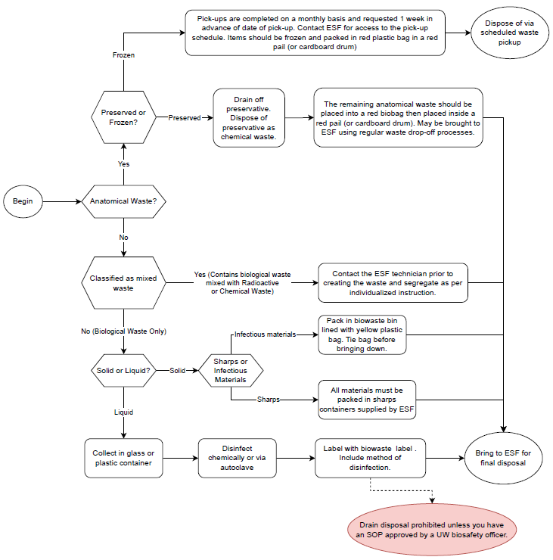

Liquid biological wastes
Liquid biological wastes include used nutrient broths, cell cultures, blood and bodily fluids (animal and human), recombinant or synthetic nucleic acids, and liquids contaminated with these materials. Most liquid biological wastes can be deactivated physically or chemically.
Physical inactivation (autoclaving)
- Involves exposing the material to elevated temperatures and pressures for a specific amount of time. Some considerations include:
  - There are both dry and wet techniques.
  - Temperatures, pressures, and cycle times are vital to successful inactivation.
  - Positioning in autoclave is also important.
- Please review the Autoclave Guidance and ensure the user is trained on the specific operating procedures of the Autoclave that is to be used.
- *Important note – autoclaved wastes cannot be disposed of as non-hazardous waste unless the efficacy of the autoclave has been validated through the use of biological indicators or chemical integrators. Please contact a Biological Safety Officers if you have any questions on this requirement (biosafety@uwaterloo.ca)

Chemical disinfection – General Guidance
- The appropriate chemical is specific to the active agent. Some considerations include:
  - Contact time
  - Concentration
  - Chemical preparation frequency is vital – as materials like bleach and hydrogen peroxide rapidly loose efficacy once exposed to air
  - Compatibility of surfaces or materials with the chemical being used
- Please review the Chemical Disinfection Guidance prior to chemically disinfecting your liquid biological waste.

Liquid Waste – Collect and Dispose

Liquid wastes (blood, bodily fluids, and potentially pathogenic materials)
- Collect in a 1 L, 4 L or 20 L container. If you need help determining which size, contact the ESF at esf@uwaterloo.ca
- Fill container only 70% of the total volume
- Before removing container from containment zone it must be sprayed with alcohol and wiped down.
- Ensure container is fully sealed.
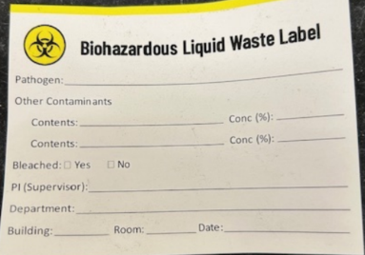
- Affix Biohazardous Liquid Waste Label prior to disposal. Labels can be picked up from the ESF
- Bring to ESF for final disposal unless SOPs indicate otherwise

Liquid Wastes – In Laboratory Treatment and Disposal
Laboratories that wish to treat and dispose of liquid biological wastes on their own must follow this guidance:
When a laboratory chooses to dispose of these materials down the drain, the following protocols must be followed:
1. Use an appropriate disinfectant. Bleach should only be used if disposal is occurring the same day because after 24 hours bleach loses its efficacy. If you don’t intend to dispose on the same day as generation, use another disinfectant that is stable over a longer period of time.
2. Remember to maintain the minimum concentration for inactivation. If bleach is used, a 1 to 10 ratio of bleach to liquid should be maintained in the container. If you add more material, more bleach needs to also be added. 3. Bleach should be prepared fresh on the day of use. 4. Let sit for a minimum of 30 minutes prior to disposal. 5. Perform efficacy monitoring as per SOPs.

Solid biological wastes
Solid biological wastes consist of materials such as gloves, lab coats, paper towels, petri dishes, centrifuge tubes, etc. contaminated with biological wastes. Agar should be allowed to solidify then be treated as solid waste.
At the University of Waterloo, all waste collected in the bio-waste bins lined with yellow bags are sent to a third party for final sterilization and disposal.

Solid Waste Contaminated with Infectious Materials (medical waste, infectious materials, cultures)
- All material must be packed in biohazard bins (see images below) with liners supplied by the ESF.
- Bags inside bins must be sealed (tied) and lid secured.
- Outside of bin must be disinfected by spraying with alcohol and then wiped down.
- Bin must not be over packed (14kg max).
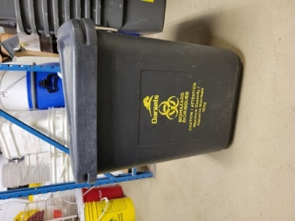
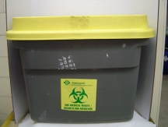

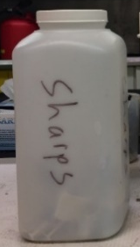
Sharps (syringes, blades etc. contaminated with biohazardous materials)
- All material must be packed in sharps containers supplied by the ESF (4L plastic jugs like the image to the right).
- Review the Sharps and Glass Waste Segregation Guideline on the Hazardous Waste Standard page for more information.

Animal (frozen)
- All animals are to be kept frozen by the researcher.
- Pick up must be arranged in advance. Email esf@uwaterloo.ca to be added to the schedule.
- All material must be packed in red anatomical bags supplied by the ESF and placed in either a red anatomical waste pail or a cardboard anatomical waste drum.

Animal (preserved)
- All formalin must be drained off and disposed of as chemical waste.
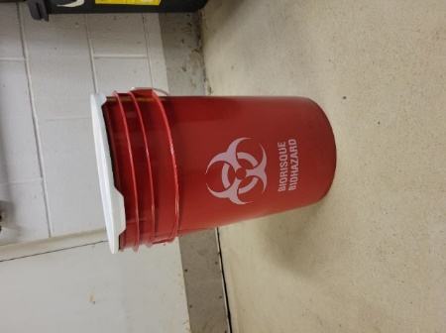
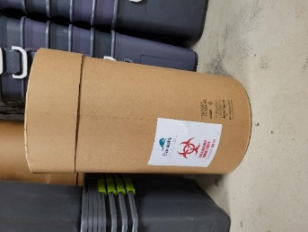
- All material must be packed in anatomical waste bins (see pictures to the right) with red bags supplied by the ESF.
- Bags inside bins must be sealed (tied) and lid secured.
- Bin must not be over packed (14kg max).

