Campus Wellness
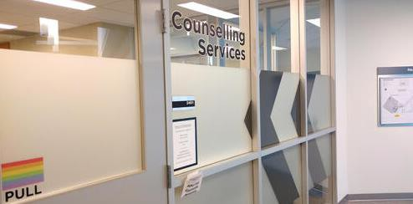
Who are we? Counselling Services’ is part of the larger Campus Wellness team of multi-disciplinary professionals who provide health and mental health services for students to achieve academic success and live a meaningful life. We strive to provide a secure, supportive environment for students of all orientations and backgrounds.

Do students have to pay for counselling? No. Counselling is provided at no additional cost to University of Waterloo students who are currently registered or on a co-op term.

What does CS do? We provide counselling, support coordination, and other resources to support students’ metal health. We also provide support requests for our campus community.

Counselling  We offer intensive single-session appointments, individual counselling, and group counselling. We also have crisis sessions available every day. | Support Coordination  We offer support co- ordination that assists students with system navigation and getting connected with on and off campus supports for mental health, academic accommodation, and other concerns. | Other Resources  We offer counselling workshops and seminars every semester. We also have information and pre-recorded workshops on several wellness and mental health topics such as: sleeping well, relaxation exercises, and stress management. (see our website below for offerings and details).

What’s new? Same Day Service re-launched this month!
Same Day Single Session appointments are a good option for students who do not want or require ongoing counselling, or who already have a counsellor but have had something come up in between sessions that is pressing they wish to discuss. These appointments are 1.5 hours—longer than traditional counselling sessions. Students can request a same day appointment on Wednesdays between the hours of 8:00am–12:00pm by submitting a form. These appointments are limited and are assigned on a first-come, first-served basis. We recommend students request an appointment early in the day!
How can students schedule an appointment? Call us at 519-888-4096. Students will be scheduled for a 30-minute meeting with an Intake Specialist who will clarify your counselling concerns and goals and match you with the service/clinician to best meet the student’s needs.
For more info: https://uwaterloo.ca/campus-wellness/counselling-services

