Event Food Safety
Intent
To outline requirements for events with food outside of usual UW food areas within the Region of Waterloo. For other locations contact the local Public Health Authority.
Exemption
Residence or dwelling units.
Contacts
Public Health Food Safety Program 519-883-2008
UW Occupational Health Nurse ext. 36264
REQUIREMENTS
Events with food must comply with following the requirements of the Region of Waterloo Public Health.
- Fill out a Public Health/UW Special Event Food Application and submit it at least 30 days before the event to the address on the form.
Certain exemptions may apply. For more information and guidance, please call ext. 36264.
- All food preparation must be done in a Public Health approved facility.
- Barbecues and Outside Cooking Equipment must comply with UW Standard.
- Home preparation of foods is not allowed except for some baked goods. Refer to Guidelines for Preparation of Non Hazardous Baked Goods.
- Only food from government approved sources is allowed
- EVENT SITE
- Countertops must be covered with a washable non-absorbent material.
- Cutting boards must be hardwood or polyethylene plastic and in good condition.
- Hand sinks must he located in a convenient location to food preparation area.
- Store foods and storage containers at least 15 cm above the floor or ground
- HANDWASHING FACILITIES
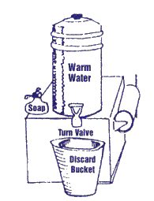
- This facility should include warm running water liquid soap, and individual paper towels in proper dispensers.
Serviced Site: A separate hand sink with hot and cold water is required.
Unserviced Site: An air pump thermos or jug of warm water with a push
button or turn spout (and a bucket to collect the dirty water) is an acceptable method.

- Food service to patrons must be via single-service articles.
- DISHWASHING FACILITIES
Serviced Site: Equipment and utensils must be washed in a two compartment sink.
- Wash in hot soapy water.
- Rinse under hot running water
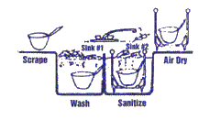
- Sanitize by immersion in an acceptable sanitizing solution (One teaspoon (5ml) of household strength chlorine bleach to one litre of water or QUAT solution at 200ppm).

Unserviced Site: Provide an extra set of clean utensils. Store in a clean, washable container.
Sanitizing Solution for use:
- For 100 ppm solutions use 1 tsp of bleach in 1 litre of water DO NOT USE SCENTED BLEACH
- FOOD PROTECTION
Food preparation and cooking areas must be separated from the serving area.
- Protect food on display from contamination with the use of sneeze guards, pre-packaging etc.
- Condiment containers must be pump type, squeeze containers, or have self closing covers or lids. Single service packets are recommended.
- Food must be handled with tongs, spoons etc. and not with bare hands.
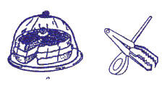
- Ensure all food contact surfaces are cleaned and sanitized.

- TEMPERATURE CONTROL
To reduce the potential of foodborne illness:
Hot Holding: Maintain food at minimum internal temperature of 60°C (140°F) after cooking or reheating.
Cold Holding: Store foods at a temperature of 4°C (39°F) or lower. Hazardous foods are milk or milk products, eggs, meat, poultry, fish, shellfish, or other products that can support the growth of disease causing micro-organisms. Examples are hamburgers, shish kabobs, hot dogs, gyros, pogos, chicken, potatoes, cooked rice, ice cream. Hazardous foods shall not be held at room temperature.
Hazardous foods shall not be held at room temperature.
Serviced Site: All hazardous food must be kept mechanically refrigerated at 4°C (39°F) or lower.
Unserviced Site: Store the minimum amount of food at the booth in a cooler (use sealed ice packs and place on top of food). The food temperature must be 4°C (39°F) or lower. Most food must be stored in a mechanically refrigerated unit off site or in a refrigerted truck.
- Accurate thermometers must be provided in all cooling units to monitor temperatures.
Reheating: Foods must be quickly reheated to the original cooking temperature (or 74°F).
Cooking/Heating: Cooking hazardous food to the following minimum internal temperatures.
- Whole poultry....................................................................82°C/180°F
- Poultry/ground poultry......................................................74°C/165°F
- Pork/pork products...........................................................71°C/160°F
- Ground meat (not poultry)................................................71°C/160°F
- Fish...................................................................................70°C/158°F
- Eggs.................................................................................63°C/145°F
- Food mixtures..................................................................74°C/165°F
- Other hazardous foods....................................................70°C/158°F
NOTE: Use a sanitized metal stem probe thermometer to check internal temperatures of food.
Leftovers : Hot held foods which have not been used by the end of the day must be discarded.
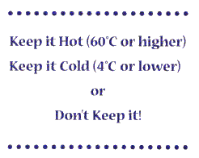
Transporting : Use properly insulated containers to transport foods and maintain food temperature cold (max 4°C) or hot (min. 60°C).

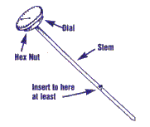
- A probe thermometer must be provided to check internal temperatures. It must be able to measure from -18°C (O°F) to 105°C (220°F).

- FOOD HANDLING TIPS
Food Service personnel must,
- wash hands thoroughly with soap and water
  - before starting to handle food
  - after using the toilet
  - after sneezing, coughing
  - between handling raw and ready to eat foods
  - anytime that hands become soiled
- do not use tobacco in the booth
- be clean, wear clean outer garments
- wear headgear that confines the hair
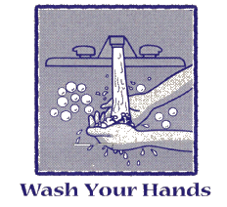
- be free from illness, i.e. diarrhea, cold, flu

- An appropriate sized garbage container must he provided. Keep it clean and empty it frequently.
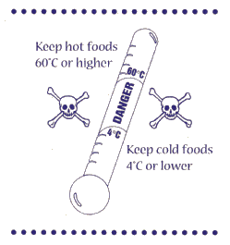
Be ready before starting! Have all your equipment ready i.e. refrigerators, steam tables, cold and hot running water etc. before bringing food to the booth.

