In support of the United Way
Flavours to Savour Raffle

$1 each, 6 for $5, or 15 for $10
– $50 gift card – $40 gift card

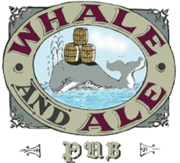
– 2 x $25 gift cards – $25 gift card

– 2 x $25 gift cards The Duke of – $25 gift basket
Wellington
- – $25 gift card – $25 gift card

Draws to be held October 31st
Tickets available from
Nancy or Shirley - CPH 1320

