Register for an Orcid iD

Directions for signing up and making use of an Orcid iD

Created by Alissa Droog, May, 2018

Contents

Part 1: About Orcid 2

Why have an Orcid iD? 2

Publishers that integrate with Orcid 2

Optometry Journals that integrate with Orcid 2

Example 1: Orcid integration with *Optometry and Vision Science* 3

Example 2: How an Orcid iD may appear in publications 3

Part 2: Register and populate account 4

Register 4

Add “Also known as”, Country and Emails 6

Add Employment 7

Privacy Settings 8

Login using your WatIAM 9

Part 3: Adding publications 11

Adding works using Wizards via “Search & link” 12

Adding works using the Scopus-Elsevier wizard 13

Add works using CrossRef Metadata Search 15

Add works using your Researcher ID 16

Add works from Google Scholar using BibTeX 17

Add works manually 18

Part 4: Using your Orcid ID and account 19

Places you can use your Orcid iD 19

Questions? 19

# Part 1: About Orcid

Orcid is a global non-profit organization founded in 2011 that provides Orcid iD’s to researchers. An Open Researcher and Contributor ID, or Orcid iD for short, is a unique digital identifier which allows researchers to disambiguate their name from similar names and associate variations in their name under one identifier. An Orcid iD also “through integration in key research workflows such as manuscript and grand submission, supports automated linkages between you and your professional activities ensuring that you work is recognized” (<https://orcid.org/>). Orcid iD’s are the future of scholarly publication and many granting agencies and journal submission processes now allow (or require) researchers to include their iD in the submission process. For example, it is likely that the tri-council awards in Canada are in the process of integrating Orcid iD’s into the submission process right now.

## Why have an Orcid iD?

* Disambiguate authors with similar, different variations or changed names
* This helps the researcher get credit for their work
* Researcher controlled account with privacy settings
* iD follows the researcher throughout their career, regardless of their employer
* Allows researcher to create and organize a virtual publication list including various publication types
* Allows researchers to better link their works together using tools
* Integrates with many publication and grant application programs
  + Over 200 journals now integrate with Orcid either through registration or in your account settings
  + Orbit Project: granting agencies are assigning Orcid iD’s to funding so they can track it
  + Tri-council agencies are moving towards Orcid integration
  + Ex: In Italy, every researcher is required to have an Orcid iD and Europe is ahead of North America in Orcid uptake
* Integrates with Pure (My Research) and UW Scholar

## Publishers that integrate with Orcid

* Elsevier
* ScholarOne
* Springer-Nature

## Optometry Journals that integrate with Orcid

* Clinical and Experimental Optometry
* Optometry and Vision Science
* Eye and Contact Lens Journal
* Vision Research
* Ophthalmology
* Archives or Ophthalmology and the American Journal of Ophthalmology

## Example 1: Orcid integration with *Optometry and Vision Science*

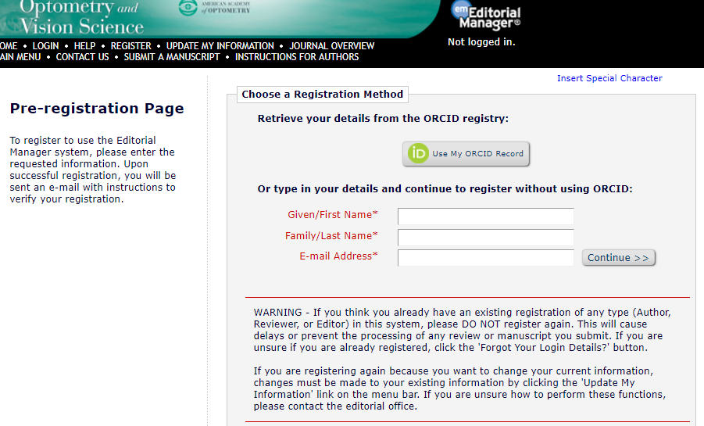

## Example 2: How an Orcid iD may appear in publications



# Part 2: Register and populate account

## Register

Go to <http://www.orcid.org> and click on “Register for an Orcid iD”

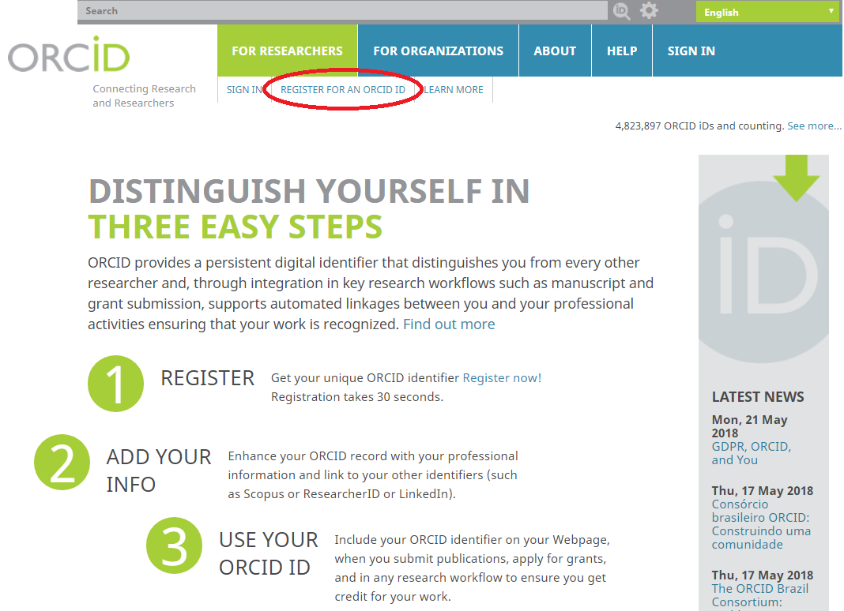

Fill in the registration page

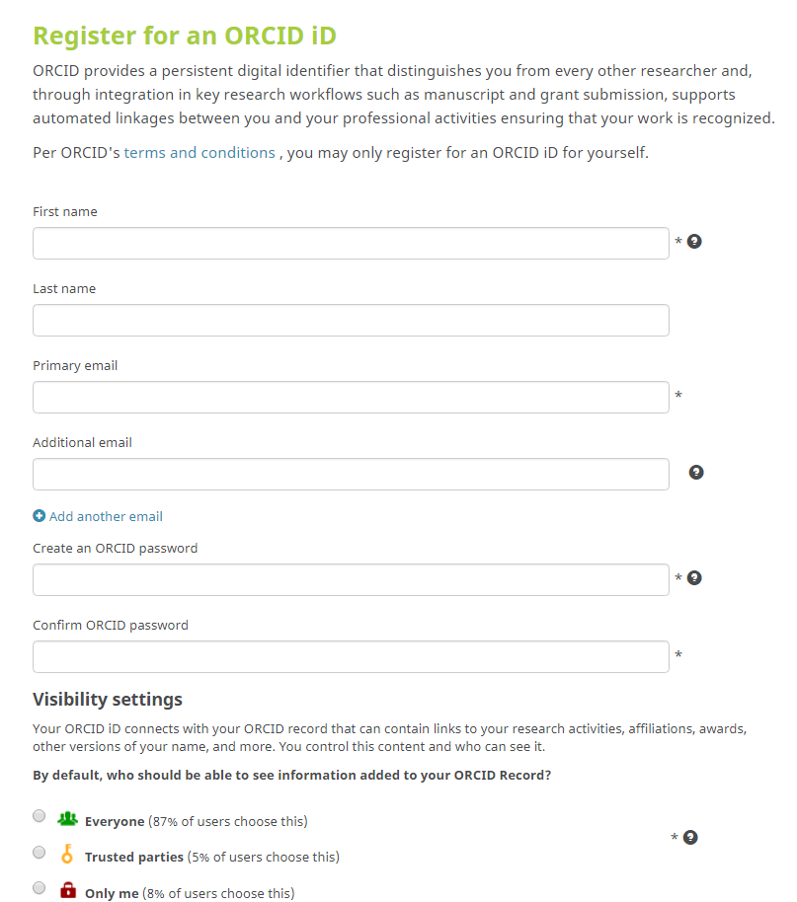

Write down your Orcid iD number including hyperlink information, somewhere where you will remember it.



## Add “Also known as”, Country and Emails

Update “Also known as” to any other names that you have published under. Then update “Country” to Canada.You can also add an alternate email. This is really valuable if you forget your password and can use your alternate email to access the account.

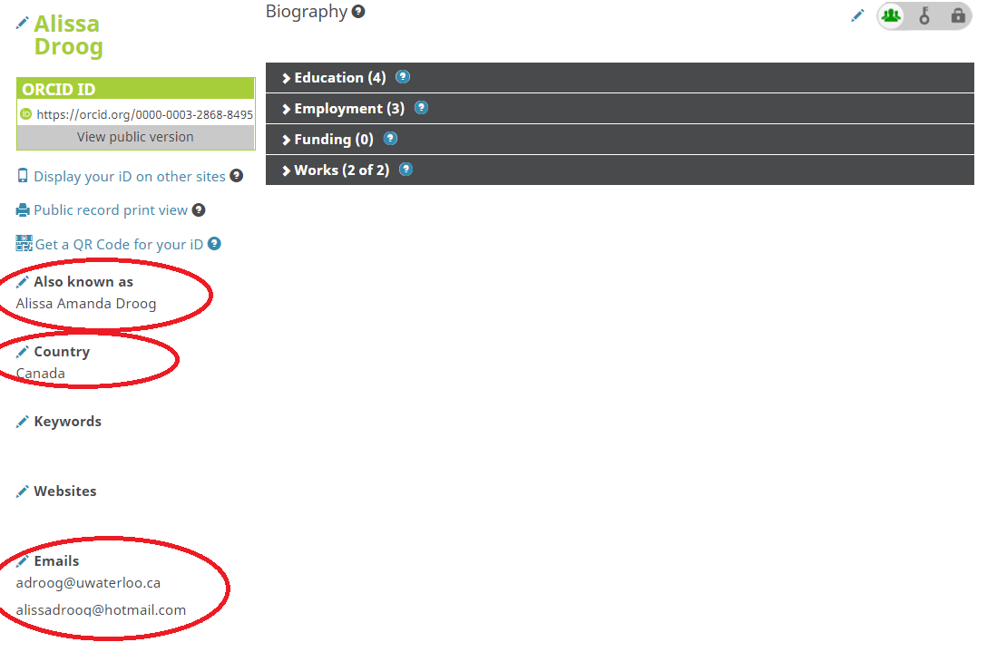

## Add Employment

Add employment by clicking “Add employment” and then “add manually.” By adding employment at the University of Waterloo, it will show up in searches for you name as an affiliation which helps distinguish you from other researchers with similar names in search results.

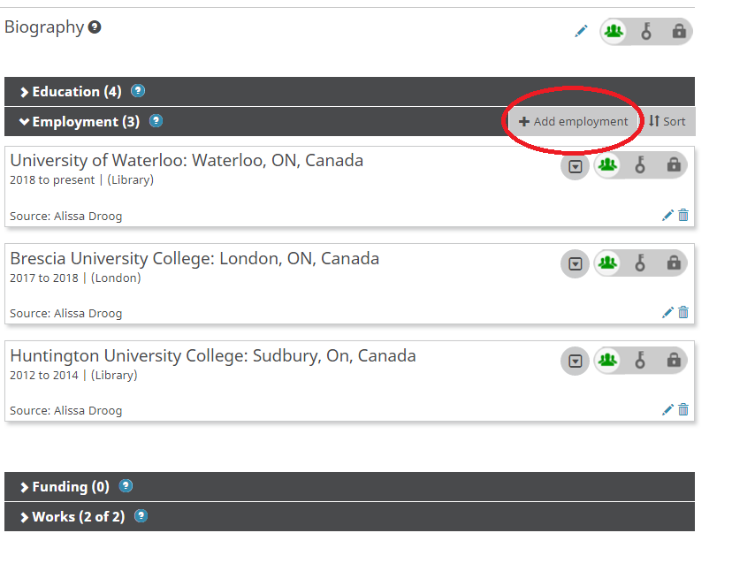

Add your employment at the University of Waterloo by typing in the university name in the Institution field. Waterloo should show up and click it to auto-populate fields. Add your **department as the “School of Optometry and Vision Studies”** and your role at the institution. When complete, click “Add to list.”

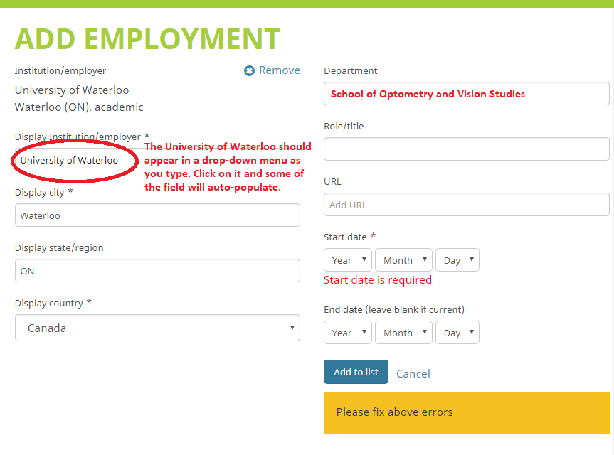

## Privacy Settings

You can control who can see any information about you in the privacy settings. We recommend that you keep your employment with the University of Waterloo public so that you can be found via a name search in the Orcid registry.



## Login using your WatIAM

Connect your account to your WatIam for institutional access. To do this, first log out of your account.



Prepare to log back into your account, but this time click on “Institutional Account.” Where it says to enter your organization’s name, type in Waterloo and click on the University of Waterloo when it pops up. Then click “Continue.”

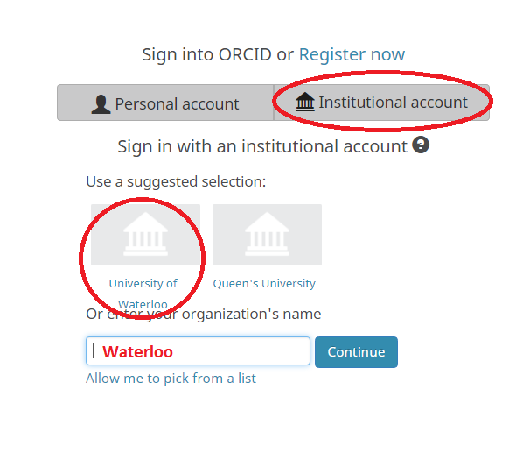

Link to your existing Orcid iD by logging in. Follow the directions on-screen until you have signed back in. From now on, you can sign into your Orcid account using your WatIam credentials.

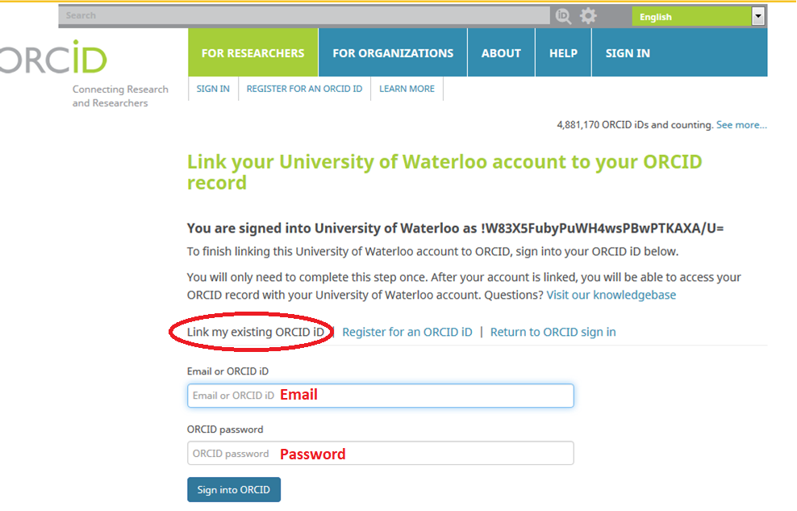

# Part 3: Adding publications

There are a couple of ways to add publications to your Orcid account. The easiest is to use the wizards found under “Search & Link” that will automatically populate publications that can be found. For example, you can link your Researcher ID or Scopus ID and have Orcid auto-populate your publications by that route. You can also export your publication list from Google Scholar via “Import BibTeX” or add publications manually by filling in various fields. See the sections below for adding works by different methods:

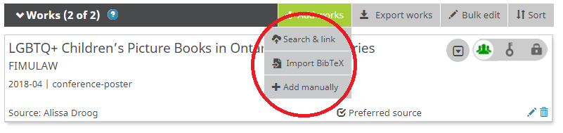

## Adding works using Wizards via “Search & link”

After clicking on “Add works” and “Search & link”, choose one of the wizards to auto-populate your account. We recommend using CrossRef Metadata Search, or linking your Researcher ID or Scopus ID to your Orcid account so publications associated with those ID’s can be associated with your Orcid ID. If you use CrossRef Metadata Search, you will need to add each work by you to your Orcid account. If you choose to link your Researcher ID or Scopus ID, we also recommend that you log into those accounts and inform either/both of your Orcid iD number so they can associate your research with your Orcid iD in their databases. In order to use these wizards, you will need to authorize the wizards to search the applicable databases for the Orcid names you provided.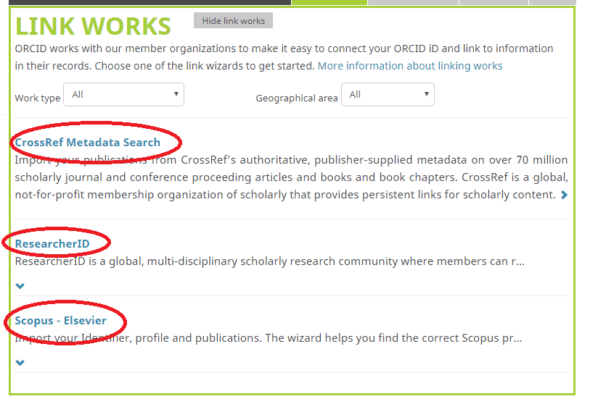

## Adding works using the Scopus-Elsevier wizard

Scopus ID’s are assigned automatically and you may not know that you have one. Don’t know if you have a Scopus ID? Go to Scopus and search for yourself under “author” and see if you have a Scopus ID already. If you do, this wizard should be your first step to adding works to your Orcid account. Once activated, the Scopus-Elsevier wizard will automatically push any works tired to your name/Scopus ID to your Orcid account. It also establishes a link between the two programs and will automatically send new publications to your Orcid record.

1. Authorize Scopus-Elsevier to search their databases for your name.

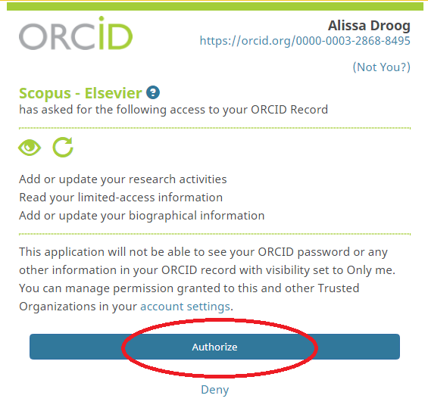

1. Search for your name using the Wizard and follow the onscreen instructions to add the Scopus ID to your profile.

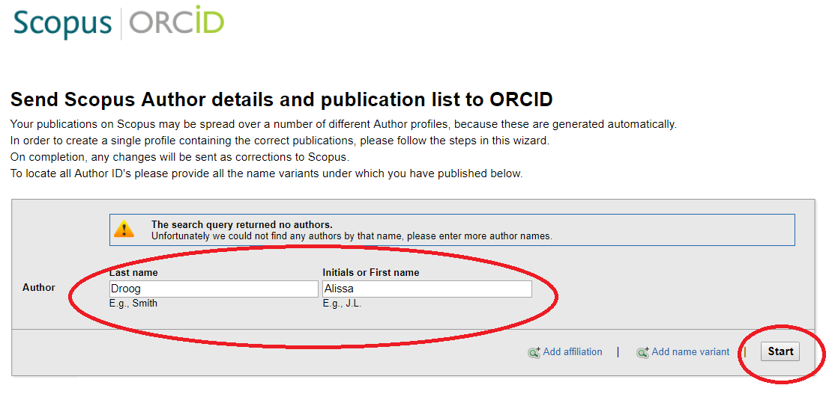

Note: There is a known bug in the Scopus-Elsevier wizard and it may take a couple of tries to get this link established.

## Add works using CrossRef Metadata Search

1. Authorize the search to search the database for you name.

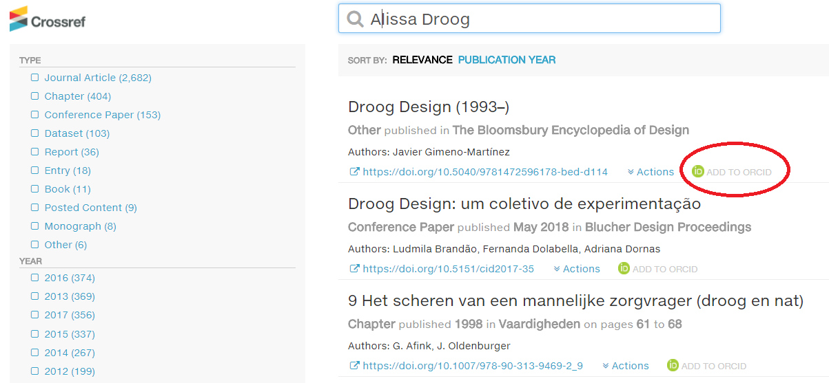

1. Add applicable works to your account by clicking on “Add to Orcid”

## Add works using your Researcher ID

1. Authorize the Researcher ID search to search their databases for your Researcher ID.

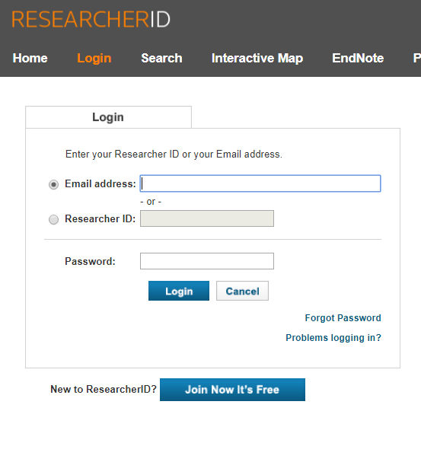

1. You will be prompted to login to your Researcher ID account. Once there, you will be allowed to push works from your Researcher ID to your Orcid account.

## Add works from Google Scholar using BibTeX

Note: This only works if you have an existing Google Scholar Account.



1. Open Google Google Scholar in a new tab and click on “my profile.”
2. Check off all works you would like to export into Orcid.
3. Click Export to BibTeX. A window will appear with text similar to that shown below.



1. Copy the BibTeX information which appears and paste it into a text editor such as Notepad. Save the file.



1. Go to back to your Orcid Account, and click to add works via “Import BibTex”. Click “Choose file” and add the file saved as in the text editor. Your publications should now appear in Orcid.

## Add works manually

* + - 1. Adding works manually is the most time-consuming of the ways to add publications to your account. It is advised to use this method if your works aren’t showing up by other methods discussed above. Frist, click “Add works” and “Add manually.”



* + - 1. Fill in the appropriate fields to add the work. Note that you can add conference posters, conference papers, and other unique works to your account in this way.

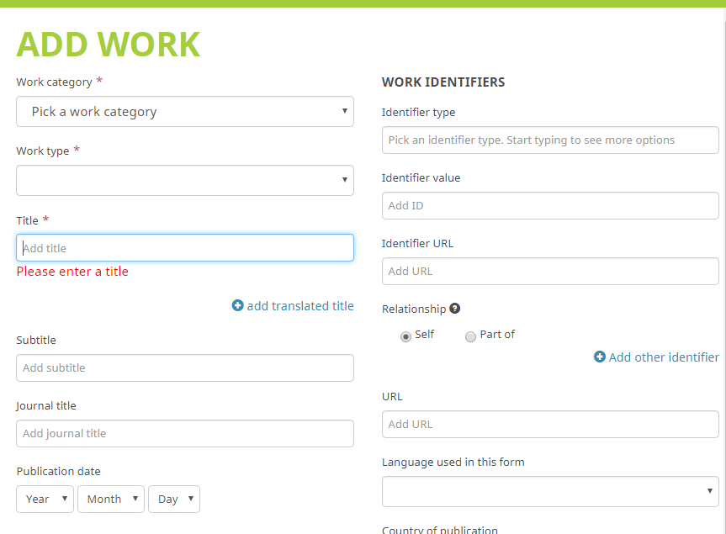

# Part 4: Using your Orcid ID and account

Your Orcid account is like your electronic CV which can be accessed via our Orcid ID hyperlink. To use your Orcid ID, ensure to include your Orcid ID in grant and publication submissions, and display it in places where it can be seen by others.

## Places you can use your Orcid iD

* + - Grant applications
    - Publication submission process
    - UW Scholar profile can auto-populate your CV using your Orcid account
    - Researcher profile on the School of Optometry website
    - Email signature
    - Orcid iD can be added to your profile in Research Gate and Academia.edu

# Questions?

Alissa Droog

MLIS Co-op student

Dana Porter Library

[adroog@uwaterloo.ca](mailto:adroog@uwaterloo.ca)

Gloria Booth-Morrison, MLIS

ORCID-CA Member Support Specialist

T : 613.907.7038

[gboothmorrison@crkn.ca](mailto:gboothmorrison@crkn.ca)

ORCID<https://orcid.org/0000-0002-4042-1868>